Questioning for Quality Thinking
Using Bloom’s Revised Taxonomy

When asking questions either in oral or written form, it is wise to vary your questions across all 6 categories of Bloom’s Taxonomy. Benjamin Bloom was a university professor and in 1956 he devised three domains of learning (cognitive, affective and psychomotor). Bloom’s cognitive domain seems to be referenced more as it outlines 6 levels of thinking skills. Still in use today, it has undergone one significant revision. In 2001, Lorin Anderson (a former student of Bloom) replaced the nouns with verbs (Knowledge is now Remembering) and switched the last two categories around.

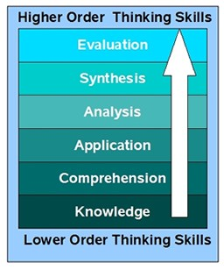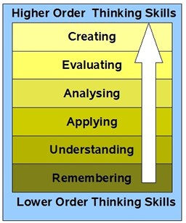1956 Original 2001 Revision

HOTS

LOTS

Charts: http://www.techlearning.com/shared/printableArticle.php?articleID=196605124

Remembering /Knowledge
This refers to asking questions about identification and recall of information – knowledge of events, places, dates and major ideas. Questions may include the words: list, define, tell, describe, identify, label, examine, tabulate, quote, name, who, when, where…

Who, what, when, where, how ? Describe .
Name the person who .

Basic Recall of Facts/Knowledge – Often short answer

Understanding/Comprehension
This refers to asking questions about the organization and selection of facts and ideas – understanding information, grasping meaning, translating knowledge into a new context, order, group and infer causes. Questions may include the words: summarize, describe, interpret, contrast, predict, associate, distinguish, estimate, differentiate, discuss, extend….

Retell in your own words. What is the main idea of ?
Predict what will happen after .
Understanding facts –
one to a few
sentences answer

Applying/Application
This refers to asking questions about the facts, rules and principles: use information, methods concepts and theories in new situations. Solve problems using required skills and knowledge. Questions may include the words: apply, demonstrate, calculate, complete, illustrate, show, solve, examine, modify, relate, change, classify, experiment, discover…

How is an example of ? How is related to ? Why is significant?

Analysing/Analysis

Applying knowledge of facts, principles to an example – showing
you understand by doing.

This refers to asking questions about the subdivision of a whole into component parts: seeing patterns, recognition of hidden meanings, and identification of components. Questions may include the words: analyze, separate, order, explain, connect, classify, arrange, divide, compare, select, explain, infer…

What are the parts or features of ? Classify according to ? How does compare/contrast with ?
Breaking down whole into parts, analyzing parts, comparing one to another – could be charts, tables, graphs

Evaluating/Evaluation
This refers to asking questions about the development of options, judgments or decisions: compare and discriminate between ideas, assess value of theories, make choices based on reasoned argument, verify value of evidence and recognize subjectivity. Questions may include the words: assess, decide, rank, grade, test, measure, recommend, convince, select, judge, explain, discriminate, support, conclude, compare, summarize…

Do you agree ?

What do you think about ? What is the most important ? Prioritize according to .
How would you decide about ?
What criteria would you use to assess ?
Making decisions, judgments and evaluations – usually longer answers

Creating/Synthesis
This refers to asking questions about the combination of ideas to form a new whole: using old ideas to create new ones, generalize from given facts, relate knowledge from several areas and predict/draw conclusions. Questions may include the words: combine, integrate, modify, rearrange, substitute, plan, create, design, invent, what if, compose, formulate, prepare, generalize, rewrite…

What would you infer from ? What ideas can you add to ?
How would you create/design a new ?
What might happen if you combined with ? What solutions would you suggest for ?

Adding new ideas and info and consider the outcome – usually longer answers

Bloom§ fK5®:YJa§@@
T@

Higher Order thinking

Create
Design, build construct, plan

produce devise

Analyse Compare, organ question, res;earch
deconstruct
Evaluate
Check, Judge,
ue, experiment hypothesis,
test, detect

outline, attribute Apply

Do, carry out, use,

Understan
Interpret, summarise,
explain, rephrase classify, infer, paraphrase, compare
run, implement

Remember Recall, list, retrieve, find, name, recognise
identify, locate decribe

Lower Order Thinking

From Andrew Churches (Bloom's and ICTTools)
http://edorigami.wikispaces.com/BIoom%27s•and•ICT•tools

