Overview
There are two roles you can assign to a participant when you add them to your course: Instructor and Student.
The instructor role will give the user unlimited access to your course and course materials. Instructors can do everything you can do in your course including editing content, exporting the content to another course, and viewing hidden or restricted content.
The student role gives the user limited access to the course and course materials. The student view is limited by restrictions you place on the content and this role cannot make any changes to the course materials within VIULearn.

To Add a Participant
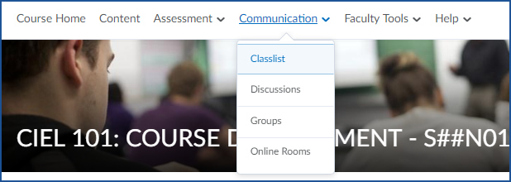
- Navigate to the Classlist by clicking Communications and Classlist on the Course Navigation bar

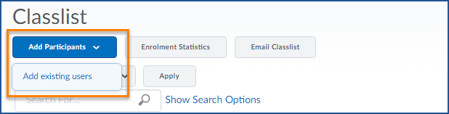
- Click the blue Add Participants button and choose Add existing users

- Enter the name of the person you wish to add to your course in the search box and click the magnifying glass

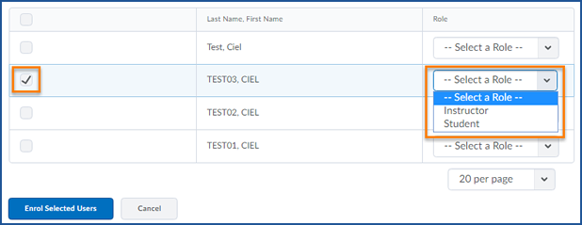
- Check the box next to the user and select the role you want to give them in your course

- Click the blue Enrol Selected Users button to add the user to your course
- You will see a confirmation screen.
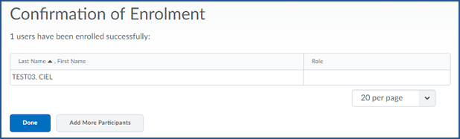
Note: if you chose the role of student for the user, the role field will appear blank on this page.

- Click Done to go back to the Classlist or Add More Participants to add another user to your course

