Overview
Flickr is an image and video hosting platform where you can find creative commons and open licensed media for use in your courses. Adding a Flickr file to your course is similar to adding a VIUTube or YouTube video.

Add an Image from Flickr to a VIULearn File
- Click Content on the course navigation bar to open the Content Tool.

- Choose the module or sub-module where you want to add the file.
- Select the blue Upload/Create button and choose Create a File.

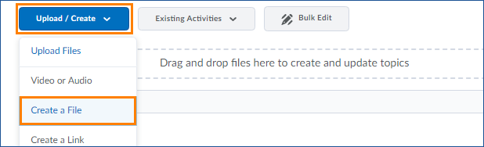

- Click Insert Stuff

- Choose Flickr from the list of options
- Search by keyword for an image
- You can click on an image’s thumbnail to preview it or click on the description to select it.
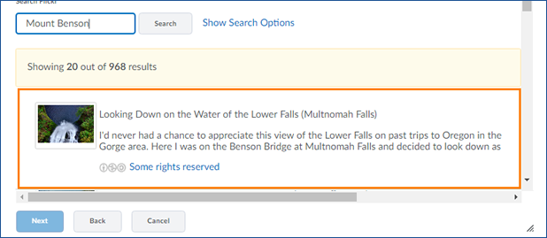

- Once you have selected your image, click the blue Next button.
- Make any changes to the Alternate text and size of the image and click the blue Insert button.
- Add any text or other content to your file. When you are finished editing the file, click the blue Publish button to publish your page or the grey Save as Draft to save your changes without publishing them
Please Note: If your course is active, learners will be able to see the Published page immediately unless you have set specific restrictions to hide the module or submodule.

