Overview
You can add files that are stored in your Manage Files area directly to Content. You can add items from Manage Files to your Content either through the Content Tool or from the Manage Files Area
Please Note that adding these files to your course does not create a new copy of the file. If you add the same file to more than one place in the course, any changes you make to the file will display in all of the places you have the file.

Add Items through Content

- Click Content on the course navigation bar to open the Content Tool.

- Choose the Module or Sub-Module where you want to add the files.

- Select the blue Upload/Create button and choose Add from Manage Files.
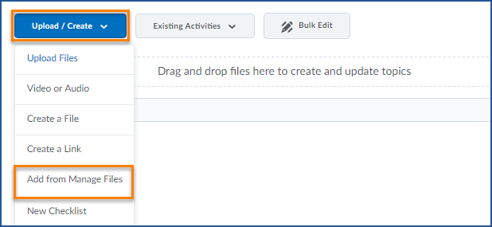

- Navigate to the files you wish to add and check the box beside each file.
To add all the files in a folder, check this box at the top to automatically select every item in the list.
You can use the drop down menu at the bottom of the window to filter your files so only one file type is showing. This is useful if you have several of a single file type in one folder that you want to add without adding the entire folder contents.
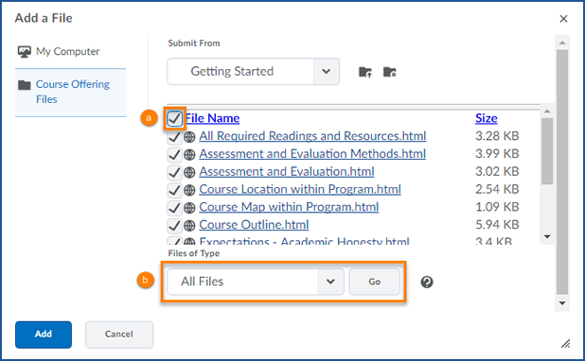
- When you have selected all the items you wish to add, click the blue Add button.
- You will now see all of the files displayed in your course content.

Add Items to Content from Manage Files
Note: You cannot add multiple files to Content simultaneously through the Manage Files area.
- Navigate to the File Manager by selecting Faculty Tools and Manage Files on the navigation bar.
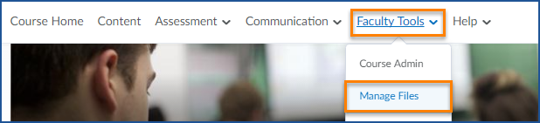
- Navigate to the location where you have placed the file you want to use.
- Click on the arrow to the right of the name of the file you wish to add to the course to open the context menu and click Add Content Topic
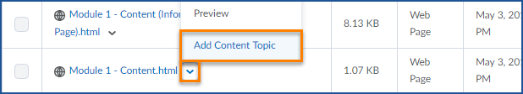

- Choose the Module or Sub-Module where you would like the content to be added

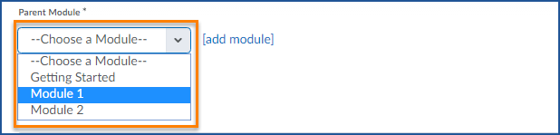

- Click the blue Add button.

