Overview
In order to give learners in your course access to the Glossary, you must provide them with a link to the Glossary either in Content or in another tool. This handout will give you the steps to create a Glossary and add it to your course content.

Create a Course Glossary in VIULearn
- Choose Faculty Tools and Course Admin.
- Select the Glossary.
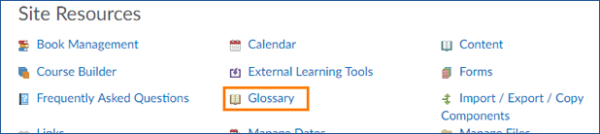
- To build your Glossary within VIULearn, click the blue New Term button.
- Enter your Term and Definition in the designated boxes and click the blue Save button to return to the Glossary, or the grey Save and New button to add another term.

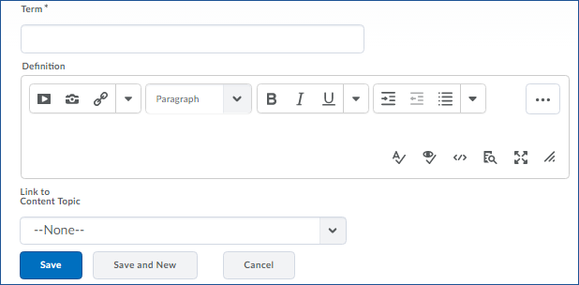

Create and Import a Glossary Using a CSV File
- Choose Faculty Tools and Course Admin.
- Select the Glossary.
- Click the grey Import Terms button.
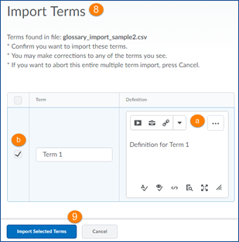
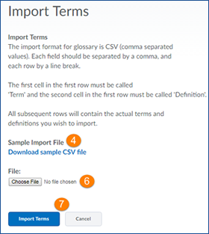
- Download the sample CSV file.

- Fill in your terms and descriptions as indicated in the CSV file.
- When you are finished building your Glossary, return to the Import Terms page and click Choose File to browse for an upload your Glossary CSV.
- Click the blue Import Terms button at the bottom of the page.
- You will be taken to a confirmation page.
  - On this page you can format your definitions, including adding media, and make any necessary corrections.
  - If a term did not import correctly or you do not want VIULearn to import that term, uncheck the box beside it to choose not to add it to the Glossary.
- Click the blue Import Selected Terms to add the terms to your Glossary.

Add the Glossary to Content
- Choose Faculty Tools and Course Admin.
- Select the Glossary.
- Copy the URL from your browser’s address bar.
- Navigate to the module or submodule you want the link to be in.

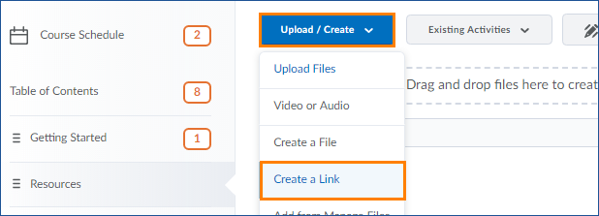
- Choose the blue New button and click Create a Link.

- Give your link a title.

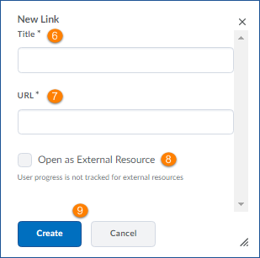
- Paste the URL into the URL box.
- Select the box beside Open in a New
Window to have the glossary open as an
external tool or leave it unchecked to have
the Glossary open in frame.
- Click the blue Create button.

Edit a Glossary Term
- Go to the Glossary (either by clicking on the link in Content or by choosing Faculty Tools, Course Admin, and Glossary)
- Click the arrow to the right of the term you want to edit and choose Edit Term
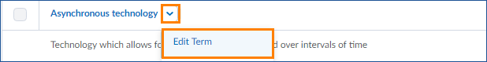
- Make any changes.
- Click the blue Save button.

