Overview
Modules and Sub-Modules act like folders to allow you to organize your course content. You must add a module in order to add submodules or topics to your course. Topics are simply content files you have created or uploaded, or any activities you have chosen to add to your course. Sub-modules allow you to create a deeper hierarchy within your course.

Best Practices
To make your course easy for learners to navigate, we recommend using sub-modules to divide up any module that contains 20 or more topics. If you have more than 20 items in the main module folder or in a sub-module, learners will need to click a Load More button to see all of the contents and may miss important information.
In order to keep all of the files in your course organized, it is a good practice to set the default path for each new module when it is created. This will tell the system where in the Manage Files area to store the module’s content by default and help keep your Manage Files area organized.

Adding a Module and Sub-Module
- From the Content tool, click Add a Module
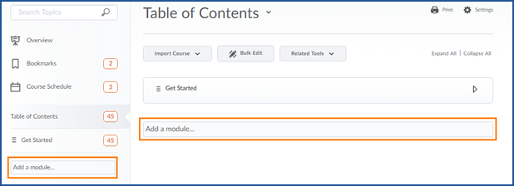
- Type the title of your Module and press the enter key
- You will get a notification that your module has been created successfully
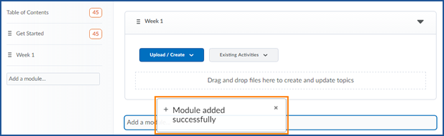
The system will automatically put you into the module you have just created. From this view you can add a submodule to your module.
- Click Add a Sub-Module
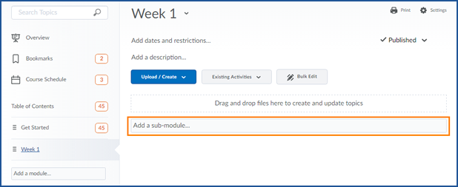
- Enter the title for your Sub-Module and press the enter key.
- One again you will see a notification that your submodule has been successfully created
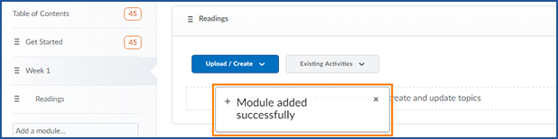

Set the Default Path
- Click Content in the Navigation Bar to go to the Content tool

- Click on the module you want to edit
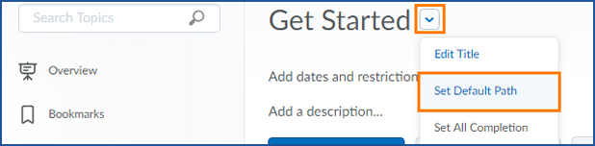
- Click the arrow to the right of the module title and choose Set Default Path from the menu

- Click Change Path and then select the folder you want to save this module’s files to or click New Folder to create a new folder
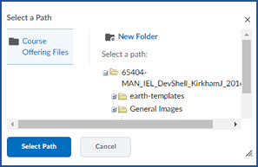
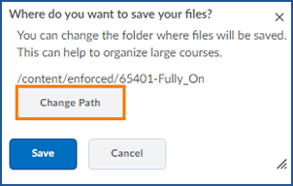

- Click Select Path and then Save

