Overview
You can add links to internal and external content to a file in VIULearn. Links can allow you to share additional information with your learners before directing them to another resource, or to link back or forward to other parts of the course to help students solidify connections from one topic to another. This handout will cover how to link to pages or activities within a VIULearn file as well as how to add links to external resources.

Add an Internal Link to a VIULearn File
- Click Content on the course navigation bar to open the Content Tool.

- Choose the module or sub-module where you want to add the file.
- Select the blue Upload/Create button and choose Create a File.

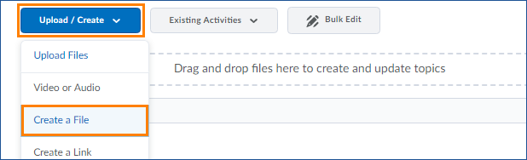

- Click the Insert Quicklink button

- Choose which type of file or activity you want to link to and then choose from the list of available options.
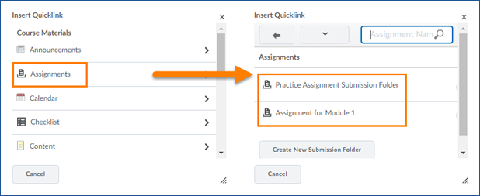

- Add any other text or media you want in the file and click the blue Publish button to save and publish your changes, or the grey Save as Draft if you want to keep the file in a draft state.

Add an External Link to a VIULearn File
- Click Content on the course navigation bar to open the Content Tool.
- Navigate to the module or sub-module where you want to add your file.
- Select the blue Upload/Create button and choose Create a File.
- Click the Insert Quicklink button
- Scroll down until you see URL and click URL
- Paste the link in the URL box and give your link a title.
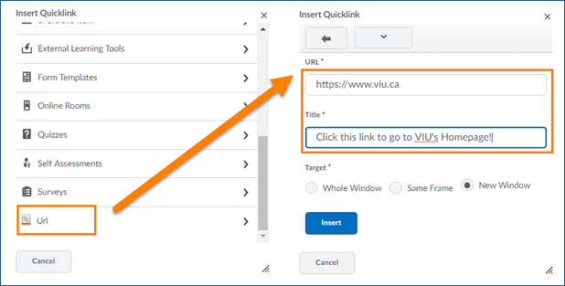
- Choose how the link should open.
Note: For links outside of VIULearn we recommend setting the link to open in a new window so learners can return to their course material when they are finished with the linked resource. Opening an external link “In frame” may lead to users seeing errors depending on their individual browser settings.
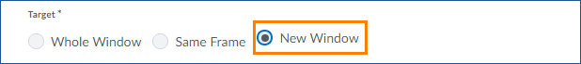
- Click the blue Insert button
- Add any other text or media you want in the file and click the blue Publish button to save and publish your changes, or the grey Save as Draft if you want to keep the file in a draft state.

Edit a Link in a VIULearn File
- Click the small arrow to the right of the page you want to edit
- Choose Edit HTML
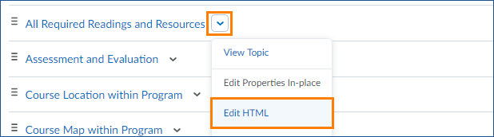
- Click on your link so the cursor is within the link text
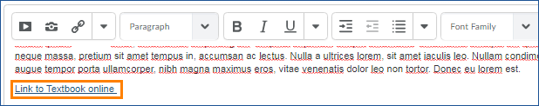
- Click the Quicklink button
- Remove URL and Paste new URL

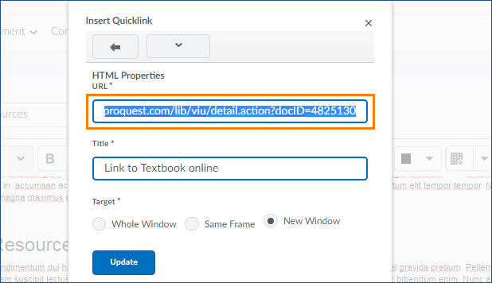
- Click Update
- Once you have finished editing your file, click Update
Note: If you are making significant changes to a file in an active course, you can check the box marked “Notify students that the content has changed” to send a notification to any learners who have subscribed to content alerts in VIULearn.

