Overview
Self Assessments and Surveys can be used to help users measure their progress and to gather information from your students. Unlike quizzes, these activities cannot be scored or linked to a grade item. Learners also cannot access Self Assessments or Surveys from the navigation bar. In order to give your learners access to a Self Assessment or Survey, you must link this activity to Content.

Add a Self Assessment or Survey to Content
The steps for adding a Self Assessment or a Survey to Content are the same:
- Navigate to the Content Tool by clicking Content on the course navigation bar.

- Click on the module you want to add the Self Assessment or Survey to.
- Click the grey Existing Activities button and choose Self Assessment or Survey.

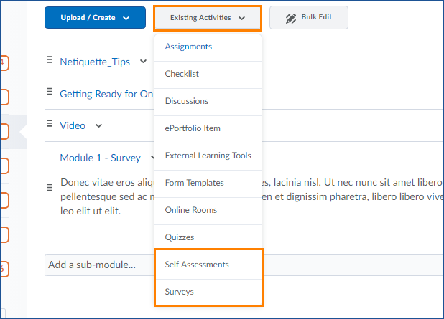

- You will see a list of all the Self Assessments or Surveys in your course, click on the one you want to add to your course content.

