Add a Video to Your Course Content
- Click Content on the course navigation bar to open the Content Tool.

- Choose the module or sub-module where you want to add the video.
- Select the blue Upload/Create button and choose Video or Audio

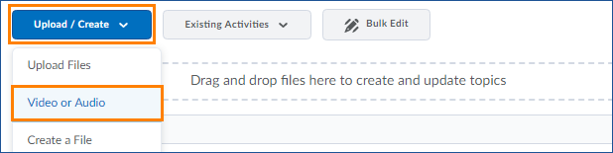

- Paste the embed code (or link if you are adding a YouTube video) in the top box.

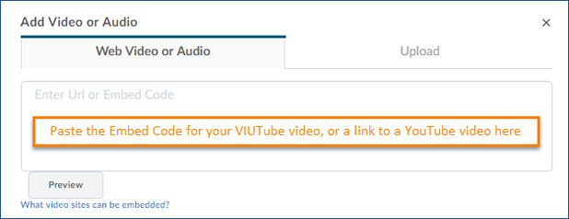

- Give your video a title and click the blue Save button to add the video to your content.

Add a Video to a File
If you want to convey any additional information about a video when adding it to your course, you can embed the video into a file.
- Navigate to the module or submodule where you want to add your video.
- Select the blue Upload/Create button and choose Create a File.

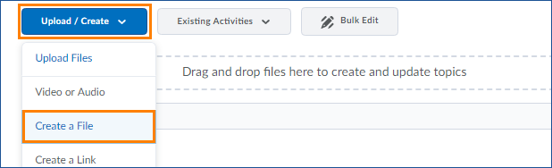

- Click the Insert Stuff button

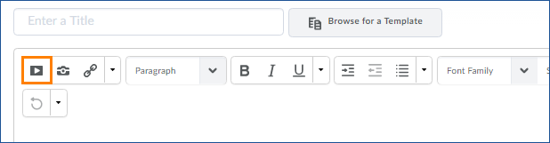

- Choose Enter Embed Code

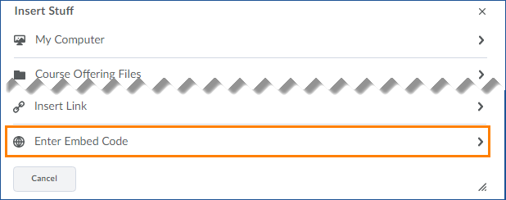
- Paste the Embed Code for your media (found by clicking the Share Button under your video on VIUTube or YouTube) and click the blue Next button

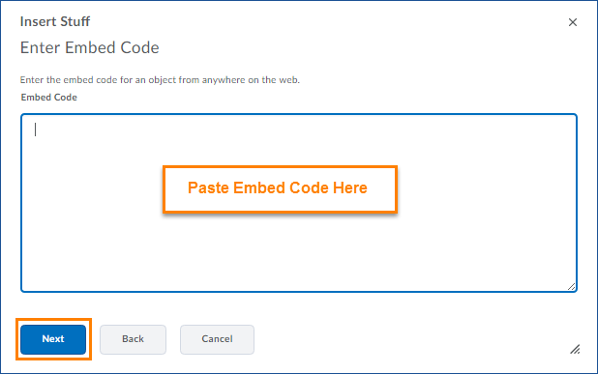

- Preview your video and then click the blue Insert button to add it to your file
- Add any text or other content to your file. When you are finished editing the file, click the blue Publish button to publish your page or the grey Save as Draft to save your changes without publishing them
Please Note: If your course is active, learners will be able to see the Published page immediately unless you have set specific restrictions to hide the module or submodule.

