Overview
Once you have built your course in VIULearn, you can reuse it by importing the course components into your new shell each semester. You can choose to import an entire course, or to only import specific sections of the course material.
There are two ways to access the Import/Export/Copy Components Tool. This handout will walk you through the steps for importing course content from the Content Tool. You can also access this tool by clicking on Faculty Tools choosing Course Admin and opening the Import/Export/Copy Components tool.

Best Practices
If you are copying components into a course that is active, you will want to make sure you draft any modules or pages you do not want learners to have immediate access to.
You may also want to expire any announcements you are importing to avoid learners being overwhelmed by too many notifications.
Any dates attached to assignments, quizzes, events, and release conditions will not automatically update to reflect the dates of your new semester. You will want to either remove these dates or update them through the Manage Dates tool before making the material available to learners. You can do this in the new course shell before publishing the content or activating the course

To Import Your Course Components
- Navigate to the course you want to import content into
- Click Content on the Course Navigation bar
- If you are not directed there automatically, click Table of Contents
- Click the grey Import Course button and choose Copy Existing Course
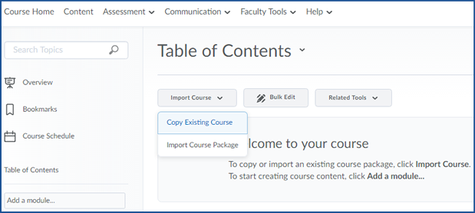

- Copy Components from another Org Unit will be selected by default
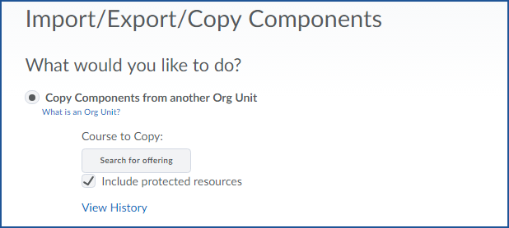
- Click the grey Search for Offering button

- Enter the name of the course you want to copy from in the search box
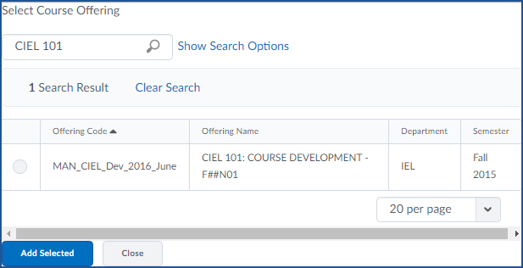
- Click the magnifying glass to search

- Select the radio button next to the course
- Click the blue Add Selected button

- To copy the entire course click Copy All Components and go to step 17
- To copy only some components of the course click Select Components

- Check the box next to any content you want to copy
  - You can choose to copy all items in a category or select individual items to copy
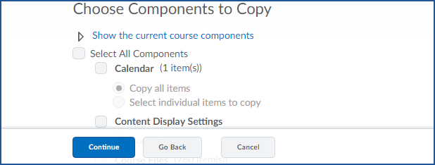
- When you have selected all the components you want to copy, click the blue Continue button

- You will be taken to a confirmation screen where you can review the components you have selected
  - Click Modify to return to the previous screen and change your selection
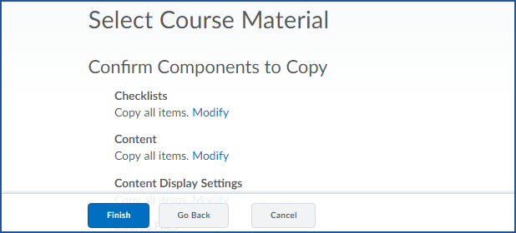
- Click Finish to import the selected components

- You will be taken to the Copy Course Components History page. You may need to wait for your imported materials to copy over.
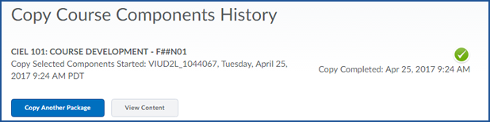
- Once everything is copied, you will see a green check mark on the right side of the page

- Click View Content to go to the Content tool and confirm everything has copied over.

