Overview
If you are working on content in an active course, you can set modules or content topics to draft. This will hide the module or item from learners’ view.

To Set a Module (or Sub-Module) to Draft
- Go to the Content tool by clicking Content on the Navigation Bar

- Click on the Module or Sub-Module you want to hide
- On the right side of the page you will see the module’s status is Published

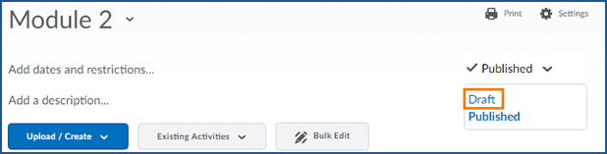
- Click on Published to open a menu and then click Draft

- You will now see the status of the module is set to Draft

- If you use Role Switch to view your course as a Student, you will not see this module

To Set a Topic to Draft
- Navigate to the module with your content topic
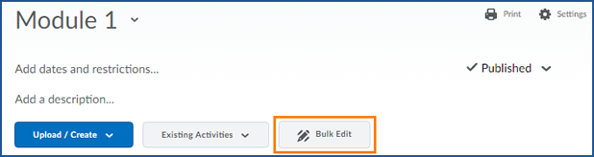
- Click the grey Bulk Edit button

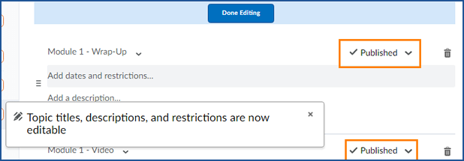
- You will now see the Published status of all of your modules listed.

- Click Published to open the menu and then choose Draft
- You can draft a single item, or several items.
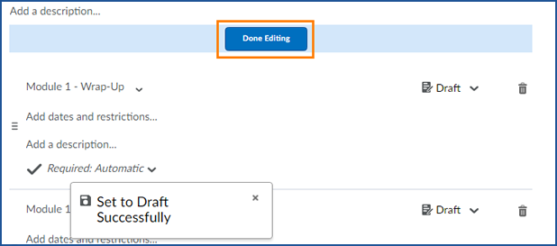
- When you are done, scroll up and click Done Editing

