Overview
The content tool in VIULearn is where the majority of your course content will be shared with learners. You can use modules and sub-modules to organize your content and even link quizzes, assignments, and discussions into Content so your learners can access all of their important course components in one place.
This guide will give you an overview of the different areas of the Content tool. For more information on the Content tool and some of the specific ways you can use this tool to build your course, please see our website ciel.viu.ca/learning-technologies-innovation/viulearn.

Best Practices
We recommend having no more than 20 items inside a single section. If there are more than 20 items, users will need to click a Load More button to view all of the topics in the module. This can cause some users to miss content items. You can use sub-modules to break up a large module into smaller sections.
It is best to build quizzes, discussions, and assignment submission folders from their individual tools and then add them to content once they are created. While VIULearn will allow you to create these items directly from Content, you will see a limited set of options when doing so. To use the full range of options, you will want to access these tools individually from the navigation bar.

Accessing and Navigating Content
- Once you have chosen a course from your My Home page by clicking the course icon, you will be taken to the Course Home page.
- Click on Content in the course navigation bar to access the Content tool.

- You will see that the mini bar and the course navigation bar follow you to Content. This makes it easier for you to navigate back to ❶ My Home, use the ❷ Course Selector to jump to another course or use the ❸ Personal Menu to Log Out from anywhere from within the VIULearn learning environment.
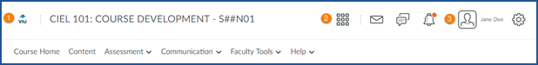

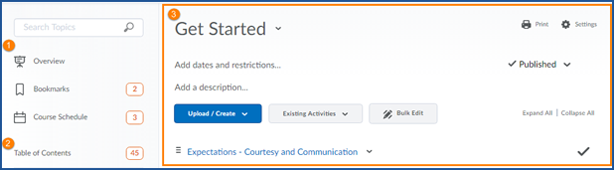
- The main features of the Content tool page are the ❶ Overview, Bookmarks and Course Schedule, ❷ Table of Contents and the ❸ Right Hand Side Reading pane.

Overview
If this is your first time in the content tool you will be taken to the ❶ Overview area. The ❷ Overview Information will appear in the right hand side of the page (right hand reading pane). The Overview is where you can add a welcome message and add an attachment if you wish. Many faculty members use this area as a place to attach their course outline or syllabus as seen below. If an attachment is added, once the learner clicks on Overview, the document will open immediately.
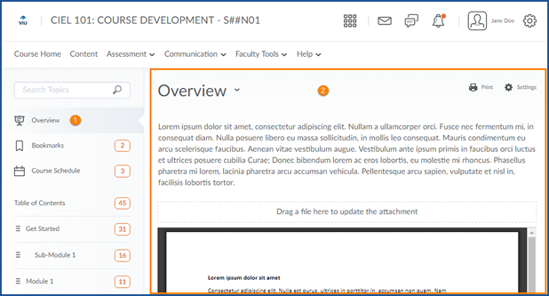

Bookmarks
The Bookmarks area is for your learners and allows them to save specific pages to make them easier to find in your course.
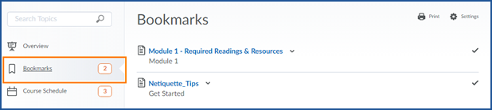

Course Schedule
The Course Schedule lists upcoming events Today, Tomorrow and the Next 7 Days that are in your course calendar. You can also click on Full Schedule to view all scheduled events for the course. It is best practice to manage your schedule and events from the Calendar Tool on the Course Home page not from the Course Schedule within your course.
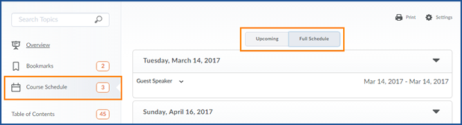

Table of Contents
The Table of Contents is an overview of all the Modules and Sub-Modules and in your course. When you click on the Table of Contents, it lists all of the course information in one big long thread in the right hand side reading pane. Use the right hand scroll bar to scroll down the page to see all of your Modules and Sub-Modules. Notice there are three Modules in the screenshot below. Getting Started and Module 1 are “Published” and Module 2 is labelled Draft. Published Modules are visible to your learners. Draft Modules are not visible to your learners.
