Overview
The default path tells VIULearn where in Manage Files to store the files for each module. Arranging your content into folders in the Manage Files area can make it easier to find specific course files in the future.

Setting the Default Path for a Module
- Click Content in the Navigation Bar to go to the Content tool

- Click on the module you want to edit
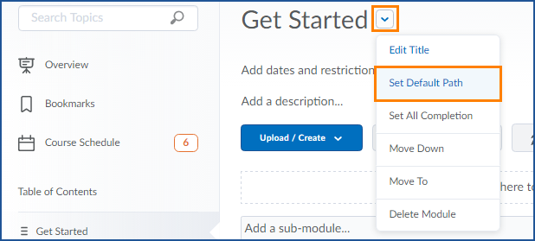
- Click the arrow to the right of the module title and choose Set Default Path from the menu

- Click Change Path and then select the folder you want to save this module’s files to or click New Folder to create a new folder
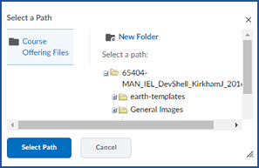
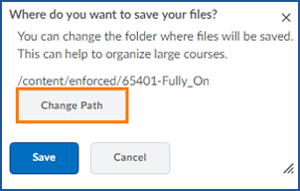

- Click Select Path and then Save

