Overview
The Course Home page is the first page that will load when you enter your course. There are six sections to the Course Home page. This guide will give you an overview of each of these areas. The sections are:
Mini-bar
Course Navigation bar
Announcements
Updates
Bookmarks
Calendar
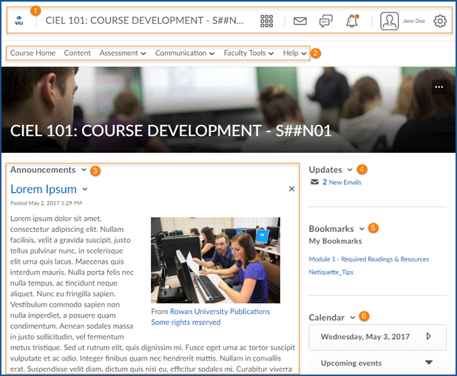

The Mini-bar
The Mini-bar appears on every page within VIULearn. It contains a link to My Home, the Course Selector, Message Alerts, Subscription Alerts, Update Alerts, and the Personal Menu.
At any time, click on the VIU logo to return to the My Home page
Click the Course Selector from any page in VIULearn to see a list of your courses and navigate to another course.
Clicking on Message Alerts will give you access to the Email tool and show you any email alerts.
Subscription Alerts will notify you of activity on topics you have subscribed to.
Update Alerts notify you of activity you have subscribed to such as new announcements, or updated course content.
Your Personal Menu gives you access to your Account Settings, Notification Settings, Role Switch, and the Log Off link.

The Course Navigation Bar
The course navigation bar appears on every page within your course. This bar contains links to your course content and to tools within VIULearn.
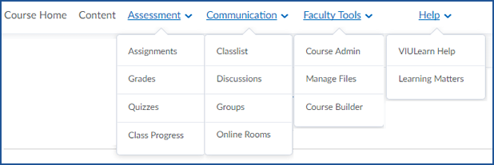
Course Home and Content will take you straight to those tools. The other links on the Course Navigation bar will open drop-down menus with several options. For more on these tools, please see the related sections on our website.

Announcements
The Announcements tool can be used to share important information with your learners. Users can subscribe to Announcements under Notification Settings in VIULearn to receive email notification when a new Announcement is made available. You can set up announcements to display for a specific date and time or to specific learners based on Release Conditions.

Updates
The Updates area alerts you to new discussion posts, learner assignment or quiz submissions, and emails. Clicking on an alert will take you to that tool within VIULearn.

Bookmarks
You can add Bookmarks to Content pages to make them easy to find later. Pages that have been bookmarked will show up on the Course Home page under Bookmarks. You can click on a bookmarked page to navigate directly from the Course Home page to that place in Content.

Calendar
The Calendar will display upcoming events that you have scheduled for the course such as assignment due dates, and end dates for date restricted instructions. You can click on Calendar to enter the Calendar tool and create events for learners.

