- Log into VIULearn and access your course.
- Using the course navigation bar, choose Assessment & Evaluation and Assignments.
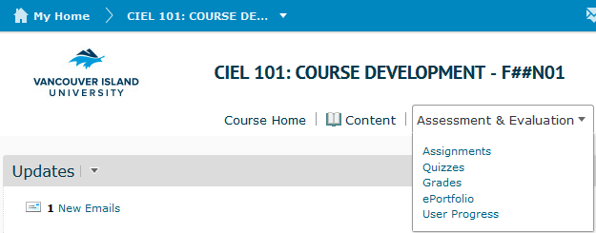

- Click on the blue New Submission Folder button.
- Give your submission folder a name and specify the folder type (individual or group submission).

- If you want to organize your submission folders into categories (like “Graded” and “Ungraded”) you can either select a category you have already created or click [New Category] to create a new category.
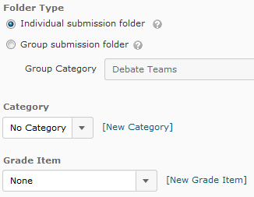
- You can attach this submission folder to a grade item if you are using the Grades tool. You can also attach a rubric to this submission folder if you are using the Rubric tool. If you want to be able to add a numeric grade to the submission, make sure to put a number in the Out Of box.
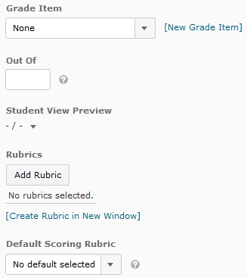

- Add any instructions about submitting the assignment in the Instructions box. You can also attach a file or record audio as part of your instructions using the Add a File and Record Audio buttons.
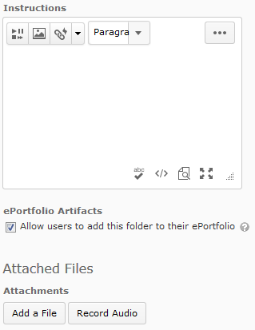
- Select the Submission Options you would like. The default settings are the most permissive and will present the fewest challenges to students.

- When you are done, you can click Save and Close to save and return to the first screen, or Save and New to save and start creating a brand new submission folder. You can also choose Save to save and keep editing your current submission folder.

