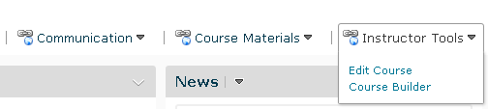1. Go to Instructor Tools located in the course Navigation Bar and select Edit Course.

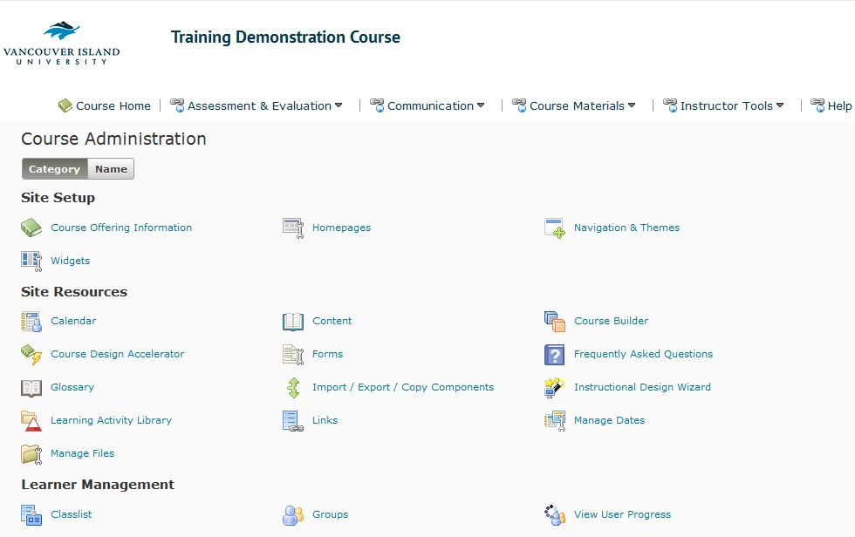2. You should see a screen like this:

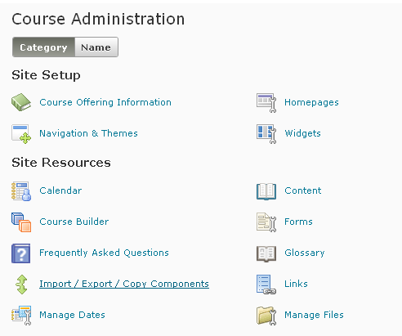3. Select Import/Export/Copy Components under Site Resources.

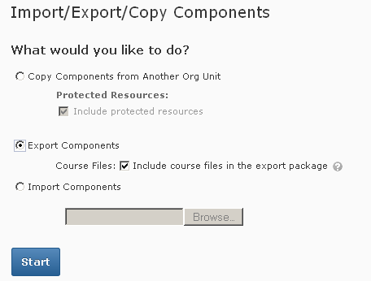4. Under Import/Export/Copy Components select Export Components.

5. If you want to include course files with the backup of your course make sure to check mark

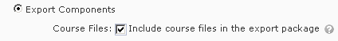“Include course files in the export package.”

6. Click on Start.

Backing up Your Course in Desire2Learn

7. If you want to back up your entire course, checkmark "Select All Components."

However, if you only want to back up specific components of your course checkmark only those specific components you wish to back up. Once you are done selecting everything you would like to back up. Click Continue.

Select Course MateriaI

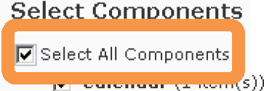to Export

r. E xport all items
r Select individual items to e xport
P' Content (21item(s))
r. E xport all items
r Select individual items to e xport
P' Discussions (16 item(s))
r. E xport a ll items
r Select individual items to e xport
P' DropboM (7 item(s))
r. E xport a ll items
r Select individual items to e xport
P' Grades (10 item(s))
r. E xport a ll items
r Select individual items to e xport
P' Ne\IIS (1item(s))
r. E xport a ll items
r Select individual items to e xport
P' Question Library (50 item(s))
r. E xport all items
r Select individual items to export
P' Quizzes (4 item(s))
r. E xport all items
r Select individual items to export
P' Rubrics (1 item(s))
r. E xport all items
----r S-elect individual items to export
...

VIU -VANCOUVE R IS L AN D
Go Back Cancel ]

UNIVERSI T Y Centre for Innovation and Excellence in Learning Page 3 of 7

10. You should see a screen like this. This menu allows you to confirm the components you have decided to back up and if everything looks right - click Continue. If you wish to make
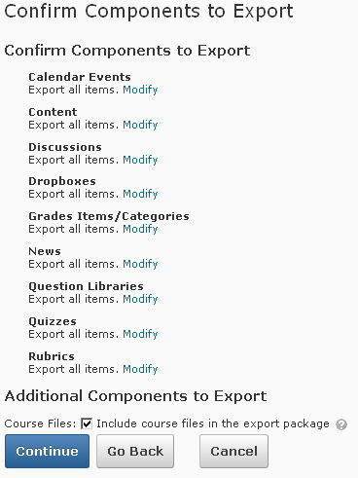changes click “Go Back”.

Click Continue if
everything looks right.

If you wish to make changes click “Go Back”

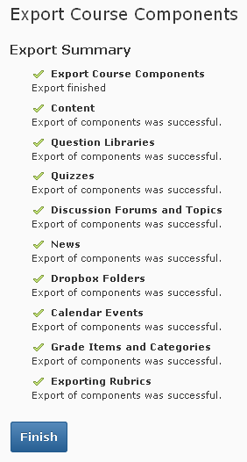11. When you click Continue, Desire2Learn will export your course. You will be able to tell the export is completed because every item you have chosen to export will have a green check mark beside it. Once the export is completed select Finish.

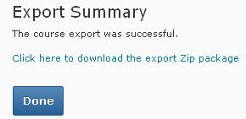12. Desire2Learn will now prompt you to download the export zip package. The zip file is the back-up of your course. Click on the zip file to download.

13. You should see a pop-up window like this:

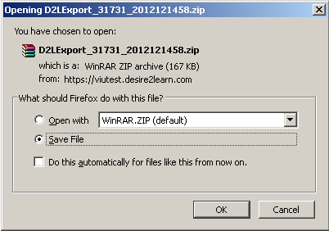

14. Depending on your browser you zip file may save automatically to a specified folder , usually your downloads folder. You may be prompted to save to a downloads folder or you may be prompted to save to a folder of your selection .
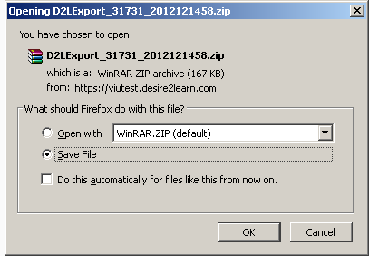15. Select the settings that are necessary and click OK

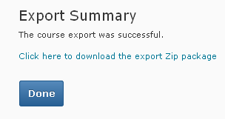16. Once your download is complete – click Done

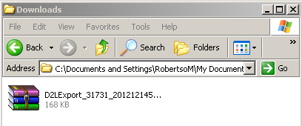17. You can now verify that your course back up has been completed by opening the folder were you saved your course back up file. If you see a zip file your course was successfully backed up.

