Basic Operations and Views

1. Use the Calendar tool to arrange and visualize your course events.

2. You can use iCal to synchronize your course calendar with your personal calendars (Outlook, Google

Calendar, iPhone, Android and Blackberry)

3. Find the Calendar widget and select either the Calendar name or use the drop-down menu to select

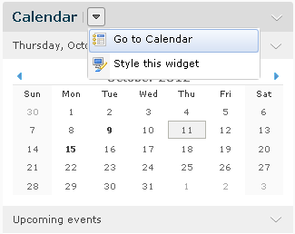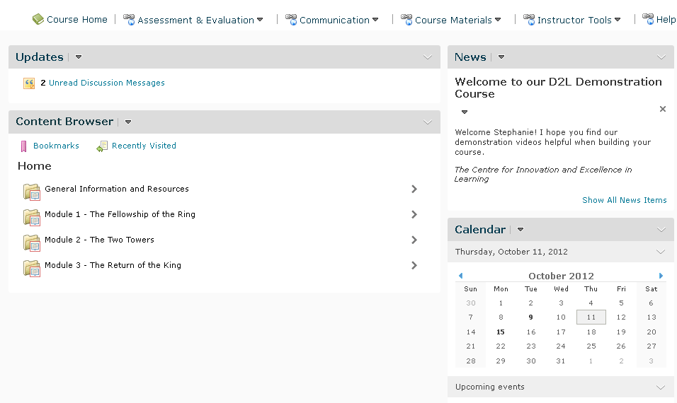Go to Calendar.

4. You should see a screen like this:

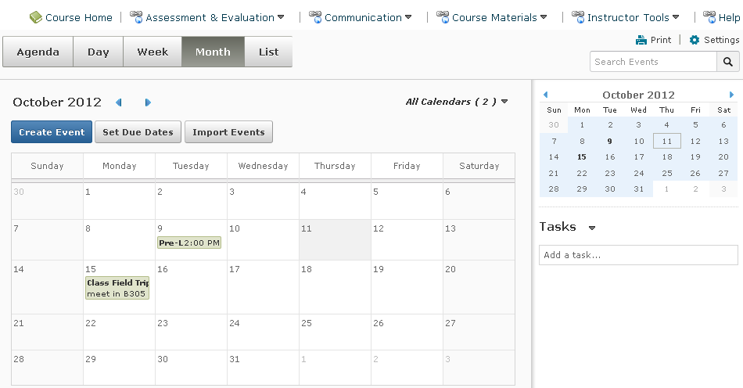

5. | Th | e two types of events in the calendar are Availability Events and General Events.
 | a. | Availability Events indicate the availability and due date of course objects and do not have to be
 |  | put into the calendar manually. When the object is created you can set whether or not it will
 |  | appear in the calendar, and from the calendar tool you can edit or delete course objects.
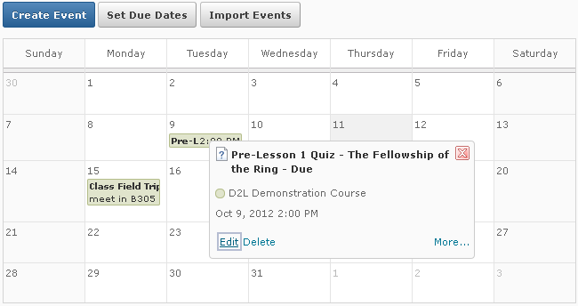

b. General Events are ones that you create in the calendar itself. You can create multiple events for the same course object, and add details about presenters, locations, and a seating chart for the event.
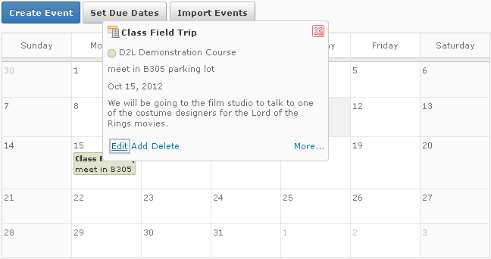

6. Using your calendar views area you can toggle between display areas for events in the calendar.

7. Agenda view will group events by date, course or category. Events will be in chronological order,

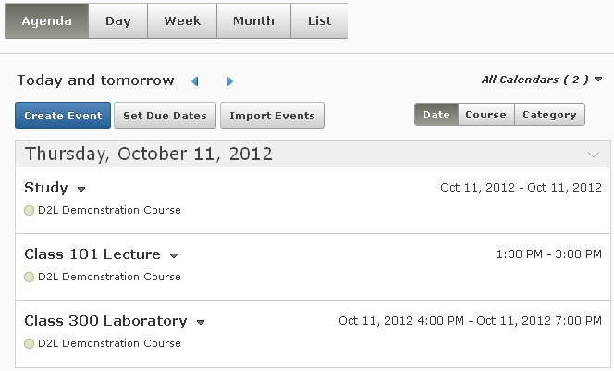with all-day events at the top of a group.

Agenda View

All Day Event

Scheduled Events

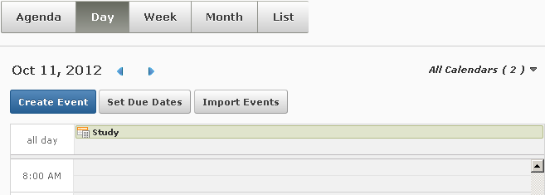8. Day, Week, and Month view to group your events in daily, weekly or monthly increments.

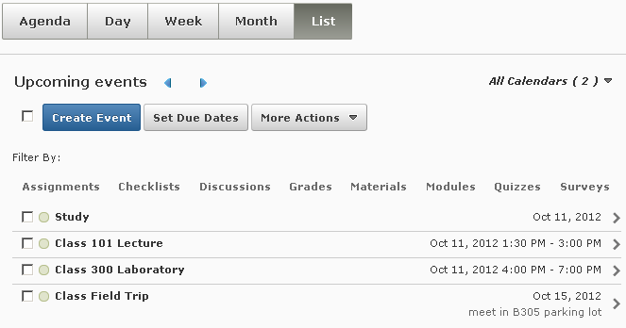9. List view allows you to filter your events by Assignments, Checklists, Discussions, Grades, Materials, Modules, Quizzes, and Surveys.

List View

Filters

Changing Multiple Events
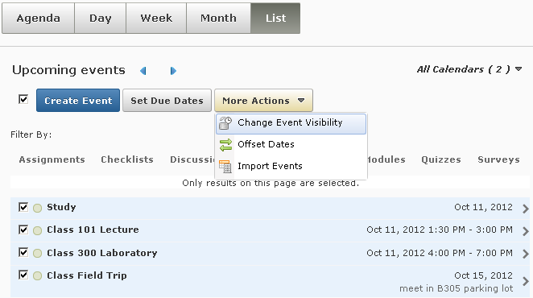1. You can make bulk changes to the dates and visibility of events in the List view. (1) Select the checkbox beside the Create Event blue button to highlight all events. (2) Using the drop-down More Actions button, you can Change Event Visibility, Offset Dates, and Import Events.

1

2

2. Change Event Visibility will give you the option to have your events be visible or hidden with no restrictions. As well you can hide the event until or after a certain day, hour or minute. Select your
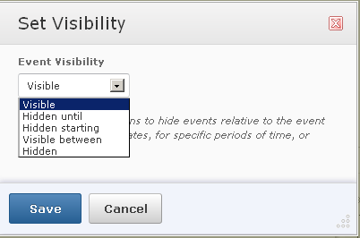visibility and hit Save.

Select an option, and set the time range
if appropriate

3. Offset Dates will allow you to shift all events selected forward or backward by a set amount of time.

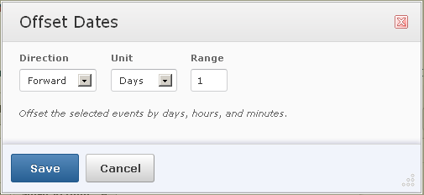Fill in your options and hit Save.

Fill in your
options

4. Import Events will allow you to import iCal files.

Other Options and Settings

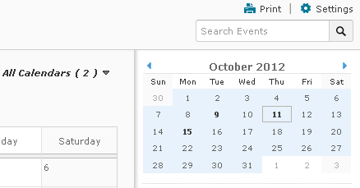1. You can also print your calendar, adjust your calendar setting and search your calendar from any of the views using the icons in the top right hand corner of the calendar.

Creating Events and Due Dates
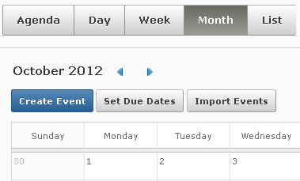1. From the Agenda, Day, Week and Month views you can (1) Create Events, Set Due Dates or Import Events from iCal using the button below the view ribbon. Additionally, you can (2) browse through your calendar using the blue arrow buttons.

2
1

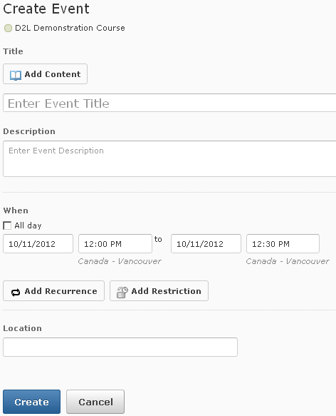2. Create Events will open a screen like the one below:

Link to course
content if desired

Select date
and time

Add event recurrence and/ or
restrictions if desired

Add Location if desired

When finished, select
Create

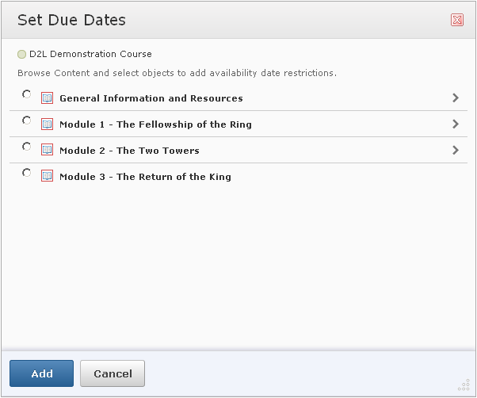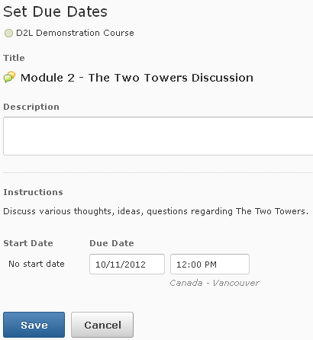3. Set Due Dates will open a screen like the one below, where you can set due dates to course content, after selecting it and clicking Add, set the date and click Save.

Other Tools
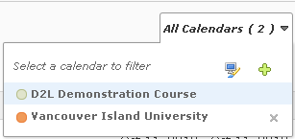1. Use the calendar view button to choose what calendars you, want to display, change the scheme for the individual calendars, or add a new calendar.

Calendars to Display
Change
Scheme
Add New
Calendar

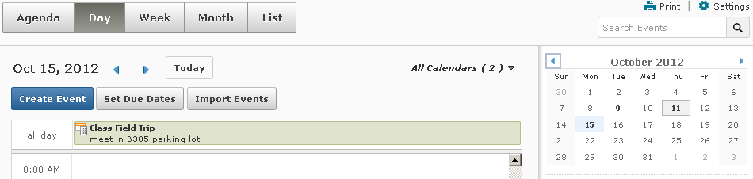2. Use the mini calendar to navigate quickly to a specific day, week or month. To view a specific day in detail, (1) click Day view, and then (2) click on the day you wish to see in detail on the mini calendar. This also works for specific weeks and months in detail. You can browse through the months in the mini calendar by clicking the blue arrows to the right and left.
1

2

3. You can use the Task pane under the mini calendar to create, track and maintain personal tasks.

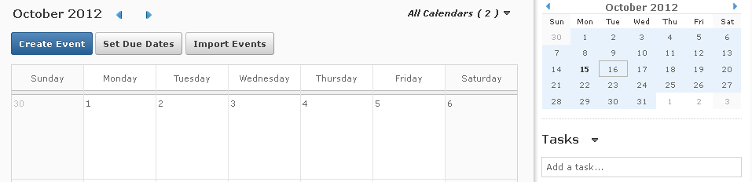Create a task by typing in the Add a task … pane.

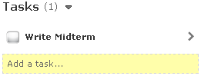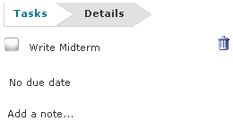4. Once a task is created, click on the arrow on the right hand side to edit the task and add due dates or notes. You can also check the box beside a task to list it as completed.

