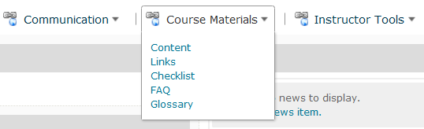1. Go to Course Materials located in the course Navigation Bar and select Content

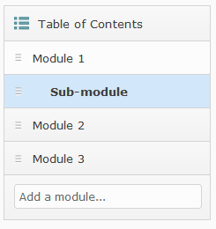2. Under Table of Contents, select the Module where you want to create a File.

3. You should see a screen like this:

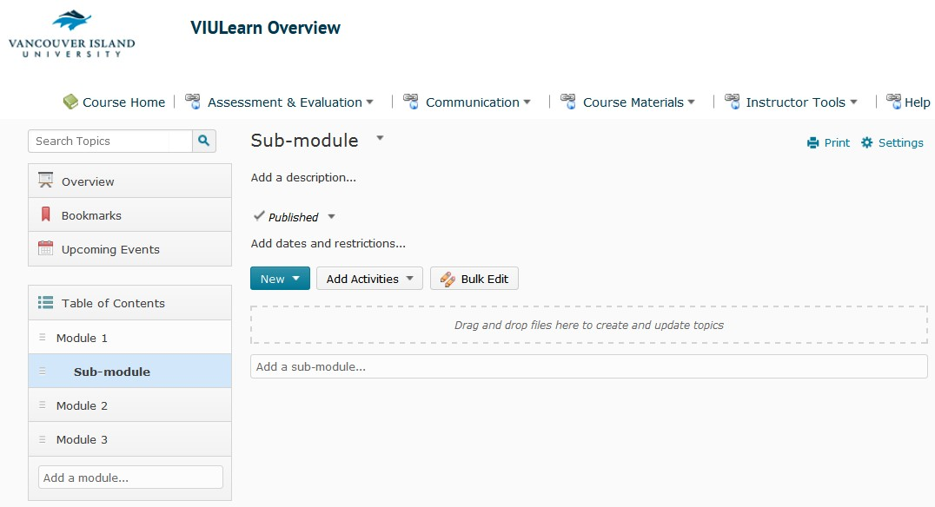

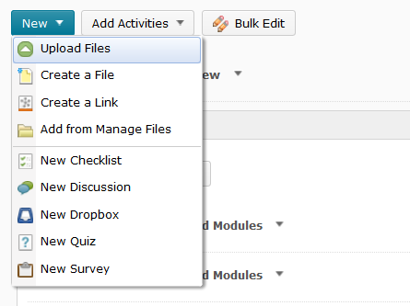4. Click the New dropdown menu and select Create a File.

5. You should see a screen like this:

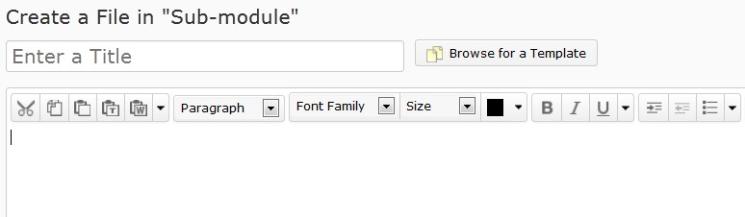

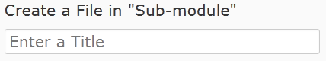6. Enter your title into the “Enter a Title” field.

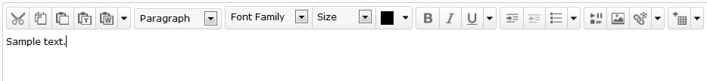7. Enter your text. Use the HTML Editor to format your text.

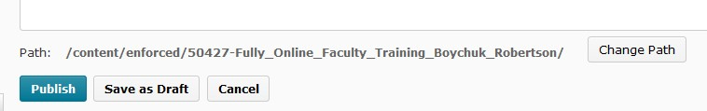

8. You should see a window like this.

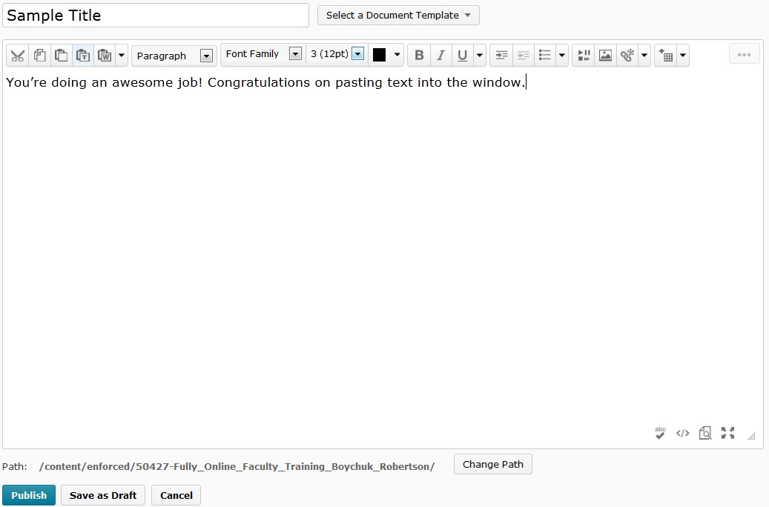

9. Select Change Path at the bottom of your screen.

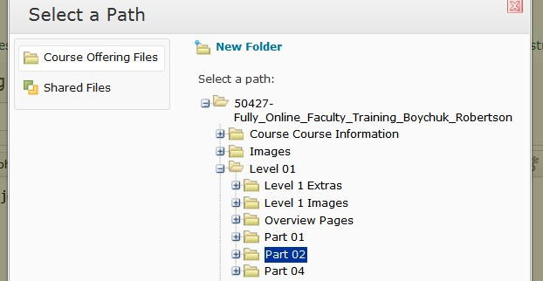10. Select the folder where you want to store the File.

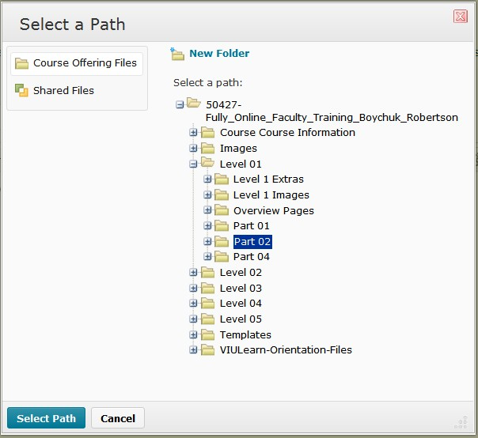11. Click Select Path.

12. Now, you will see the updated path on your screen.

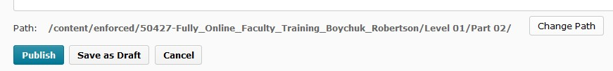

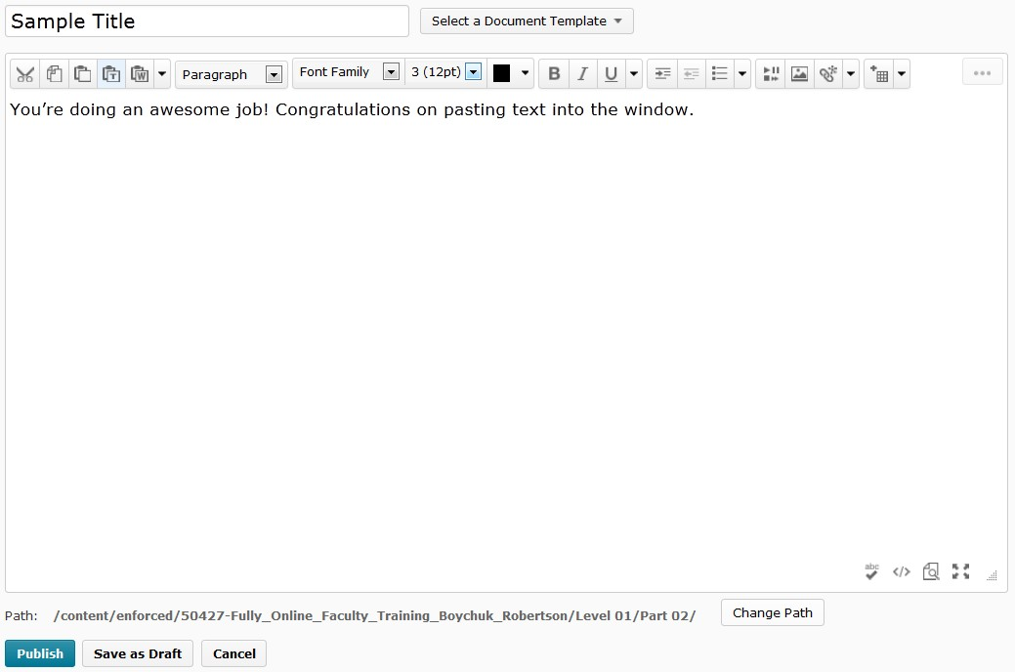13. Review your content. If you are satisfied with your page, select Publish.

