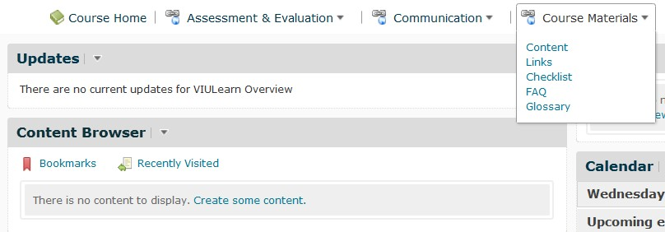1. Go to Course Materials located in the course Navigation Bar and select Content.

2. You should see a screen like this:

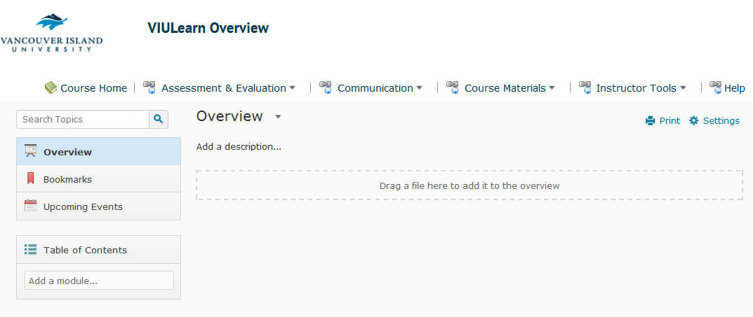

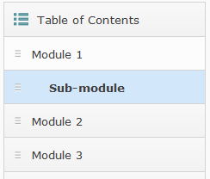3. Select the Module where you want to Create a Link.

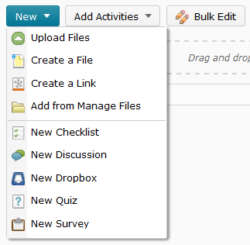4. Click the New dropdown menu and select Create a Link.

5. You should see the New Link window.

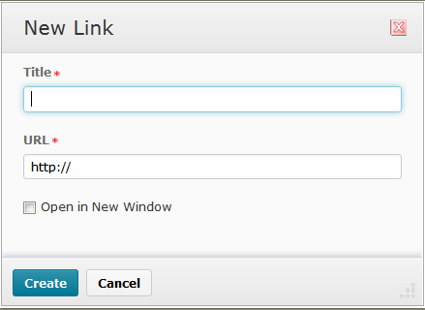

6. Enter the title of your link.

7. Enter the URL address.

8. Check the box Open in New Window.

9. Select Create.

