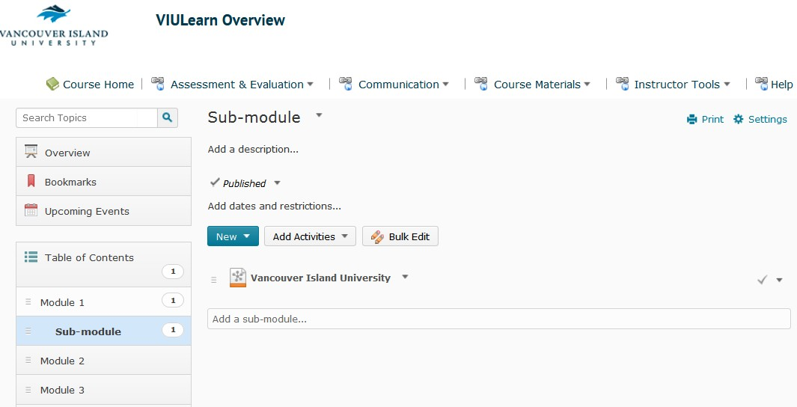1. Locate the link you want to edit or delete in the Content area.

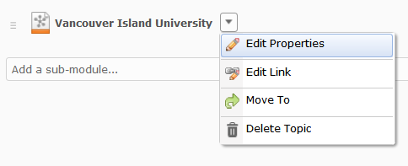2. Select the dropdown arrow to the right of the link and click either Edit Link or Delete Topic

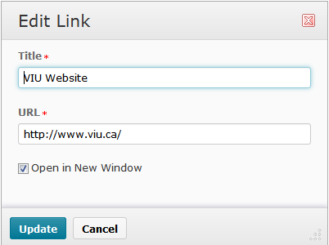3. When editing your link you will see a pop up window with the link name and URL – edit as necessary and click update.

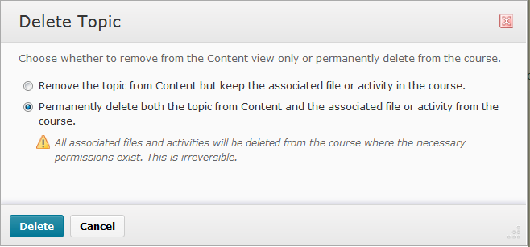4. You will see the Delete Topic window. Select Permanently delete… and click Delete.

