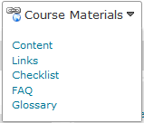1. From your Home page, go to Course Materials and click on Content.

2. You should see a screen like this:
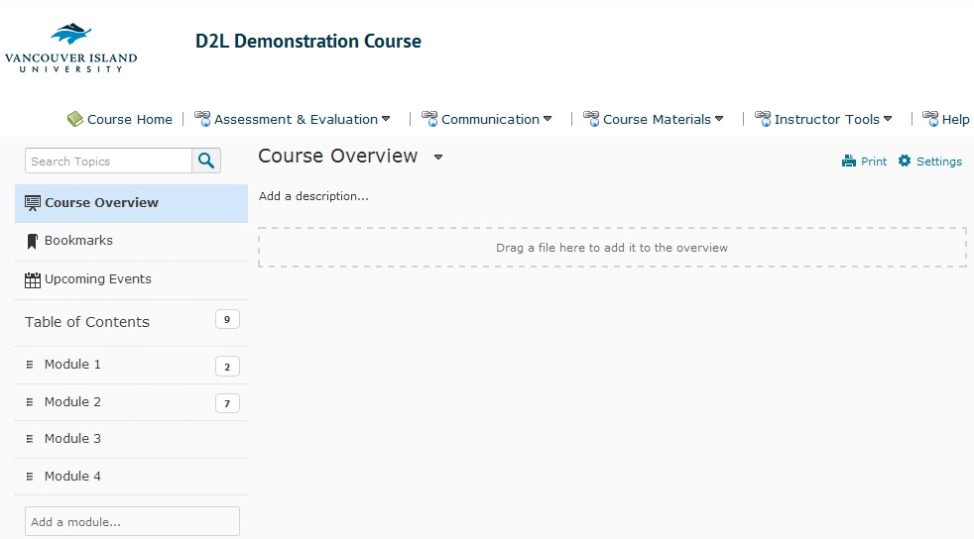
In the example above, there are four modules present on the left side of the screen, in a static pane.

3. For this example, we have two documents present in Module 1.
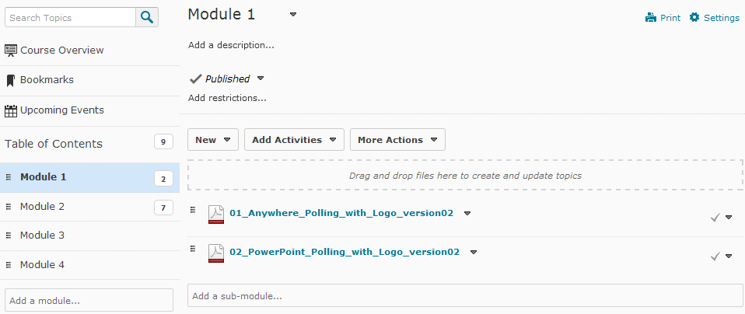

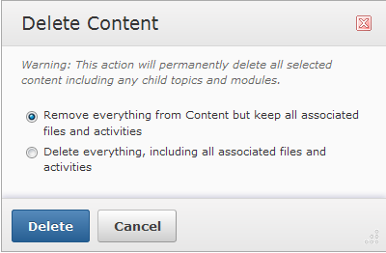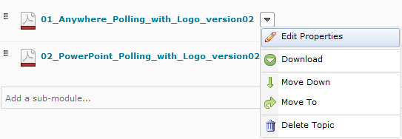4. In order to remove a document from student view, choose the drop-down arrow to the right of the document title and select Delete Topic.

a. If you still want the associated file in your file structure (for example: if you might want to use it again) use option number one, Remove everything from Content but keep all associated files and activities.
b. If you didn’t want anything and you were never going to use the file again, you could
choose option two, Delete everything, including all associated files and activities.
5. Select your option and click Delete.

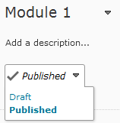6. Please notice that if you want to work on an area of your course without the students being able to see anything, you can work in a Draft mode.

Draft = Invisible to students

Published = Visible to students

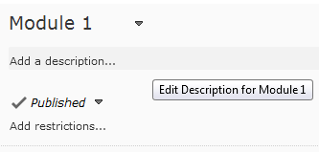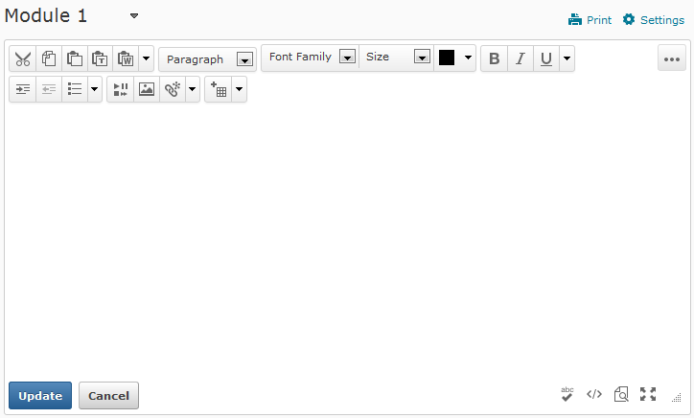7. You can also add a description to your modules clicking on the Add a description… area

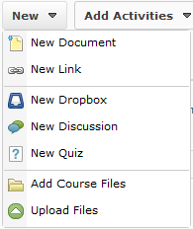8. Notice also that you can use the New button to add content, dropboxes, discussions, quizzes, or even upload files.

9. You can also drag & drop files into the content area. For more information, please see
Creating Structure (Modules & Topics using Drag/Drop in our video library.

