Please Note: Drag and drop functionality in D2L 10.1 is currently not available using Internet Explorer 8.

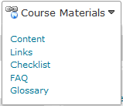1. First, go to Course Materials and choose Content.

2. You should see a screen like this:
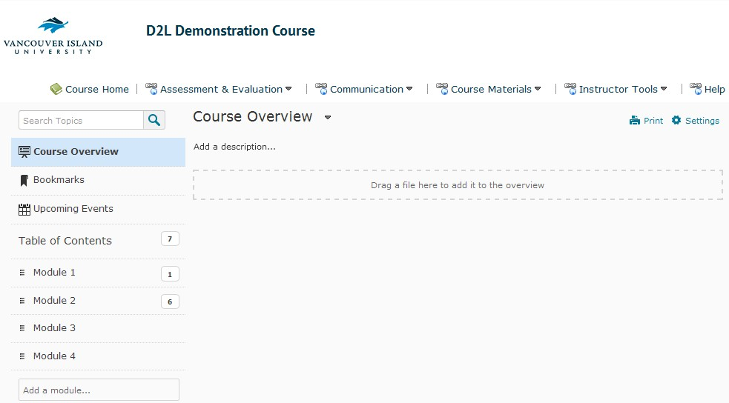
In the example above, there are four modules present on the left side of the screen, in a static pane.

3. You can drag & drop files instead of manually uploading them.

4. Locate your files on your desktop

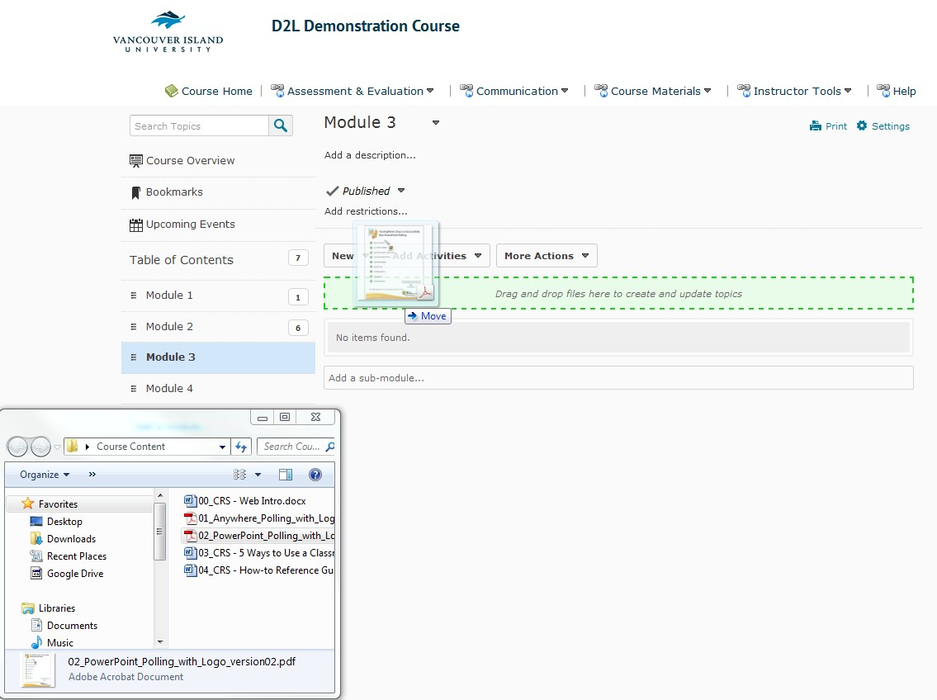

5. Once you have your files chosen, simply click on them, pull and drag, and release once you see the green highlighted area.

6. The file will appear in the module you dropped it in:
