Renaming Modules

1. Either click on the Content Browser link, or under Course Materials select Content to go to the

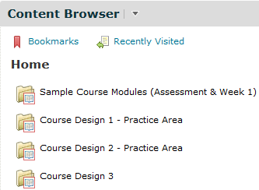Content Area.

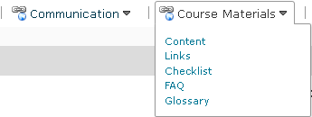2. You should see the following screen:

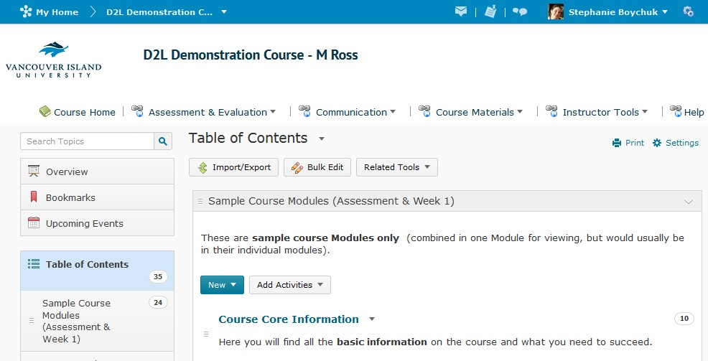

3. Click on the module you want to rename under the Table of Contents on the left hand side of the

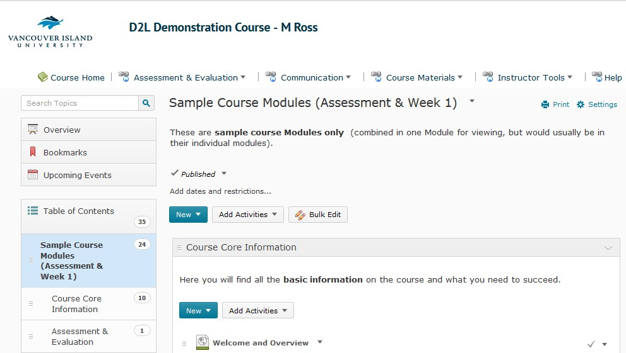screen, and then click on the module title.

2
Click once on the module title

1
Click on the module you want to edit on the left-hand side of the screen under Table of Contents

4. Type your changes into the box:

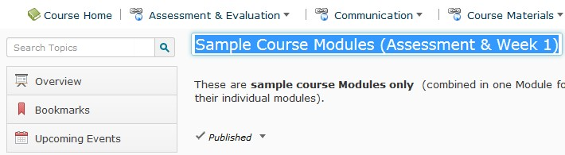

5. And press the Enter key on your keyboard or click outside of the box. You changes will be automatically saved.

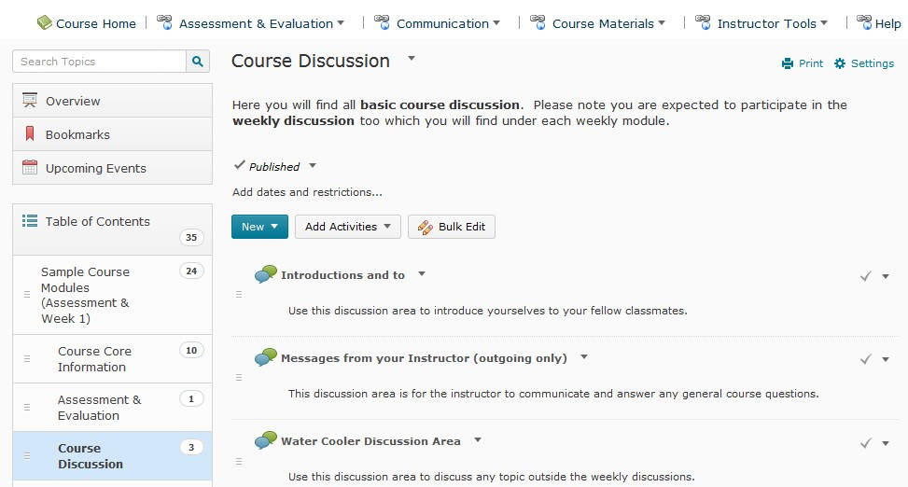

Renaming Topics
1. Navigate to the topics you want to rename using the Table of Contents on the left hand side of the screen.

Topics

Module that contains the
Topics

2. Use the arrow to the right of the topic name and choose Edit Properties.

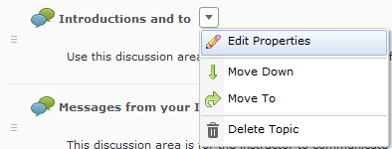

3. Click on the topic title once, and make your changes.

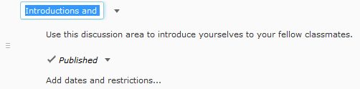

4. Click Enter on your keyboard or click outside the box to save your changes.

5. You can also change the name of a topic from the Content Viewer. Click on the topic to open it, and then click on the title to make your changes.
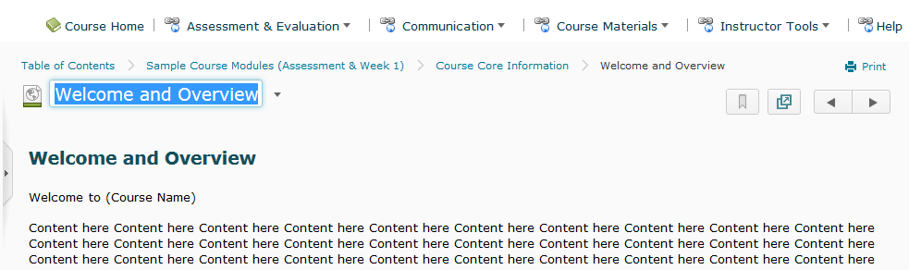

6. Click Enter on your keyboard or click outside the box to save your changes.

