As a student, you may want to save and print materials from the course. Here are instructions on how to save and print Pages and Files.
Pages are created in VIULearn using HTML and may contain links, video and text.

Files are created outside VIULearn and uploaded to the course. e.g., PDF, JPEG, Word doc, etc.

Pages – How to Save and Print

1. A Page looks like this in the reading frame of the Content area:

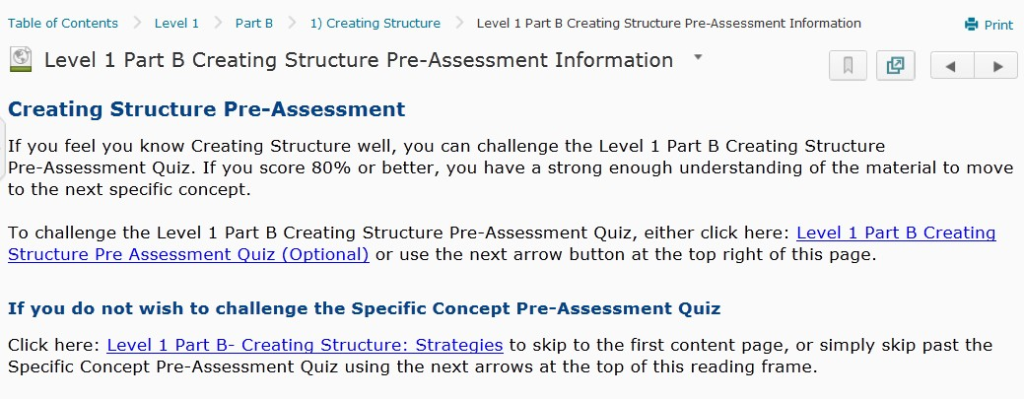

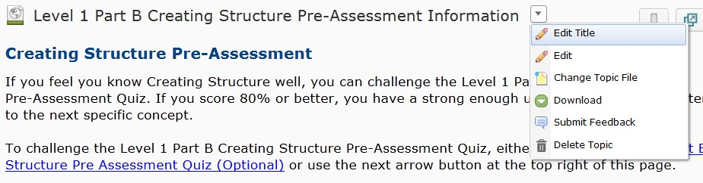2. To save the Page, select Download from the dropdown menu.

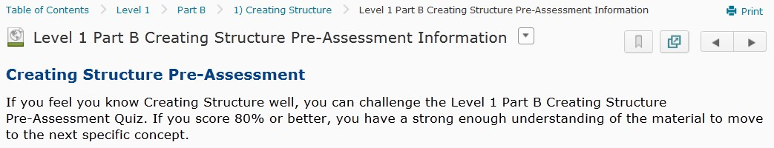3. To print the Page, select Print at the top right.

Files – How to Save and Print

1. A File looks like this in the reading frame of the Content area:

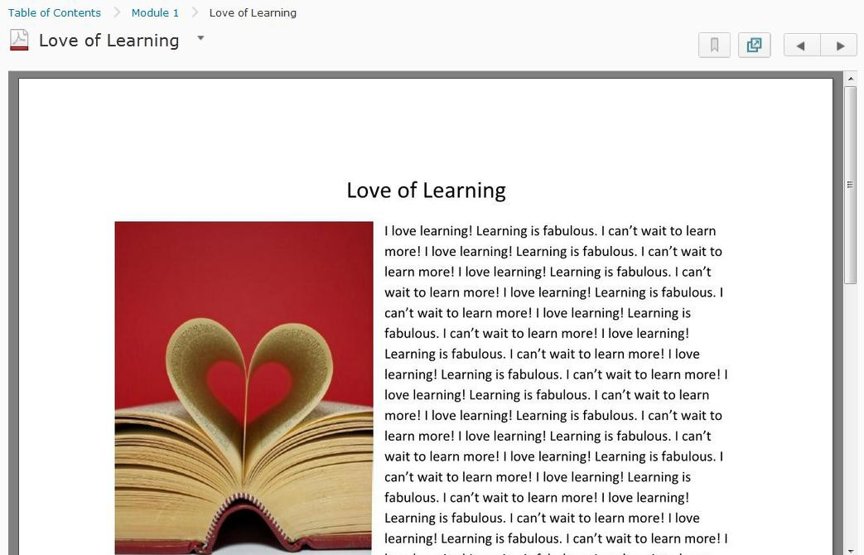

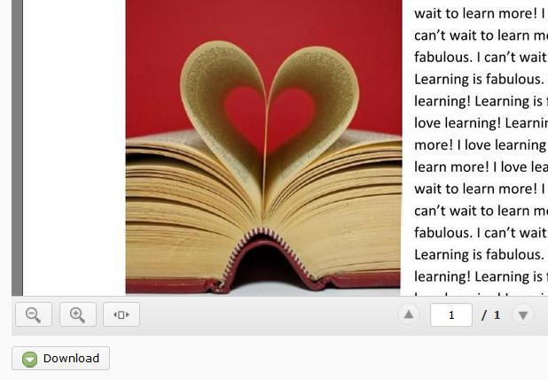2. To save the File, select Download at the bottom left.

3. Save the File to your computer.

4. To print the File, you must download it first. Open the File and print.

