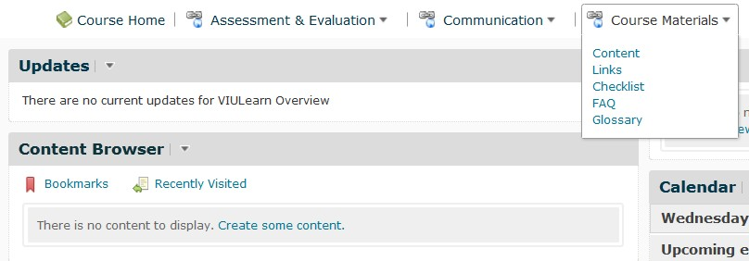1. Go to Course Materials located in the course Navigation Bar and select Content.

2. You should see a screen like this:

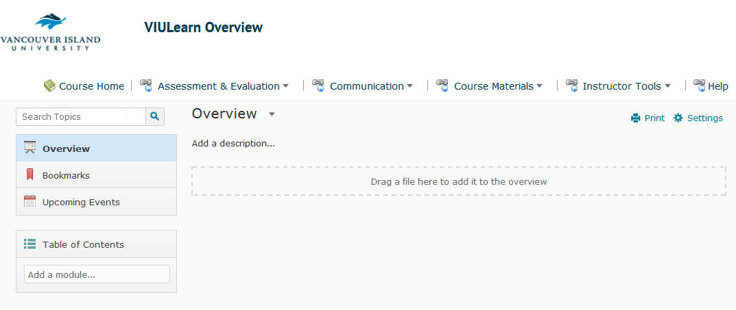

3. Select the Module where you want to add content under Table of Contents.

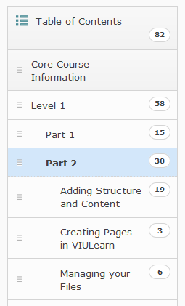Centre for Innovation and Excellence in Learning Page 1 of 4

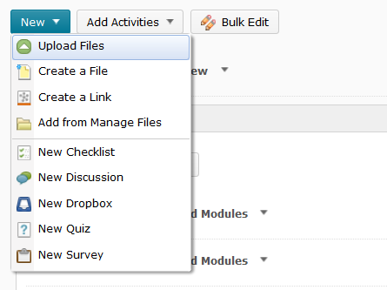4. Go to the New dropdown menu and select Upload Files.

5. You should see a screen like this:

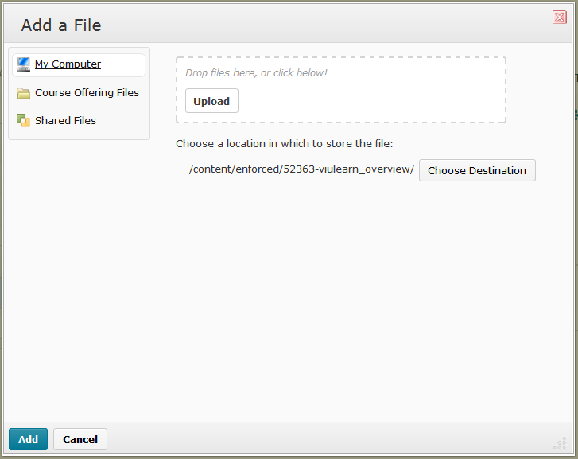

6. Select Upload.

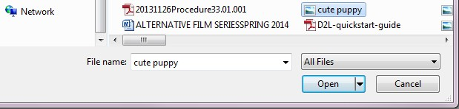

7. Choose the file from your computer and select Open.

8. Alternatively, drag and drop the file into the Upload area. When the Upload area turns green, the file is in the correct position.
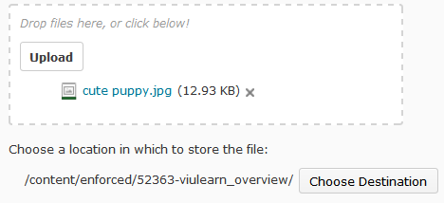9. Once your file is in the Upload area, select Choose Destination.

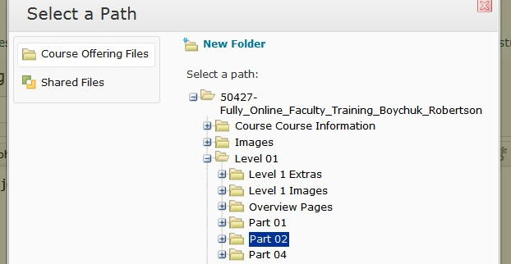10. Select the folder where you want to store the file.

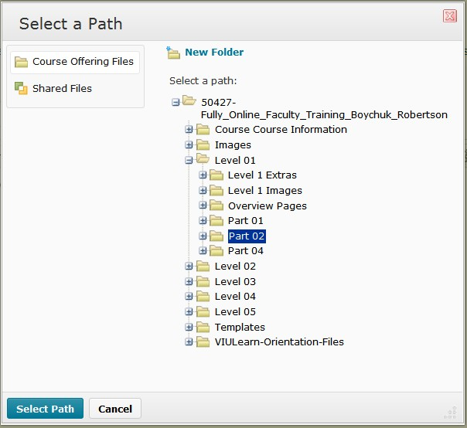11. Click Select Path.

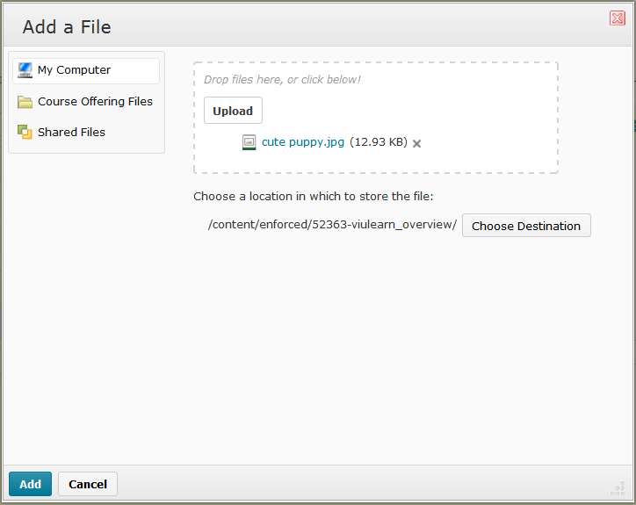12. Select Add.

