From your course home page, select Course Materials from the course navigation bar and choose
Content.

Navigate to the module you want to add your video to, and select the New button and choose Create a
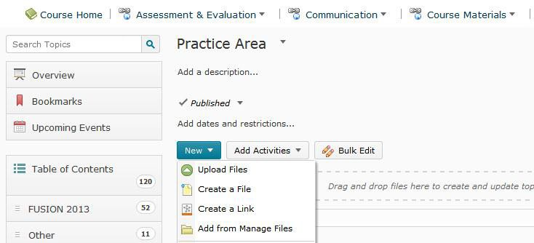File.

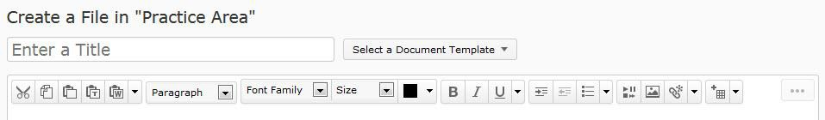You will be re-directed to a new page. Title your page in the space labled Enter a Title.

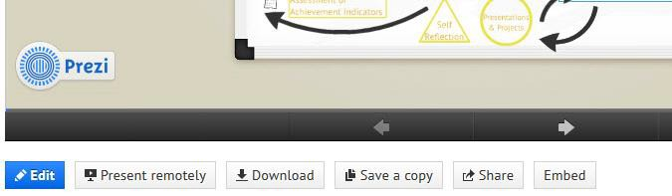Open your Prezi in a new window or tab. Open the Prezi you want to embed. Click on Embed.

Click on the embed code box and use “Ctrl” and “A” on your keyboard to select the code. Then click on
“Ctrl” and “C” on your keyboard to copy the code.

Once that is done, go back to the window where you have VIULearn open.

Find the button that has a play and pause icon on it. (You may need to click on the button with the
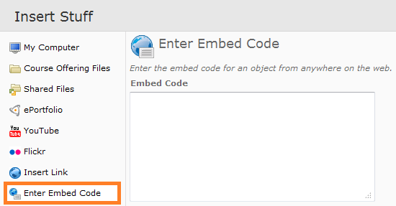elipsis (…) on it to find the button.) It is called Insert Stuff and looks like this: On left-hand side of the box that appears, choose Enter Embed Code.

Click into the box and choose “Ctrl” and “V” on your keyboard to paste the code into the box.

Click on the blue Next button. You may be prompted with a security warning. If you are, choose to allow the content.

Click the blue Insert button. Depending on your security settings, you may or may not see your Prezi appear.

It is suggested that you type a statement on the page like: “If the Prezi does not load correctly, please check your internet browser's security settings.” so if the students have browser issues they are not faced with a blank page. You may also consider adding a link to your Prezi.

Once you are done, click on Publish to save your page and make it live to students.

