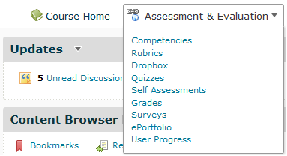1. Choose Assessment & Evaluation and click on Quizzes

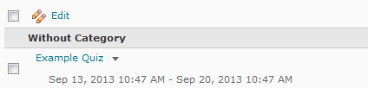2. Find the quiz you want to add special access to and click on it to edit

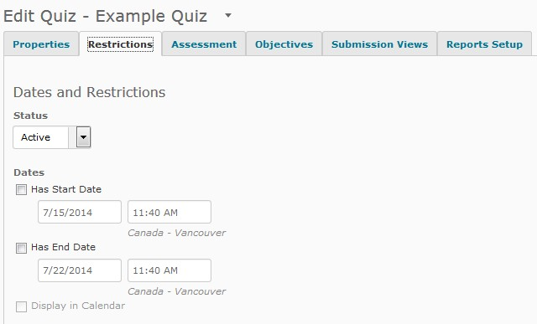3. Choose the Restrictions tab

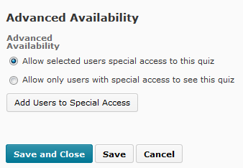4. Scroll to the bottom of the screen, find Advanced Availability, and click on Add Users to Special Access

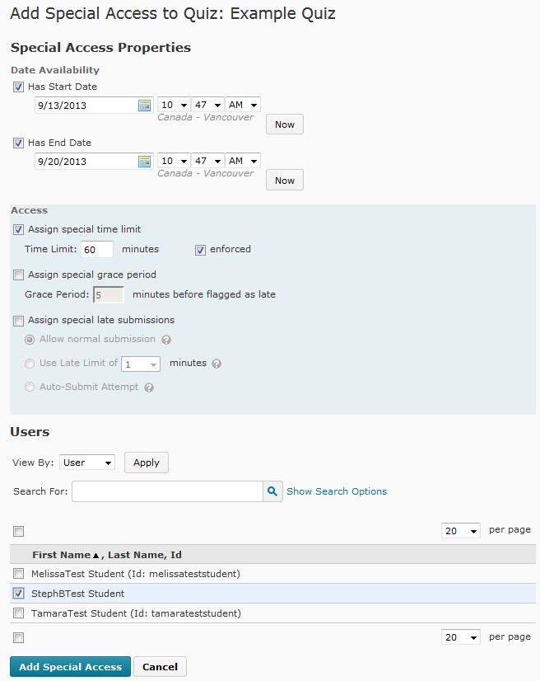5. By default, the start and end will be the same as the quiz. Adjust these if desired.
6. To add special time limits, check the box beside Assign special time limit and type the number of minutes into the box.
7. Under Users find the students that require special access and check their names. TIP: if your classlist is spread over 2 or more pages, adjust the number of students you can see on each page until your entire classlist appears on one screen.
8. Click on the blue Add Special Access button to save and return to the quiz editing screen

9. You can check what Special Access you have given to students by clicking on the grey Add Users to Special

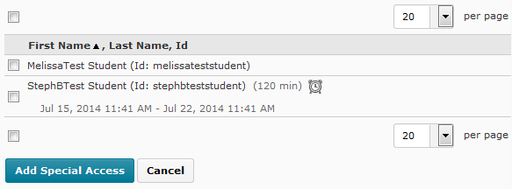Access button, and viewing the classlist at the bottom of the page.

For inquiries and support, please contact learnsupport@viu.ca or call 250-740-6167.

