Overview
Depending on the settings you have chosen in the Grades Setup Wizard, you may also have to calculate the Final Calculated Grade before releasing it. The fastest way to calculate the Final Calculated Grade is by changing your settings to automatically keep the final grade calculated.
Please Note: In order for students to see their Final Calculated Grade, you must release it to them.

Change How the Final Grade Is Calculated
- Click on Assessment and Grades from the course navigation bar

- Click Settings in the upper right corner of the Manage Grades screen

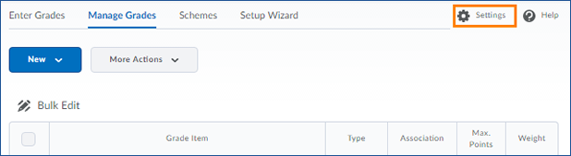

- Click the Calculations Options tab

- Scroll down until you see the “Auto Update” heading. To allow VIULearn to automatically calculate the final grade, check the box beside Automatically keep final grades updated.
- Click the blue Save and Close button and confirm that you want to make your changes.
- Click the grey Close button to return to the Manage Grades screen

Release the Final Calculated Grade
- On the Manage Grades screen, click the arrow beside Final Calculated Grade at the bottom of your gradebook.
- Choose Enter Grades from the menu that appears.

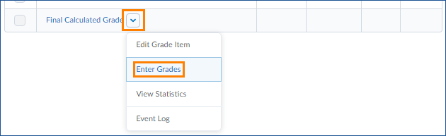

- On the Final Grades screen that loads, check the box beside the learners whose grades you want to release. You can click the box at the top to select all users on the page.

Please note: if you have more than 20 learners in your course, you can change how many users appear on each page using the drop down menu on the bottom right of the list of students.

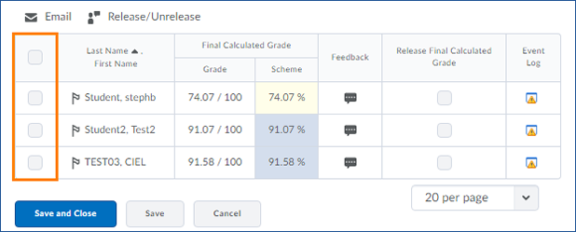

- Click Release/Unrelease to release (or unreleased if the grades were already released) the final grade for each selected learner.

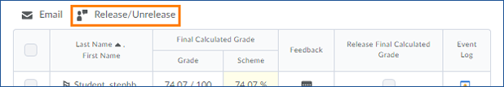

- You will see a checkmark in the box under “Release Final Calculated Grade” to indicate that the learners’ grades have been set for release.
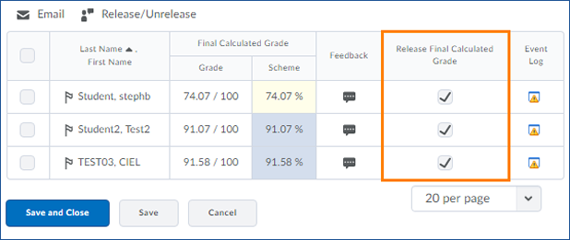
- Click the blue Save and Close button to apply your changes and go to the Enter Grades screen.

