Overview
Every assignment, activity, and assessment you want to assign a grade to needs a grade item in the grade book. In a weighted gradebook you can assign both a number of points and a weight to each grade item. Categories allow you to organize related grade items into groups. If you want to set up your gradebook to automatically drop a learner’s lowest mark from a group of assignments, you will need to set up a category.
Please note: In a weighted gradebook the total weight of all items not in categories and all categories must add up to 100. All items within a single category must also have a cumulative weight of 100%.

Best Practices for VIULearn Gradebooks
Make sure the Max. Points assigned to grade items reflect how much you want them to be worth. For example, don’t grade each of your 20 homework assignments out of 50 points and then your final exam out of 80 points.
When naming grade items and categories in your grade book, make sure to match as closely as possible to your syllabus and the name of the item in your course material. This will help learners know exactly which grade is associated with which item.
Create all of your gradebook items before creating the assignments, quizzes, or graded discussions you may want to link to your gradebook in VIULearn

Create a Grade Category
- Click on Assessment and Grades from the course navigation bar

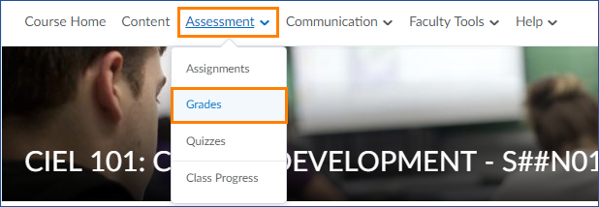

- From the Manage Grades screen, click New and choose Category
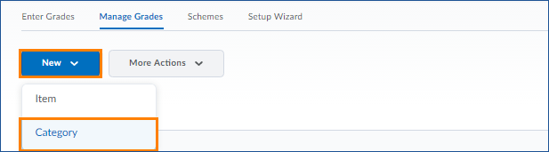

- On the properties tab:
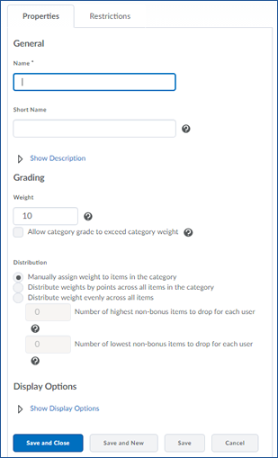

- Give your category a name. You can also add a description
if you want to by clicking “Show Description”

- You can give your Category a Short Name which will display
in the gradebook
- You can enter a Description of the grade category. If you
want to make the description available to users,
select Allow users to view description.
- Assign a weight for the category (if using a weighted
gradebook)

- Choose how to distribute category weight (if using a
weighted gradebook)

- Choose what information learners can see for the category
under Display options

- On the Restrictions tab:
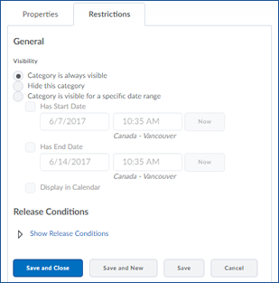

- Choose whether or when users can see the
category

- Set up Release Conditions which determine when a
category is visible

- When you are done customizing your category, click the blue Save and Close button

Create a Grade Item
- From the Manage Grades screen, click New and choose Item

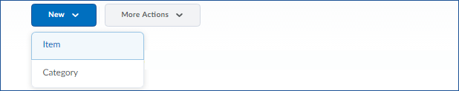

- Choose your grade item type (This will almost always be Numeric)

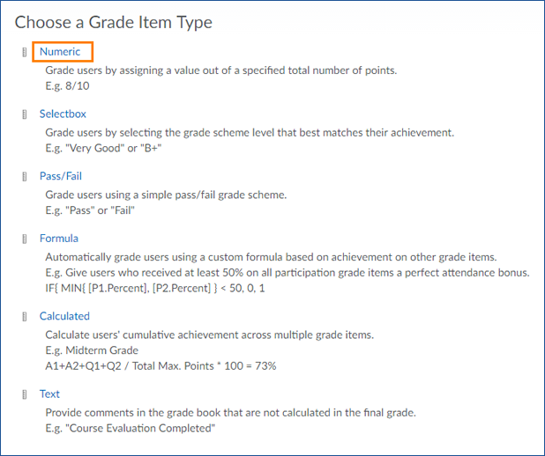

- On the Properties tab:
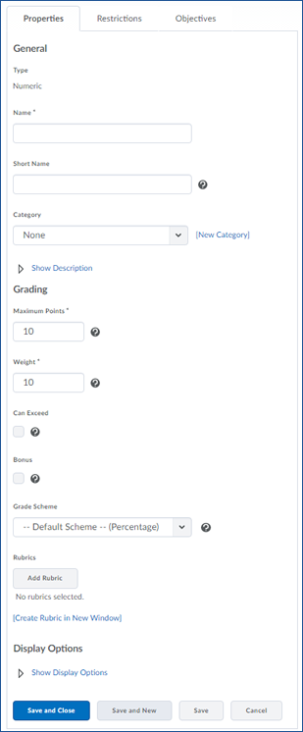

- Enter a Name for the grade item.

- You can enter a Short Name to display in the grade book.
          - If you want the grade item associated with a category, select a category from the Category drop-down list.
          - Enter a Description of the grade item if desired. If you want to make the description available to users, select Allow users to view grade item description.
          - Enter the value you want the item graded out of in the Maximum Points field.

          - For a weighted gradebook, enter the value the item will contribute towards the final grade in the Weight field.

          - Check the Can Exceed box to allow the item to exceed the maximum points for the category
          - Select the Bonus check box if you want the item counted as a bonus item.

- Select a Grade Scheme to associate with the item.

- You can click Add Rubric to add a rubric.

          - Click Show Display Options to choose what information your learners can see about a grade item

          - Click the blue Save and Close button to return to the Manage Grades screen, or scroll up and click the Restrictions tab to set restrictions on your Grade Item
- On the restrictions tab:
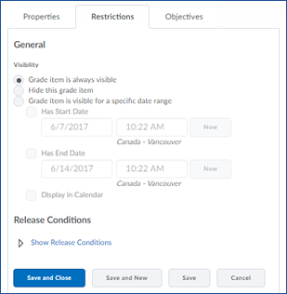

- Choose whether the grade item is visible to
learners. You can manually hide and show the
grade item, or set a start and/or end date for the
item’s visibility.

- Set Release Conditions for the grade item

- When you are done customizing your grade item, click the blue Save and Close button

Review Your Gradebook
When you have finished creating all categories and items for our gradebook, you want to make sure everything is set up correctly. If you are using a weighted gradebook, VIULearn will check that all items in categories, and the gradebook as a whole add up to a weight of 100%. If not, you will see an error message at the top of the gradebook.
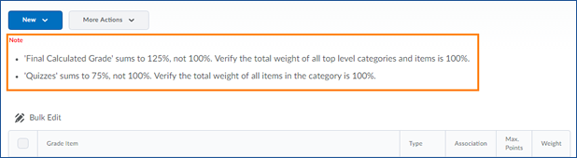
You can make changes to Items and Categories in your Gradebook until you begin entering grades for learners. Once you have entered any grades into the gradebook, changes made to how grades are calculated or weight is distributed can lead to errors.

