Overview
Creating a custom grade scheme in your VIULearn makes your gradebook work for you. Set custom achievement ranges (such as minimum standards for passing) or simple Pass/Fail schemes. Easily identify students requiring additional support.

Create a custom grade scheme
- Navigate to the gradebook: Assessment and choose Grades.
- Click on Schemes and choose New Scheme.
- Name your scheme.
- Type in your symbol (“Pass”, “A+”, etc.), choose a representative color, and set your range starting percent. Remember that the ranges increase down the page.
- Choose Save when you are finished to return to the schemes page.

Apply a custom grade scheme
You can set a custom grade scheme as the default for your gradebook:
- Click on the Schemes tab in the Grades tool.
- Click on the checkmark in the Set as Default column beside the scheme you want.
- A confirmation screen will appear, choose Yes.
- This will change how your scheme appears on all grade items set to default, for example the Midterm, Final Exam and Final Calculated Grade
You can also apply a custom scheme to specific items from the Manage Grades tab:
- Use the checkbox to the left of the items you want to apply the scheme to.
- Choose the double pencil Edit.
- On the following screen, use the drop down list to choose the desired scheme.
- Note that you can also edit grade item titles, points, weight and category from this view.

Viewing your custom schemes
You can see your students’ grades with the custom scheme two ways:
• From Manage Grades use the arrow to the right of the grade item and choose Enter Grades. There will be a column titled Scheme and you will be able to scroll down the class list to view the scheme.
• From Enter Grades make sure you are on Standard View. Depending on your settings, you will be able to see the Points Grade, Weighted Grade, Grade Scheme Symbol and/or Grade Scheme Color.

Custom Grade Schemes Example
Below is an example of what a learner would see with multiple custom grade schemes applied to their course gradebook.
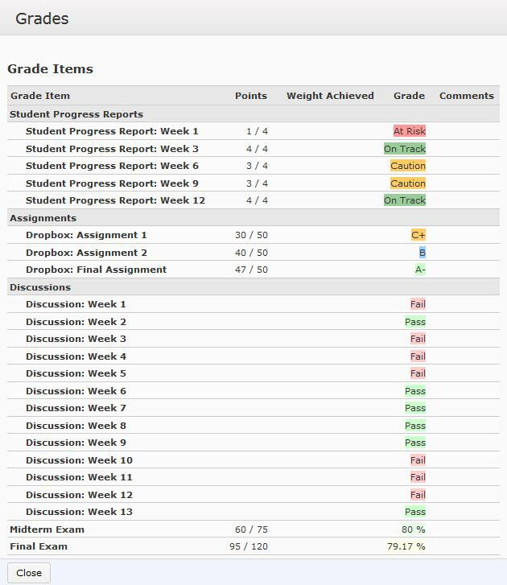

Student Progress
Report Scheme

Letter Grade
Scheme

Pass/Fail
Grade Scheme

Default Grade
Scheme

