Overview
Once you have created all of the categories and items in your gradebook, you can edit many of the grade item and category settings using the Bulk Edit option in Manage Grades. You can also edit a single Category or Item to change settings such as the restrictions on who can view the item, or the name of the grade item.
Please Note: In a weighted gradebook, the total weight of all categories and items not in categories must equal 100. The total weight of all items within a single category must also equal 100.

Bulk Edit Grade Categories and Items
- Click on Assessment and Grades from the course navigation bar

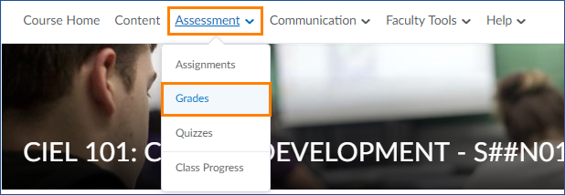

- You should be taken automatically to the Manage Grades screen. If not, click Manage Grades before moving to the next step.

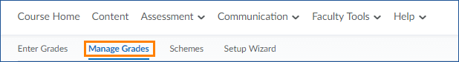

- Check the box next to the categories and items you want to edit (or check the top select box to select all categories and items) and click Bulk Edit

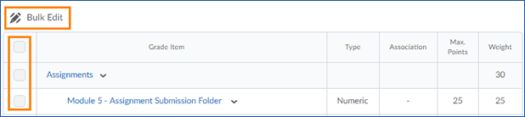

- The items you selected will load in an editable spreadsheet view (see next page)

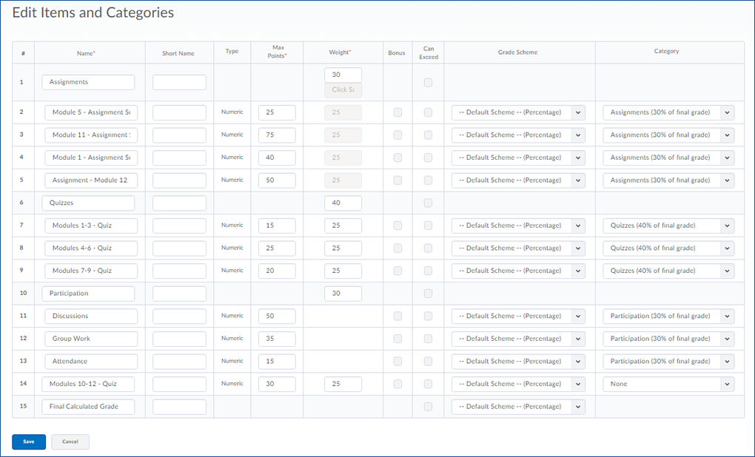
- When you are finished making changes to your categories and items, click the blue Save button to save your changes and return to the Manage Grades screen.

Edit Individual Grade Categories and Items
- Click on Assessment and Grades from the course navigation bar

- You should be taken automatically to the Manage Grades screen. If not, click Manage Grades before moving to the next step.

- Click the arrow to the right of the Item or Category you want to edit and choose Edit Item (or Edit Category) from the menu that appears.

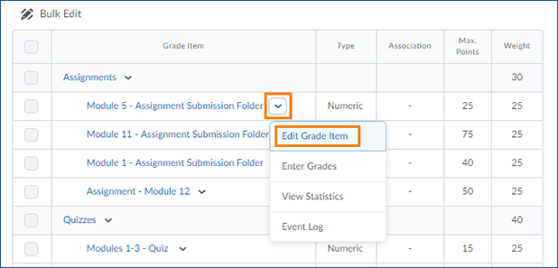

- You will be taken to an Edit Item (or Edit Category) page. Here you can make changes to the Properties and Restrictions for your item or category.
- When you are finished making changes, click the blue Save and Close button to return to the Manage Grades Screen
Please Note: Changing the weight or maximum points for a grade item after entering any grades can result in calculation errors.

