Overview
If you have graded assessments for your course which are not associated with an assignment folder, discussion forum, or quiz in VIULearn you will need to enter the grades manually. You may also choose to enter grades for assessments done in VIULearn manually rather than having the tools automatically import the learner’s grades.
It is possible to enter grades manually from Manage Grades, as well as from Enter Grades. The options available when manually entering the grades will vary depending on which view you choose as well as whether or not the grade item is connected to a tool, what tool it is connected to, and whether or not a rubric has been added to the item.

Entering Grades in Spreadsheet View
In addition to the options given above, you can also manually enter learners’ grades by changing your Enter Grades screen to Spreadsheet View. This view allows you to manually enter grades for all students on all grade items from a single screen.
To open Spreadsheet View:
- Click Assessment and Grades on the course navigation bar
- Ensure you are in Enter Grades view
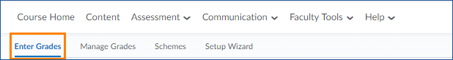
- Click the Switch to Spreadsheet View button in the upper right corner of your screen.
- Enter grades into the boxes provided.
- When you are finished, click the blue Save button to save your changes.

Accessing the Grading View

From Manage Grades
- Click Assessment and Grades on the course navigation bar
- Ensure you are in Manage Grades view
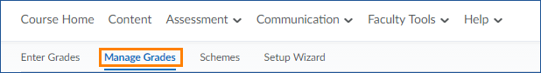
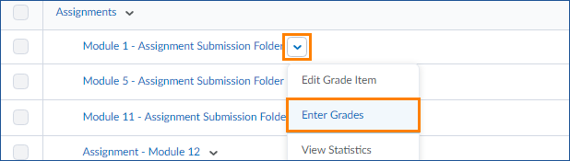
- Use the arrow to the right of a grade item to choose Enter Grades

From Enter Grades
- Click Assessment and Grades on the course navigation bar
- Ensure you are in Enter Grades view
- Use the arrow to the right of item name to choose Grade All
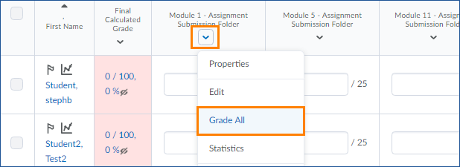

Using the Grading View
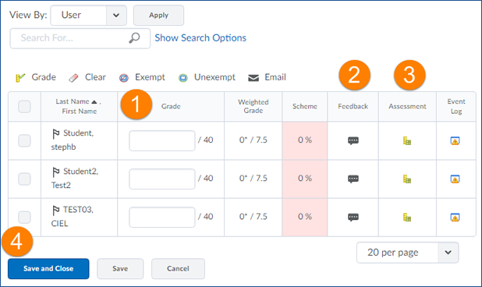
Type your grade into the box provided
If you wish to provide feedback, click on the speech bubble icon under the Feedback column and type your feedback into the space provided
You will only see the Assessment column if you have a rubric attached. Click on the rubric icon in this column to enter feedback using the rubric
Make sure to use the Save button at the bottom of the screen when you have finished entering grades

Exporting Your Gradebook
Many instructors like to keep a backup of their gradebook on their computers. You can easily export a gradebook from VIULearn and save it to your computer.
To export a Gradebook:
- Make sure you are in the Enter Grades area
- Click the Export button in the top left of the screen

- You will be able to choose some options for your export, including what grade information you need and what student details you require
- You can then select if you want to export the whole gradebook or just certain items
- At the bottom of the page, choose whether you want CSV or Excel format for your export
- A download window will open in a new window or tab
- Click directly on the file name to download the file to your computer

