Manage Grades
Manage Grades is the default landing page when you choose Assessment and Grades from the course navigation bar. That can be changed in your Settings, at the bottom of the Personal Display Options tab.
Manage Grades is the only view in the VIULearn Gradebook at allows you create new grade categories or items. This is the view that you will spend the most time building in.

Weighted Gradebook Errors
If you are using a weighted gradebook you will sometimes see Note at the top of your gradebook. VIULearn is expecting that the gradebook will add up to 100% total, and that the weight of all the individual items inside each category also add to 100%.
Weighted Gradebook Error Example:
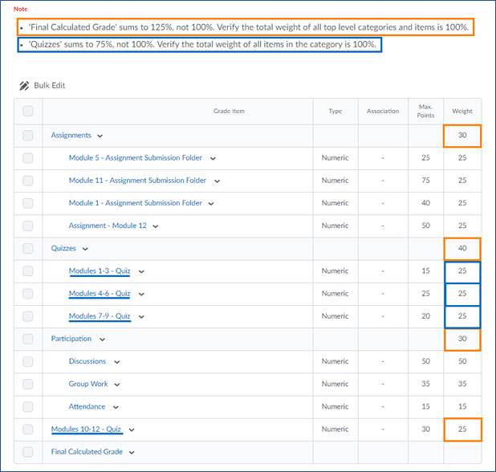
The Final Calculated Grade for this gradebook is a sum of all Categories and Items not in a category. In this case that is “Assignments” (30%), “Quizzes” (40%), “Participation” (30%), and the “Modules 10-12 – Quiz” (25%). The first bullet under Note warns you that these items total to 125%.
The second item under the Note tells you that the items in the “Quizzes” category have a combined weight of only 75%.
To fix both of these errors, we would need to move the “Module 10-12 – Quiz” into the “Quizzes” category. Follow this link to learn more about how to edit grade items and categories.

The Association Column
The Association column shows you whether or not a grade item is attached to an activity in VIULearn. In the example below, the “Module 5 – Assignment Submission Folder” and “Module 11 – Assignment Submission Folder” are both associated with Assignment Submission Folders in VIULearn. The other two assignments are not associated with any activity in VIULearn.
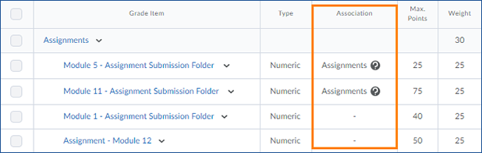
Grade items do not need to be associated with activities in VIULearn. If a grade item is not associated with an activity in VIULearn, you can manually enter the grade for that item. The Association column provides a quick reference for you to check if the grade item and activity are associated. You can click on the question mark icon next to the association to see which activity is associated with this grade item.

Reorder Grade Items and Categories
Learners will see grade categories and items in the same order that you see on your Manage Grades page. To make the gradebook easy for learners to read, you may want to put your items in a different order than they were initially created in.
To reorder your grade items and categories:
- From the Manage Grades screen, click More Actions and choose Reorder
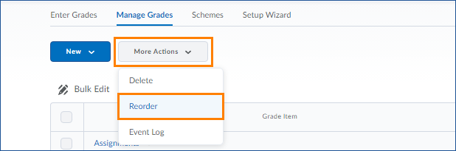

- In my example, you can see that the Assignment for Module 1 is displayed third under my Assignments category. To change this so Module 1 is at the top of that category, I click on the drop down menu where it says 3 and change it to 1.
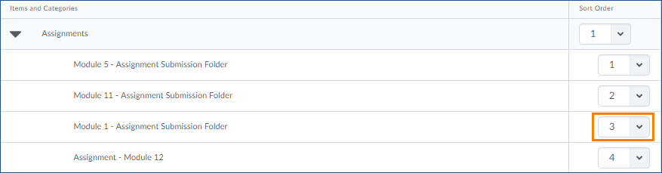
- The other items in this category are automatically renumbered to accommodate the new place for the Module 1 assignment.
- Once you are finished making changes, click on the blue Save button to return to the Manage Grades screen.

Enter Grades
You can navigate to Enter Grades using the tabs along the top of the Grades screen, if it is not your default view.
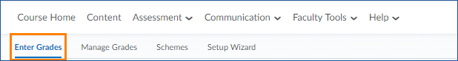
The Enter Grades view gives you an overview of you students’ grades, allows you to enter manual grades, and is the only place where you can export your gradebook to CSV or MS Office Excel formats.

Tips and Tricks for the Enter Grades View

View Your Gradebook as a Learner
You can preview your gradebook from a student's perspective from Enter Grades. To do so:
- Click directly on a student's name from the list on the left
- Use the arrow to the right of their name at the top of the page to choose Preview
- The student's view of the gradebook will open in a new window or tab
This is the best way to preview your gradebook, as it gives you the maximum amount of information possible about what your students are seeing.

The Two Enter Grades Views
There are two views in Enter Grades: Standard View and Spreadsheet View. Standard View is the default view, and gives you an overview of the gradebook.
You can use the grey button located on the far right hand side of the screen to Switch to Spreadsheet View.
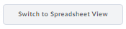
Spreadsheet View will allow you to enter grades for students directly into the gradebook.

Sorting your Gradebook
You can sort your Gradebook by nearly all of the fields you see along the top grey bar, including Last Name, First Name, Final Calculated Grade, and all other grade items, and category subtotals.
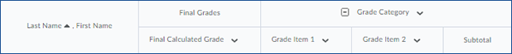
To sort by any of these columns, click on the text at the top of the column. Note that when there is an overarching header for multiple columns, such as the Grade Category header, you can only sort by the individual columns (for example, the gradebook in the example above can be sorted by clicking “Grade Item 1” but not by clicking on “Grade Category”).

