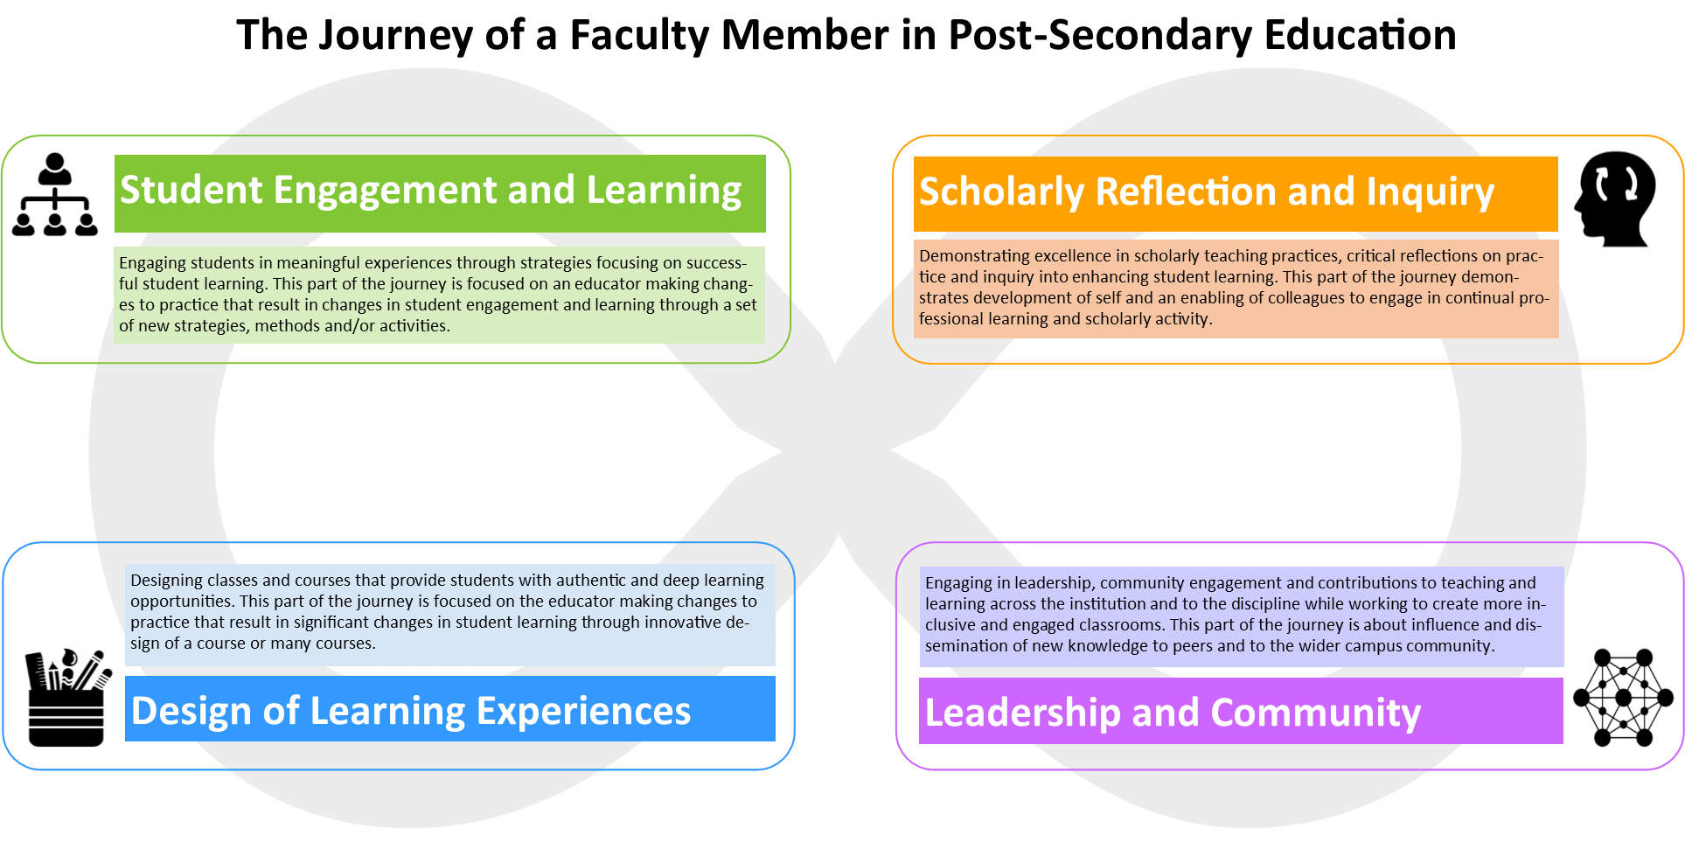
Explanation: Faculty have a journey that is much like an infinity circle: often looping around and around as they progress through the various stages of their career. Many faculty begin focusing on engaging students in learning about course components. Engaging students requires making changes to their practice and trying out new strategies, activities or ideas. After sometime, faculty members may look at the design of learning from a larger point of view. They may focus on how their course fits within the program or consider redesigning parts of or all parts of a course. The student engagement and design of learning stages might continue for several years oscillating back and forth. At some point, faculty members start looking at their practice from a scholarly reflection and inquiry point of view. They may invite colleagues in to their classes for a peer observation activity or they may begin gathering evidence of student learning and consider publicly sharing their successes and failures. Scholarly reflection sometimes leads to faculty taking on leadership roles to onboard and mentor new colleagues, lead a program redesign initiative, or undertake an institutional role in enhancing teaching and learning. This is often characterized by faculty wanting to share and learn beyond their own program. They also might take on leadership roles in provincial and national teaching and learning communities.
Creative Commons License: CC BY-SA 4.0 | Liesel Knaack, Centre for Innovation and Excellence in Learning | Vancouver Island University (2017)

