Overview
The Manage Files tool is a file management system for your course. All of the files in your course are stored in the Manage Files area. Changes you make to the files in Manage Files will reflect in those files in Content.
To allow for continued use of your content from semester to semester, we recommend keeping your Manage Files area organized. Using meaningful names for files and folders and organizing your folders in a way that makes sense to you will make it easy for you to find content items if you need to in the future.

Create a New Folder
- Navigate to Manage Files by clicking Faculty Tools and Manage Files
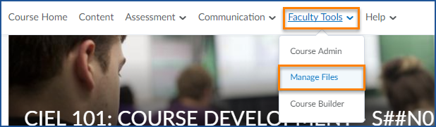
- Click on New Folder button.
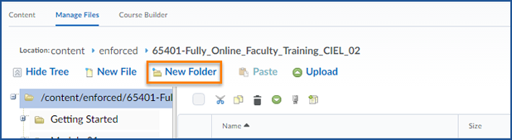
- You will see a text box appear in the file list. Type in your folder name.
- Click Save.
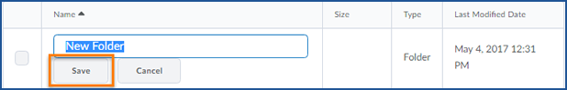
- You have now created a folder inside the Manage Files area.

Move Files into Folders
- Select the files you want to move
- Scroll to the top of the manage files are and click the cut button
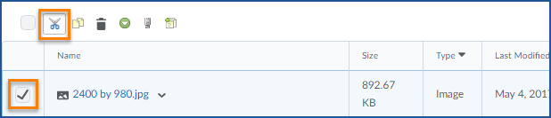
- Click on the folder you want to move those files to
- Click paste
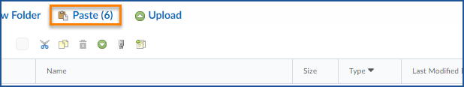
- Your items will be moved to the new folder

