Overview
The Manage Files tool is a file management system for your course. All of the files in your course are stored in the Manage Files area. Changes you make to the files in Manage Files will reflect in those files in Content.
To allow for continued use of your content from semester to semester, we recommend keeping your Manage Files area organized. Using meaningful names for files and folders and organizing your folders in a way that makes sense to you will make it easy for you to find content items if you need to in the future.

Uploading a File to Manage Files
- Click Faculty Tools and Manage Files
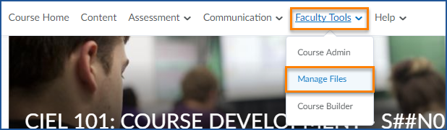
- Navigate to the folder you want to add the file to
- Click “Upload”
- You can drag your files into the box or click “Upload” to browse for your file.
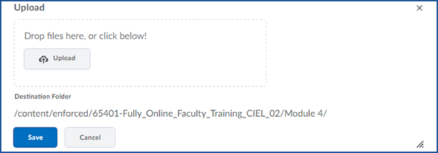
  - You may need to wait a moment for the file to finish uploading.

- Click “Save”

