Overview
The Manage Files tool is a file management system for your course. All of the files in your course are stored in the Manage Files area. Changes you make to the files in Manage Files will reflect in those files in Content.
To allow for continued use of your content from semester to semester, we recommend keeping your Manage Files area organized. Using meaningful names for files and folders and organizing your folders in a way that makes sense to you will make it easy for you to find content items if you need to in the future.

Uploading a Zipped File to Manage Files
- Click Faculty Tools and Manage Files
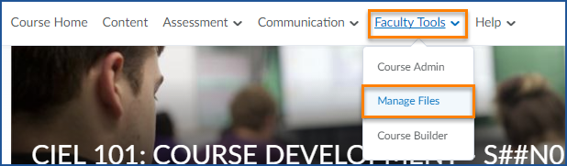
- Navigate to the folder you want to add the file to
- Click “Upload”
- You can drag your zipped file into the box or click “Upload” to browse for your file.
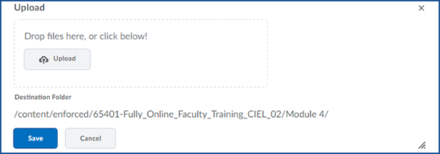
  - You may need to wait a moment for the file to finish uploading.

- Click “Save”

Unzip Your File in Manage Files
- Find the uploaded file in the file list and click on the arrow to the right of its name
- Choose “Unzip”
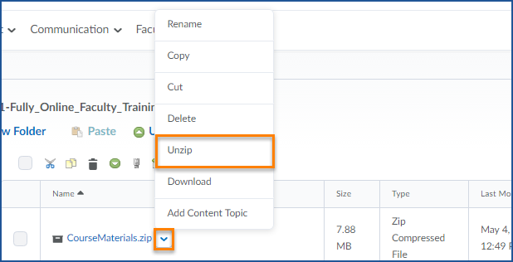
- You will see a pop-up advising you that unzipping your file may take some time. The length of time it takes to unzip the file will depend on how large it is
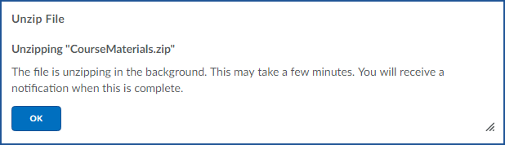
- When the file is unzipped you will see a red dot on your subscription alerts advising you that the files are ready
- You can now see all of the individual files from the zipped folder have been added to your Manage Files area. You will now be able to add these files to the Content area of your course.

