Inquiry 1SS3 (Inquiry in the Social Sciences)

(from Justice et al. 2007)

Self reflection & Self evaluation
Taking responsibility for learning

The Inquiry 1SS3 model is meant to unfold throughout a learning sequence or throughout a course. Key to this model is idea that learners need to take responsibility for their learning, and when they do their learning will be enhanced. Inquiry 1SS3 also defines questions as questions that are:
- INTERESTING; the question is both relevant to the course theme and personally significant and compelling to the asker
- ANALYTICAL; the question leads to answers that cannot be descriptive but require balanced consideration of evidence and opinions. (Often we asked students to ask ‘Why’ questions)
- PROBLEMATIC; the question is based in a contradiction, puzzle or dilemma
- COMPLEX; the question has more than one realistic possible answer
- IMPORTANT; the question is either publicly argued (controversial) or its answer would have some real effect on the world
- GENUINE; the question is something that the asker really wants to answer but presently cannot, as opposed to a question which the asker assumes the answer to and wants to prove
- RESEARCHABLE; there is evidence that pertains to it (as opposed to, for example, “Why does God not answer prayers?”)

Progressive Inquiry (PI Model)

(Muukkonen, Lakkala, & Hakkarainen, 2005)

Distributed Expertise

The Progressive Inquiry model is designed to engage learners in extended, in-depth processes of questioning. Learners will need to work together and make their ideas and progress public in order to progress through the inquiry, and in this way the PI Model mimics many professional working environments. The “Distributed Expertise” in the center of this model indicates that learners move through this inquiry cycle together or in small groups. Actions at each stage of the cycle are summarized below.
Setting up the Context | Inquiry is anchored to real-world problems and situations, learners contextualize the problem and think about why it is important and worthwhile to investigate
Presenting Research Problems | Learners set up the questions or problems that will guide the inquiry (why and how questions are especially good)
Creating Working Theories | Learners construct their own hypothesis and conjectures using their background knowledge, which helps them become aware of their pre-existing conceptions
Critical Evaluation | Learners assess the progress of their investigation and strengths and weaknesses of their explanations, allowing the learners to self-regulate their inquiry
Searching Deepening Knowledge | Using the evaluation from this step, learners gain new information and knowledge through experimentation, data collection, or literature searches
Developing Deepening Problems | In light of new knowledge, learners refine their questions and theories further and decide what new information they need to further their inquiry

“Design Thinking”

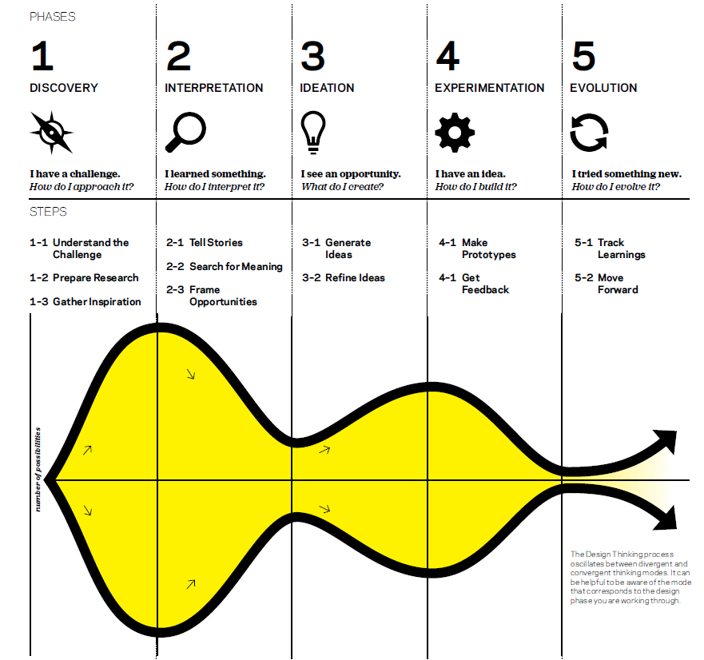

Design Thinking is a way of approaching challenges that uses divergent and convergent thinking to allow for creative and person-centered problem solving. The Design Thinking process creates an iterative approach to addressing problems, which gives space experimentation, reiteration and collaboration. This process involves both generating and evolving ideas that are meaningful to yourself and those you are designing for. This approach focuses on designing the best answer given the situation, the challenge, and those involved, and does not necessarily lead to a single “right” answer.

Stripling Model of Inquiry

The Stripling Model of Inquiry

The Stripling Model of Inquiry allows learners to progress through a series of phases, while recognizing that they may move backwards or iterate the cycle. There are aspects of reflection throughout the cycle, but the cycles also contains a specific phase dedicated to reflection. Each phase asks learners to engage with specific processes (summarized below), which may require the development of specific skills or strategies.

Phase | Processes Learners Complete
Connect | - Connect to self and previous knowledge  - Gain background and context
Wonder | - Develop questions  - Make predictions and hypothesis
Investigate | - Find and evaluate information to answer questions, test hypothesis  - Think about information to illuminate new questions and hypotheses
Construct | - Construct new understandings connected to previous knowledge  - Draw conclusions about questions and hypothesis
Express | - Apply understandings to a new context or situation  - Express new ideas to share learning with others
Reflect | - Reflect on own learning  - Ask new questions

