Overview
All courses in VIULearn are “Inactive” by default, so that learners will not see a course listed unless you choose to use it. When you are finished building your course, you will need to manually change the course from “Inactive” to “Active”. Once you activate the course, and the course start date has passed, learners will be able to see and access the course in VIULearn.
Below is an example of what your courses may look like on the My Home page.

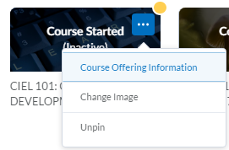
Please Note: The course must be active and the start date must have passed before learners can access your course. If you are not sure if the learners will have access to your course or not, please use the summary table below:
Activated | Start Date | Learner Access
No | Passed | No
Yes | Not Passed | No
Yes | Passed | Yes

To Activate Your Course
- Hover your mouse over the course image
- Click on the ellipse that appears in the top right corner
- Choose “Course Offering Information”
- You will be taken to a new screen
- Scroll down until you see the “Course is active” box
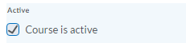
- Check this box
- Scroll down and check that the start and end date are correct
- Click “Save”

