Overview
My Home is the first page that will open when you log in to VIULearn. This guide will demonstrate the different areas of the My Home page in VIULearn.
The My Home page is made up of four sections which will be explored in greater deal throughout this guide :
The Mini Bar at the top of the page
The My Home Navigation bar
The My Courses area on the left
The Support area on the right

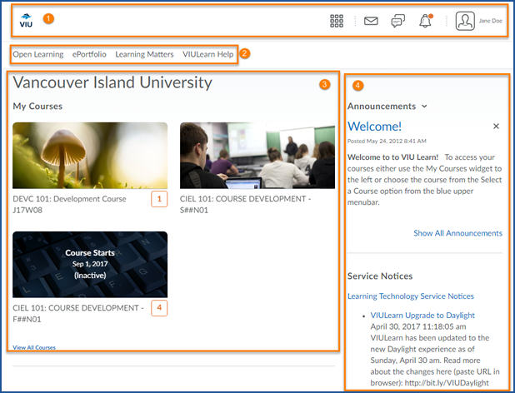

Mini bar
The mini bar appears at the top of all pages of VIULearn. It contains a link to My Home, the Course Selector, Message Alerts, Subscription Alerts, Update Alerts, and the Personal Menu.
At any time, click on the VIU logo to return to the My Home page
Click the Course Selector from any page in VIULearn to see a list of your courses and navigate to another course.
Clicking on Message Alerts will give you access to the Email tool and show you any email alerts.
Subscription Alerts will notify you of activity on topics you have subscribed to.
Update Alerts notify you of activity you have subscribed to such as new announcements, or updated course content.
Your Personal Menu gives you access to your Account Settings, Notification Settings, Role Switch, and the Log Off link.

My Home Navigation
The My Home navigation bar has links to ePortfolio, Open Learning, Learning Matters, and VIULearn Help resources.
ePortfolio is a digital portfolio tool created by D2L to allow learners to create digital portfolios to share their work. Learners can even attach ePortfolio items to assignments folders, quiz responses, and discussion posts.
Open Learning is where learners and faculty can register for free courses available through VIULearn
Learning Matters is a website created to help support student learning.
VIULearn Help will take you to the space on our website which contains support for using VIULearn.

My Courses
Below the My Home Navigation bar you will see the My Courses area. You may see courses pinned automatically or you may need to pin your courses manually. We have resources to help you with pinning courses on our website.
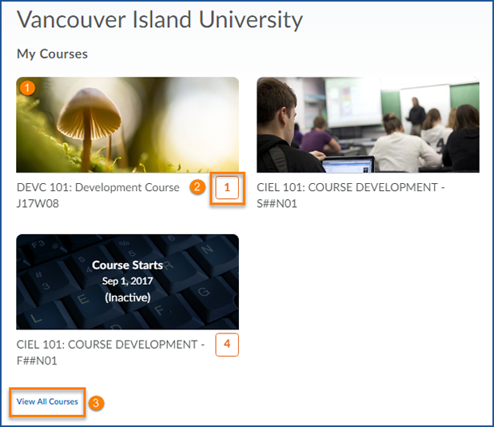
Click on a course image to access that course.
The number in orange beside the course name tells you how many updates you have for that course. Updates alert you to unread discussion posts, ungraded quizzes, or unread assignment submissions.
You can view (and Pin) additional courses by clicking on View All Courses.

The Support Area
In the Support area you will find Announcements and Service Notices
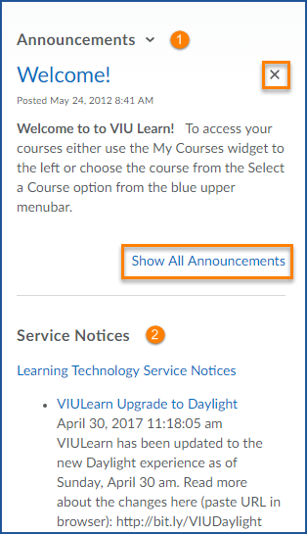
Announcements will contain important notices from the Centre for Innovation and Excellence in Learning.
When you have read an Announcement you can dismiss it by clicking the black X.
You can click Show All Announcements to view any announcements you have dismissed.

Service Notices contain important notices about outages or other major technology changes at VIU.

