This handout deals with editing and managing your quizzes. To review the setups to creating a quiz, please see Creating Quizzes 1 through 5.

Editing Your Quizzes
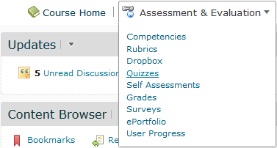First, from your Course Home page, choose Assessment and Evaluation and Quizzes.

You will be taken to the Quiz tool screen.
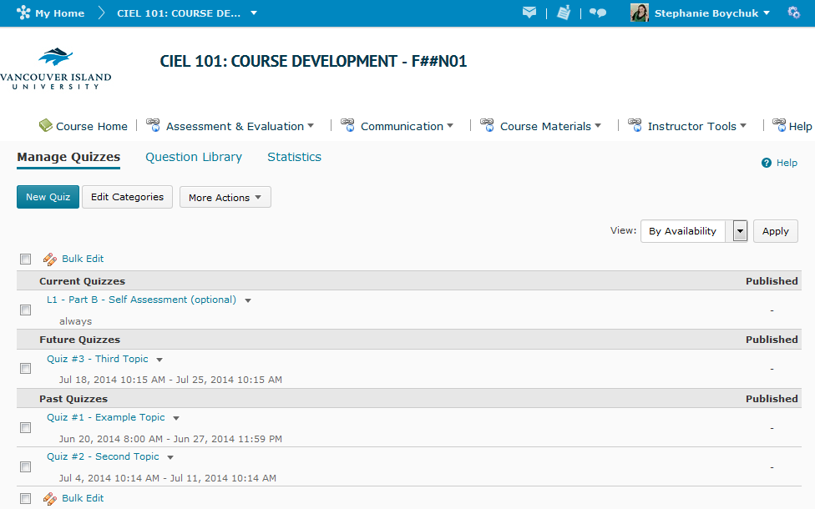

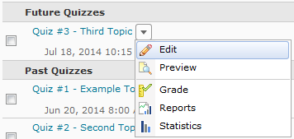From here, you can edit an individual quiz by using the drop-down arrow to the right of the quiz and choosing Edit. If you choose Edit, you will see the same quiz editing screens that you saw when creating your quiz.

The other options in the drop-down list include Preview, which lets to bypass any restrictions on the quiz and view it as a student. From this menu you can also Grade any student attempts on the quiz, as well as view any reports you have set up. You can also view the general statistics on the quiz generated by VIULearn.

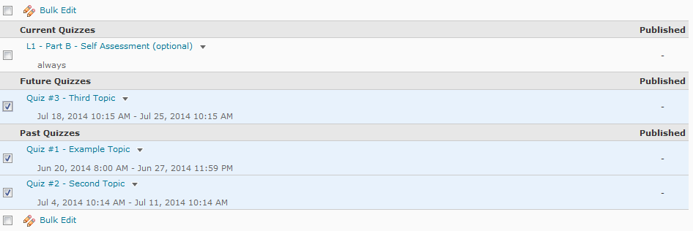If you wish to edit multiple quizzes at the same time, you can use the Bulk Edit feature by selecting the quizzes you wish to edit and then clicking on Bulk Edit.

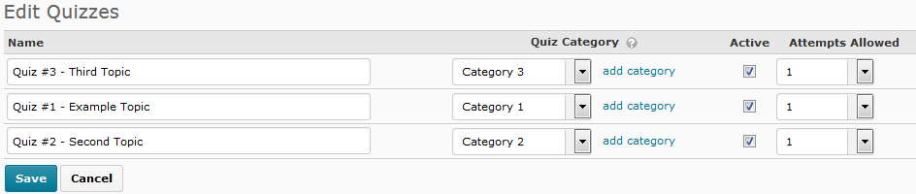This feature allows you to edit the name, category and number of attempts of all selected quizzes. You can also activate quizzes from this view. When you are done making your changes, choose Save.

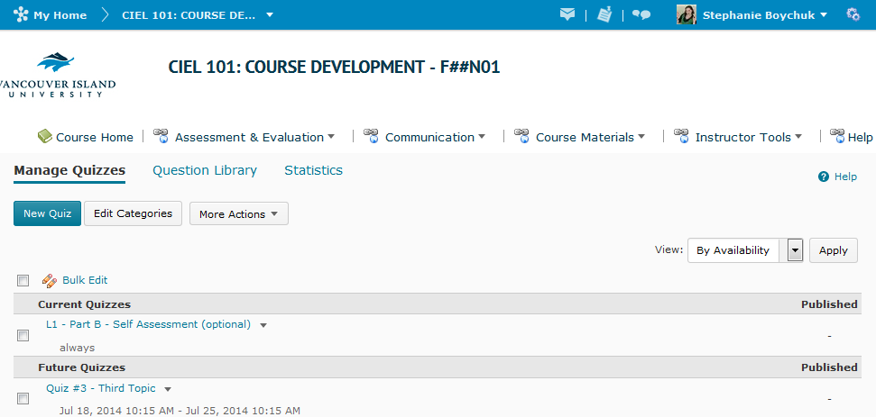From the Manage Quizzes view, you can also use the Edit Categories button to create categories, or labels, to sort your quizzes into.

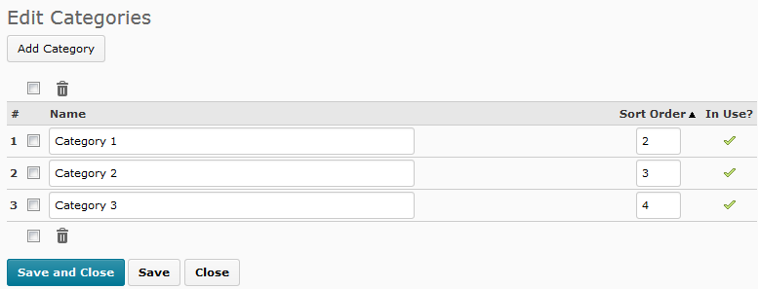You can create a new category using the Add Category button, and choose what order the categories will appear in by inserting numbers into the Sort Order column. When you have finished making your changes, you can choose the blue Save and Close button to return to the Manage Quizzes view of the Quiz Tool screen.

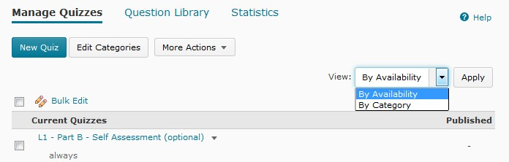To view your Quizzes by category, choose By Category from the view menu, and then click Apply. By default your quizzes will be sorted by Availability. Select the view option you want and choose Apply.

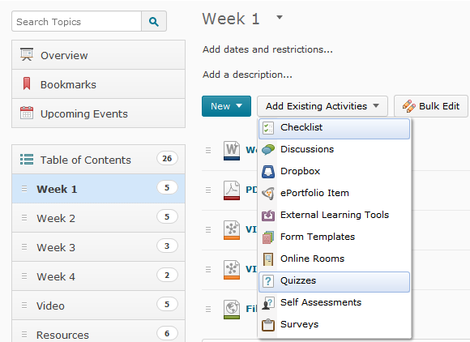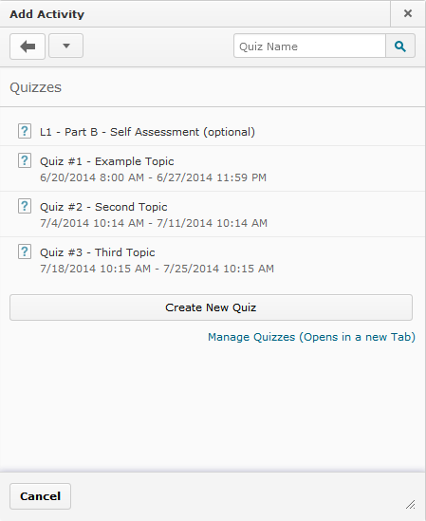

Adding Quizzes to Content
If you have created quizzes you wish for you students to access, you should always add your
quizzes into your course materials area.

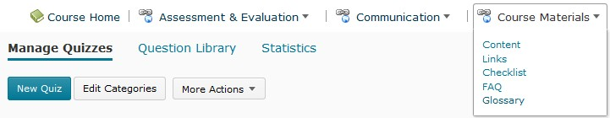Choose Course Materials from the course navigation bar and select Content.

Click on the module you wish the quiz to appear in. From there, choose the grey Add Existing
Activities button and select Quizzes. Click directly on the quiz you wish to add to your content.

The quiz will automatically save into the bottom of the module content. Remember that you can always click and drag the quiz and other content items to appear in the order you want them to. The description you put on your quiz will show beneath the quiz in the content area.

