Overview
There are multiple ways to increase the randomness of your quizzes in VIULearn:
- Shuffle the order that answers for multiple choice and multi-select questions appear
- Shuffle the order that questions or groups of questions appear in the quiz
- Randomize the questions that appear on the quiz so that not every learner is answering exactly the same quiz.
This handout will go over how to use all of these options. If you do not know how to add questions to the question library, or create a quiz, please start with our other quiz support materials.

Best Practices
We strongly recommend creating all questions in the Question Library before creating your quiz. The question library stores a copy of your questions so you do not lose them. You can always edit your questions from the Question Library in order to cascade changes to all quizzes in the course that might be using the question. In addition to these benefits, you must have your questions in the Question Library in order to create a random section.
Avoid including answers such as “All of the above” or “A and C” if you will be randomizing the answers in a multiple choice question.

Randomize the Order of Question Answers
You can set a question to randomize the question answers when creating the question, or you can edit the question to do this.
- Click Assessment and Quizzes on the course navigation bar and choose the Question Library

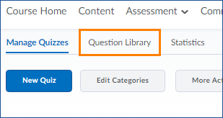
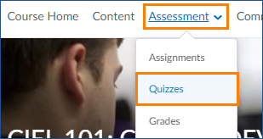

- If you have not yet created your question click New and choose your question type. OR, click on the question you want to edit.
- Check the box for “Randomize answers for each student” and click the blue Save button
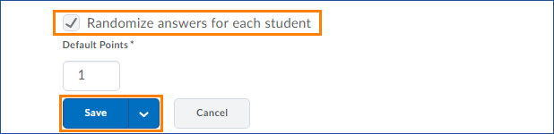

- If you have already added your question to a quiz, you will see a screen asking if you want to update the copy of the question that is in the quiz.
  - Check the box for any quiz you want to update and click Save.

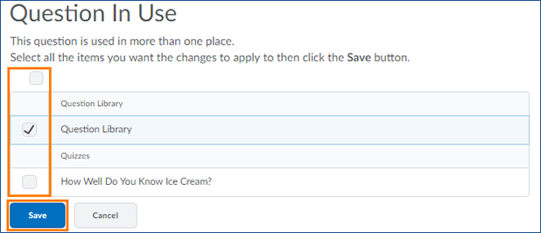

Shuffle the Question Order
Once you have added all of your questions to your quiz, in sections or at the root level, you can choose to shuffle the questions. Shuffled questions will appear in a random order for each learner and each attempt. You can shuffle everything in the quiz, specific sections of questions, or both.

Shuffle Questions in a Section
- From the Manage Quizzes section of the Quiz Tool, click on the Quiz you want to edit.
- Click the grey Add/Edit Questions button

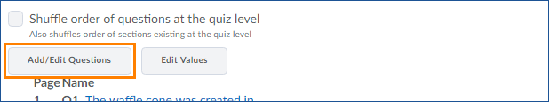

- Click the arrow to the right of the section you want to shuffle and choose Edit
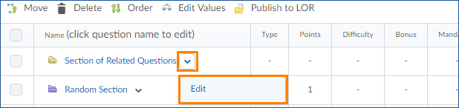

- Scroll down to the bottom of the page.
- Under Display Options, check the box for “Shuffle order of questions in this section.”

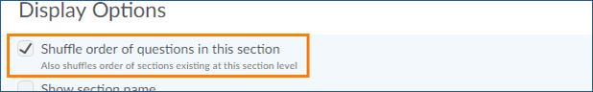

- Click the blue Save button.
- You will now see “Shuffling is on” beside the section title.

- Click the blue Done Editing Questions button.
- On the main Edit Quiz page you will now see a shuffle icon next to the questions in the section.
- Click the blue Save and Close button when you are finished making changes.

Shuffle Questions at the Quiz Level
You can also shuffle everything at the quiz level. This will shuffle the order of all questions that are not in sections and the order of all sections, but not the order of questions within sections.
- From the Manage Quizzes section of the Quiz Tool, click on the Quiz you want to edit.
- Check the box for “Shuffle order of questions at the quiz level.”

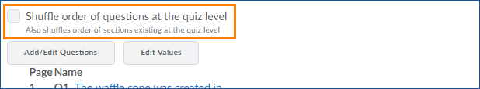

- Click the grey Save button
- You will see a shuffle icon next to the questions and sections that will be shuffled.
- When you are done making changes, click the blue Save and Close button.

Random Sections
Random sections in quizzes will present learners with a random selection of questions from the section on each attempt. You can make an entire quiz a single random section, or you can combine random sections, standard sections, and root level questions to organize and build your quiz. The questions inside a random section are automatically shuffled, but you can choose to shuffle the section within the quiz of you want additional randomization. To create a random section your questions must be in the Question Library.

Create a Random Section
- From the Manage Quizzes section of the Quiz Tool, click on the Quiz you want to edit.
- Click the grey Add/Edit Questions button

- Click the blue New button and choose Random Section.

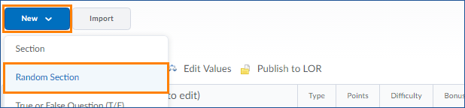

- Give your Random Section a name and set any display options for the section.
  - By default learners cannot see any details about the sections in the quiz.
  - If you want to use sections as a way to visually organize material in the quiz for learners, you can make the section visible using the Display Options
- Click the blue Save button.
- Click on your Random Section to import questions into this section.

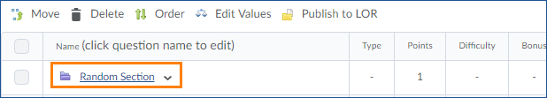

- Click the grey Import button.

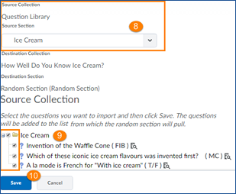
- Use the drop down menu to choose
which section in your Question Library
you want to import questions from.

- Check the box next to each section or
individual question you want to be
included in the random section.

- Click the blue Save button.

- Set the number of questions from this random section you want each learner to see in their quiz attempt and click the grey Save button.

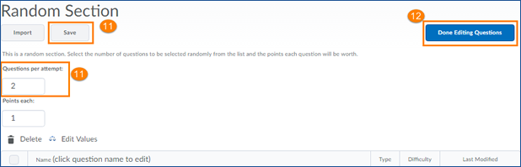

- Click the blue Done Editing Questions button
- On the Quiz Editing screen make sure that your Random Section shows the correct number of questions.
If not, go back to the Add/Edit Questions screen and click on the Random section to repeat step 11, making sure that you hit the grey Save button and let the page process before clicking Done Editing Questions.
- When you are done making changes, Click the blue Save and Close button.

