Reflective Process: Growing the Mind of a Scholarly Teacher
When you reflect purposefully, critically and with intention to improve practice, it is best to consider the following framework and guiding questions. Gibbs (1988) gives us an easy cyclical model to consider our thinking. After any teaching or learning experience, think of the experience in three parts.
- WHAT
  - DESCRIBE: What happened? Describe the situation – the important and relevant details.
  - FEEL: How did you feel and what did you think PRIOR TO the experience? How did you feel and what did you think DURING the experience? How did you react during the experience? How did you feel and what did you think AFTER the experience?
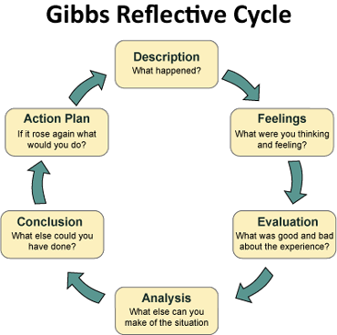
- SO WHAT
  - EVALUATE: What went well during the experience (what worked)? What went poorly or not so well during the experience (what didn’t work?) How did the experience end?
  - ANALYZE: What else can you make of the situation? Why did it go well or not so well? Do you think students were experiencing the same? What kind of feedback do you have? Think about what could have been done to avoid any consequences or poor situations?
- NOW WHAT
  - CONCLUDE: What conclusions can you draw? What specific (personal) conclusions do you have? What else could you have done? What might you have changed to improve things? What stopped you from doing this? What did you learn about yourself during this experience? What did you learn about your current knowledge or level of practice?
  - PLAN: What will you do the next time? Even if the experience was positive, what areas can you improve upon? What specific steps do you need to take to achieve improvements? What do you need to do to be better prepared to face this experience in future?
Gibbs, G. (1988). Learning by doing: a guide to teaching and learning methods. Oxford: Further Education Unit

