Overview
The Role Switch tool in VIULearn allows you to preview your course content to see what learners will see. Please note that some functions such as Quizzes and Group Restrictions cannot be previewed through Role Switch.

Impersonating a Learner Using Role Switch
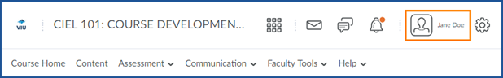
- From any page within your course, click on your name in the mini bar

- On the drop down menu that appears click View as Student
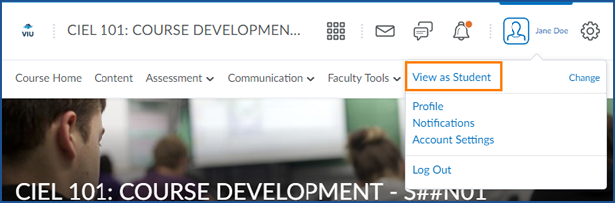
  - If you see “View as Instructor” instead, click Change to select the Student role

- You will now be able to view your course content as a student would see it.
Note: VIULearn will treat you as a learner who is enrolled in all groups for the course. You will be able to see all group restricted topics and items.
- When you are finished previewing your course, click your name on the mini bar again
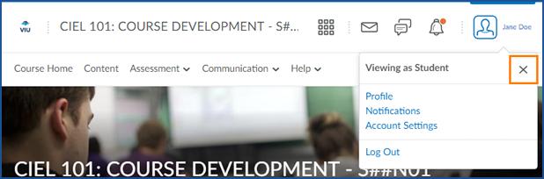
- Click the x next to Viewing as Student to return to the Instructor view

