Self - Directed Learning Projects
Contract and Plan of ( )
*Adapted from the work of Peter Norman and M. Gibbons. “Self Directed Learning” Simon Fraser Publications
The intention of this contract and plan is to assist you in directing your focus for a meaningful and rewarding learning experience.
The What? (What do you wish to learn or do?) a) vision
b) outcomes
a) Vision (Identify the general area of anticipated growth or learning)
e.g. I want to learn more about the Province of British Columbia to assist me in the preparation of an integrated unit for teaching and learning.
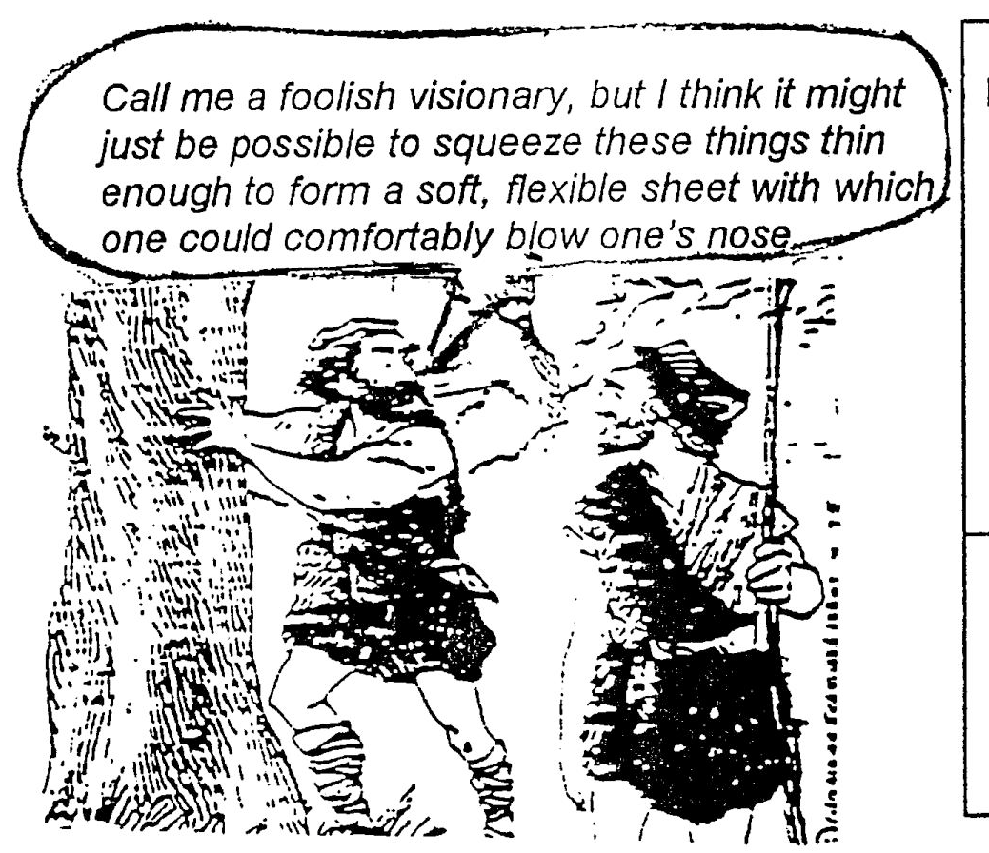
My vision is…………..

b) Outcomes (More specific identification of what you intend on learning or doing)
Example
- collect and organize resource packages of information on British Columbia
- find and organize 20 hands on activities for classroom use related to the resources
- teach and evaluate two of the activities during my weekly classroom visits (video tape lesson?)
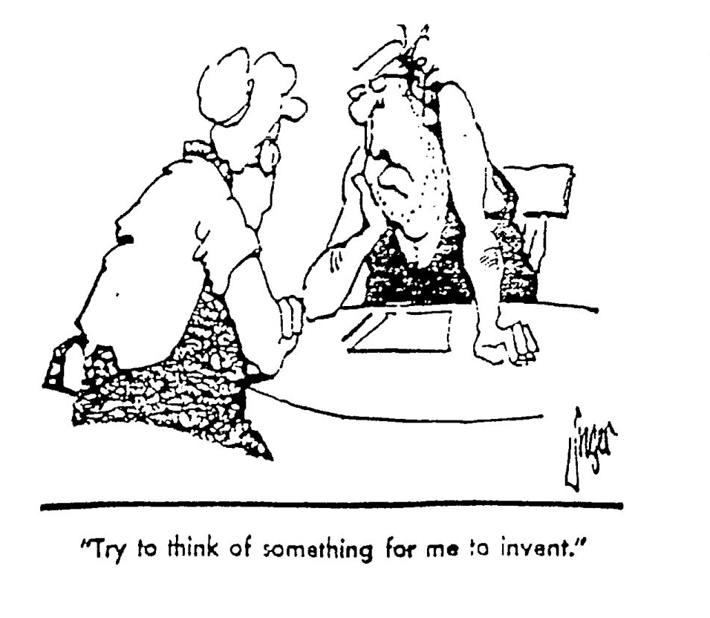

The outcomes of my project are to:

Why? (Motivation/Rationale)

Given that this is an optional assignment – why are you going to invest your time and energy?
Justify your selection of project.
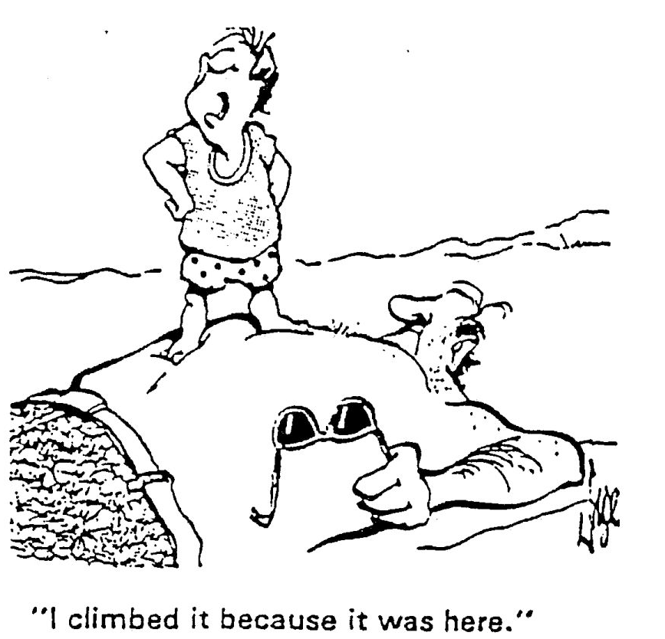
My rationale(s) for the project:

The Plan? (How? When? Possible obstacles?)

Identify specifically the sequence of steps needed in order to achieve your outcomes.
Outline a timeline to assist you in organizing time and energy in your busy life. What are some possible
obstacles to success and how can you deal with them?

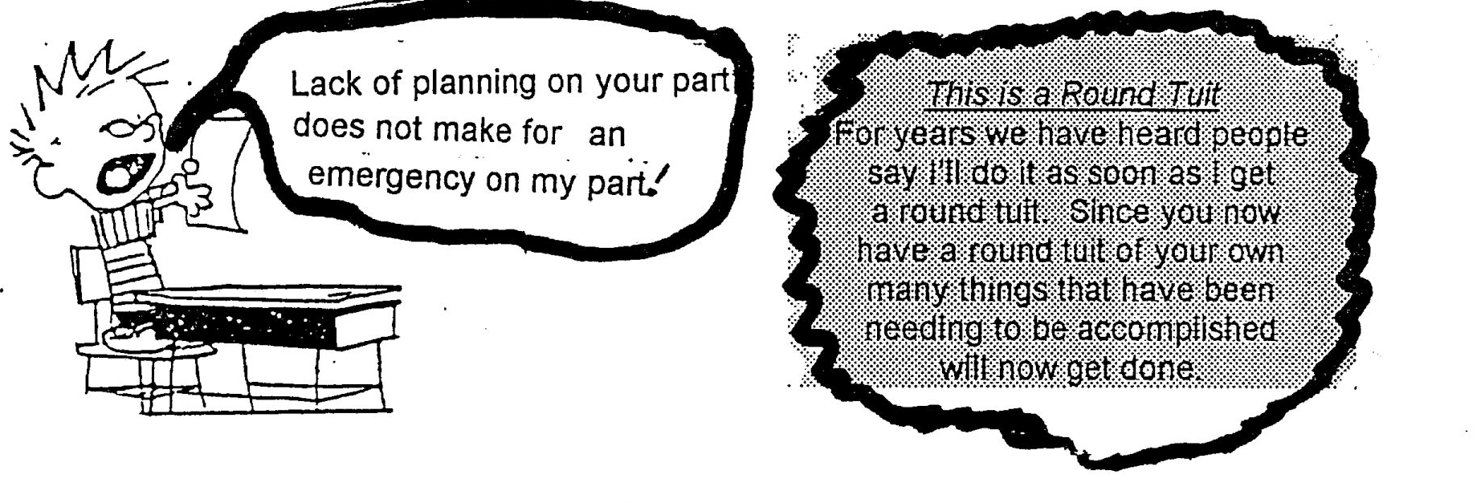

Steps | Timeline
Possible obstacles and how to deal with them?

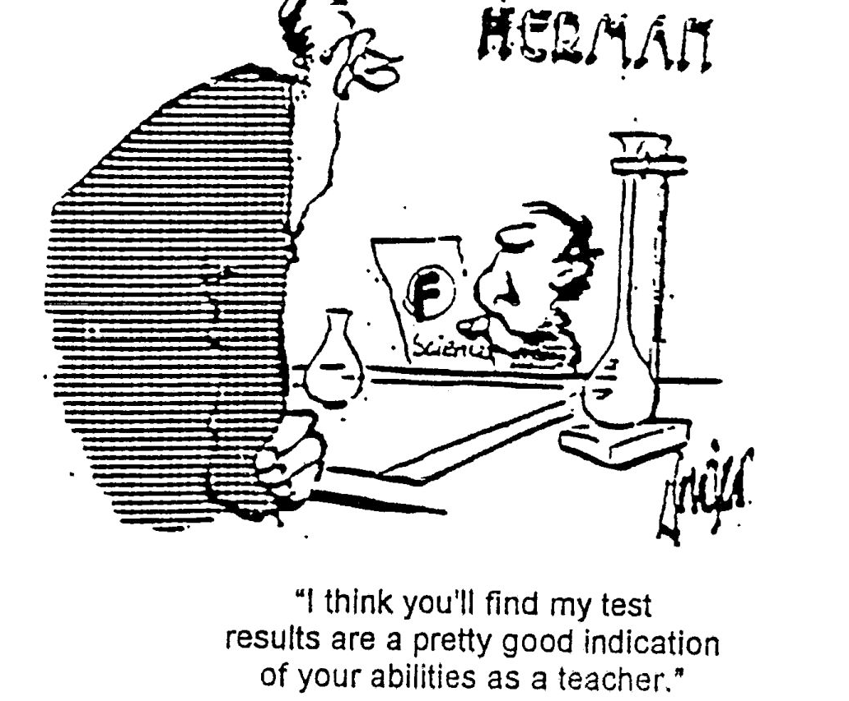
Evaluation and Criteria

- How will you personally make judgments about the success of your project in terms of the original outcomes?

- What are the specific criteria that the instructor will use to make judgments on the quality of your work? NOTE: remember to be very clear and specific about what the criteria are. Put yourself in the instructors place and think about whether or not he will be clear on what he is evaluating.

- My personal criteria are:

*

*

*

*

- Specific criteria for my instructor are:

*

*

*

*

*

This project _____________________________________________________________ has been approved. ( )
(short title)

Reminder: You will need to hand in: 1. A contract
2. some form of product
3. reflective analysis of both the process and the product
Check the course outline for specifics!

