Overview
Filling out your profile can be a good way to share some information about yourself with your learners or colleagues. However, please keep in mind that all users in your course can view your personal profile. Only add information you feel comfortable sharing with others.

Create or Edit Your Profile
- To access your personal profile, click on your name in the mini bar and choose Profile from the personal menu that appears
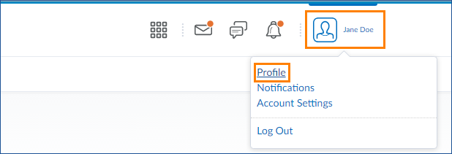
- Fill in any text fields that you want by typing in the available boxes.
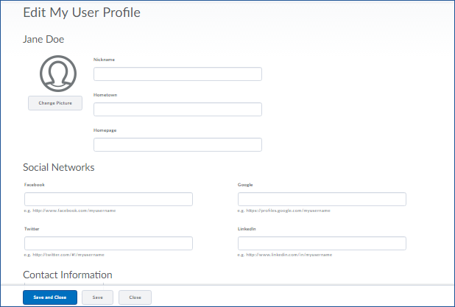

- If you want to upload and display a profile picture, click on Change Picture.
- Click the Upload button to browse for your file, or drag and drop it into the box provided.
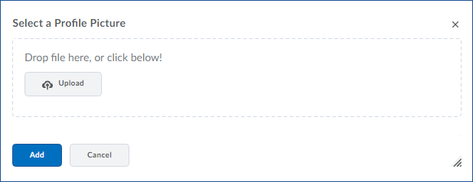
- It may take a few moments for your image to upload. Once the image has loaded, click the blue Add button to save your profile picture.

