Strategies to Help You Be a Successful Student: Learning and Studying Tips
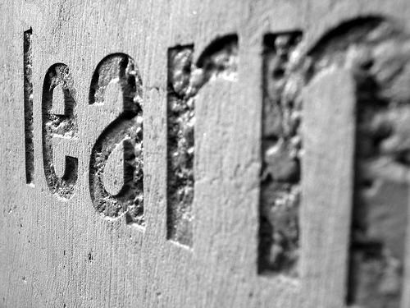
- Learn Deeply
You want to engage in deep learning - not in a shallow or surface manner. When you learn deeply it sticks in your brain much longer and helps you apply learning and remember it!
Photo Credit: http://www.flickr.com/photos/23403402@N00/1197947341 by Mark Brannan

- Don’t Multitask
Focus on maximizing focus and minimizing distractions (research clearly shows your brain can’t do any one thing very well with doing many things). Remove distractions (cell phone, Internet, etc.) to maximize your learning potential.
- Make Meaningful Connections
Make meaningful connections between all concepts (make stories, connections and relationships between new learning to help your brain remember)
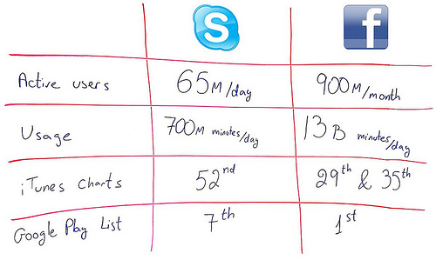
- Make Learning Personal
Relate new learning to your own personal experiences (it will stick better in your brain by making a personal connection).
- Determine Distinctiveness
Figure out what makes a concept very unique or different? (e.g., similarities and differences in new concepts so your brain can remember better).
Make a chart, a comparison list etc! Photo Credit: https://www.flickr.com/photos/86979666@N00/8015550360/
- Practice Appropriate Retrieval and Application – don’t memorize isolated facts -
if you memorize a bunch of facts that are not connected your brain won’t remember them longer term: instead figure out ways to remember what you need to know and then apply it. Practice and study related to how your teacher will want content to be recalled.
- Use Active Reading (not Passive Reading)
  - Generate questions as you are reading. If you can find the answers to your questions, this would be better. Your brain will process the readings much better and you’ll make meaning about the content. If your instructor gave some questions to consider, write out the answers as you are doing the readings. Or you can write possible test questions (with the answers) on your reading. Anytime you are thinking about questions when you are reading – will help you actively read!
  - Don’t highlight all the bolded or definitions. Pick out key words that make meaning. A big blob of yellow highlighter doesn’t help you make learning connections. Textbooks fool you into thinking bolded words help you learn.
  - Do your readings in a non-distracted spot. Reading in front of the TV or while doing another activity won’t have much go into your long term memory.
  - Make a summary note of your reading. When you put in your own words what you have read, the brain will remember it better! After you have read a chapter or an article, write a one paragraph summary. Pretend you are writing your paragraph for someone who has not read the reading.
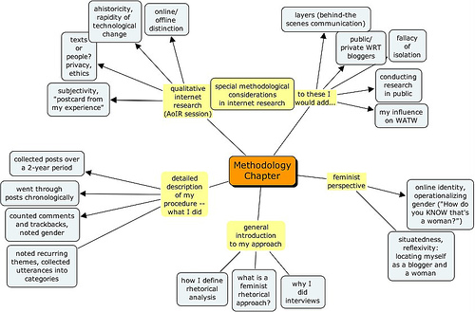
- Make a Visual Representation of a Concept
Create a visual connection of concepts, topics and components to each other. This helps you see the relationships between ideas and helps the brain learn better. Draw a map, a flowchart or a diagram to help see all the pieces and how they relate.
Photo Credit: https://www.flickr.com/photos/50018011@N00/48348326

- Think a Problem Through Out Loud!
Talk out loud through a problem. Ask someone who understands the concept to talk out loud and share with you how they think through it. When you can listen to someone describe all the processes/steps or background as to how a problem is solved – you will learn better!
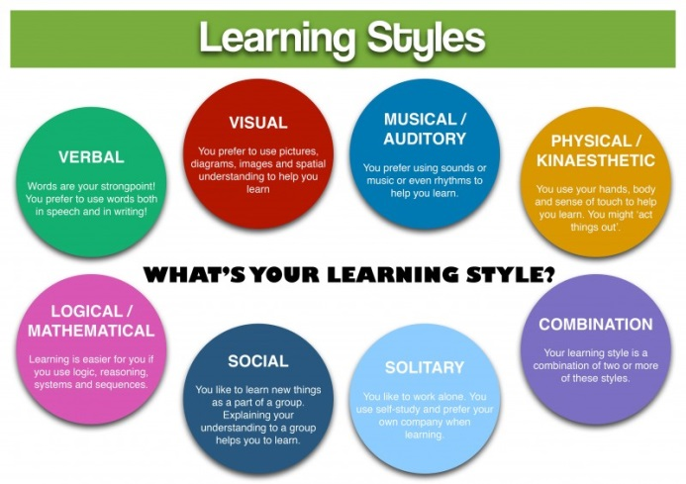
- Forget Learning Styles: Learn in More than One Way
There is no research evidence to support learning styles. You learn in many ways and you need to use a variety of methods to learn. Focus on learning in more than one way such as describing what you have learned to a friend, drawing a diagram, writing out your notes, or watching a video of a concept. Learning in many different ways will allow for storage of information in various regions of the brain. Figure out which strategies work best for you!
Image Courtesy of Ian Bradbury
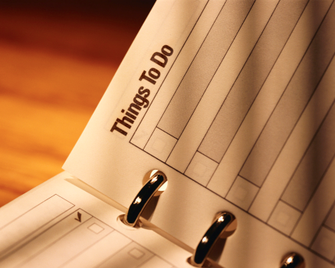
- Set Goals, Make a Plan, Choose Strategies…..and Follow Through
Research strongly shows that students who are able to self-regulate their own learning (set goals, choose strategies, modify plans, revisit goals, and evaluate learning) are some of the very best learners in terms of grades and understanding about themselves as learners.

- Teach What You Have Learned to a Friend
The best way to learn something is to teach it to someone else – someone who doesn’t know about the topic. Break down the concepts into your own words and find a way to share that learning with someone else (e.g., podcast, blog, group discussion). This is an excellent way for the brain to learn and encode new knowledge.

- Take Good Notes – By Hand is Best!
Study notes provide a key summary, create a set of memory cues and engages you in the class (how you take notes depends on how you process information – in a deep or a surface way). Taking notes by hand has been shown to result in higher understanding of content – than typing!
  - If you take down a lot of notes while just listening to the instructor – you are processing in a surface format – stop and take meaningful notes that focus on KEY ideas and major CONCEPTS
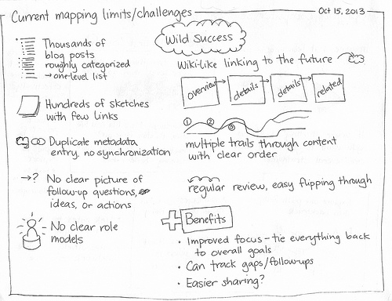
  - Get missed information right away
  - Consider recording the lecture
  - Borrowing notes is a poor substitute for missing a class – better to attend class yourself
  - Chunk your notes into sections
  - Actively organize and review your notes after the class – helps you process deeper
  - Edit your class notes soon after class to fill in missing information and organize handouts. Rewrite and review your notes after textbook readings so that your notes are all integrated.
Photo: http://farm4.staticflickr.com/3764/10302017125_57cbd03600.jpg
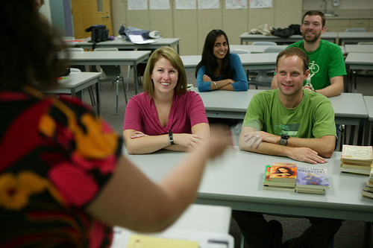
- GO TO CLASS!
Don’t miss a class! Research shows that students who go to class do better in school. Just pick up your backpack and attend class. Your brain will thank you.
Photo Credit: Vancouver Island University

(All photos not credited are part of Microsoft Office images)

