Ten Metacognitive Teaching Strategies Helping Students Learn How to Learn
Definition
meta = ‘about’ and cognition = thinking
Metacognition: Purposefully thinking about one’s own thinking strategies – when people are able to “learn to think” and “think to learn”
Metacognition is the regulatory system people use to understand and control own cognitive (brain) performance. It involves people being very aware of how they learn, what strategies meet their needs, evaluating the effectiveness of strategies and then implementing the best plan of action to optimally learn.
Learners with Strong Metacognitive Skills
- Know the limits of their own memory for a task and elicit help where required
- Do frequent self-assessments of their knowledge to ensure they can figure out how well they are learning something
- Self-monitor frequently and use a variety of strategies to learn
- Undertake careful rehearsal of a skill in order to gain confidence and competence
- Plan effectively at many levels and see the big picture of learning
There is a need to teach for metacognitive knowledge explicitly….we are continually surprised at the number of students who come to [university] having very little metacognitive knowledge; knowledge about different strategies, different cognitive tasks, and particularly accurate knowledge about themselves. (Pintrich, 2002)

The following ten metacognitive teaching strategies come from a few sources that were used including: Promoting Student Metacognition (K. Tanner, 2012), Creating Self-Regulated Learners: Strategies to Strengthen Students’ Self-Awareness and Learning Skills (L. Nilson, 2013), Metacognition (Putting Metacognition into Practice) website by Nancy Chick, Centre for Teaching Assistant Director (Vanderbilt University), Classroom Assessment Techniques (by T. Angelo and P Cross, 1993), Centre for Research on Learning and Instruction (University of Edinburgh) and Peter Arthur, Director, Centre for Teaching and Learning, University of British Columbia Okanagan.
1. Metacognitive Awareness Inventory
There are two processes going on around learning how to learn. Most often students (and adults) are unware of what they are and what is required to improve them.
- Knowledge of Cognition (Declarative, Procedural, and Conditional)
  - Awareness of factors that influence your own learning
  - Knowing a collection of strategies to use for learning
  - Choosing the appropriate strategy for the specific learning situation
- Regulation of Cognition
  - Setting goals and planning
  - Monitoring and controlling learning
  - Evaluating own regulation (assessing if the strategy you are using is working or not, making adjustments and trying something new)
In 1994, Schraw and Dennison created the Metacognitive Awareness Inventory (MAI) specifically for adult learners to bring awareness of metacognitive knowledge and metacognitive regulation (which they referred to “Knowledge of Cognition Factor” and “Regulation of Cognition Factor” respectively).
The MAI consists of 52 questions that cover these two components of cognition. They found through their research there was strong support for both of these factors and that they were also related as had been suggested by previous researchers.
Recent research has uncovered a significant correlation between the MAI and some measures of academic achievement (e.g., GPA, end of course grades etc.) However, when looking at undergraduate students and graduate students (younger adults and older adults) it was found that they do not differ in their mean scores on the ‘Knowledge of Cognition’ areas (similar for both groups), but they do differ in terms of their regulation strategies and skills.
‘Knowledge of Cognition’ is more easily acquired and improved. ‘Regulation of Cognition’ strategies are not that easy to acquire and most often students won’t improve over time in their Regulation scores – because they need to learn the strategies and have chances to practice in and out of classroom experiences. They need their instructors to use some of the teaching strategies in this booklet to help them build their strategies around regulation of learning.
Using the Metacognitive Awareness Inventory
- Copy the 52 statement handout and give to students.
- After they have completed checking off ‘true’ or ‘false’ give them the second handout (Scoring Guide).
- Discuss with students. Discuss how they can improve their knowledge and regulation.

Schraw, G. & Dennison, R.S. (1994). Assessing metacognitive awareness. Contemporary Educational Psychology, 19, 460-475.
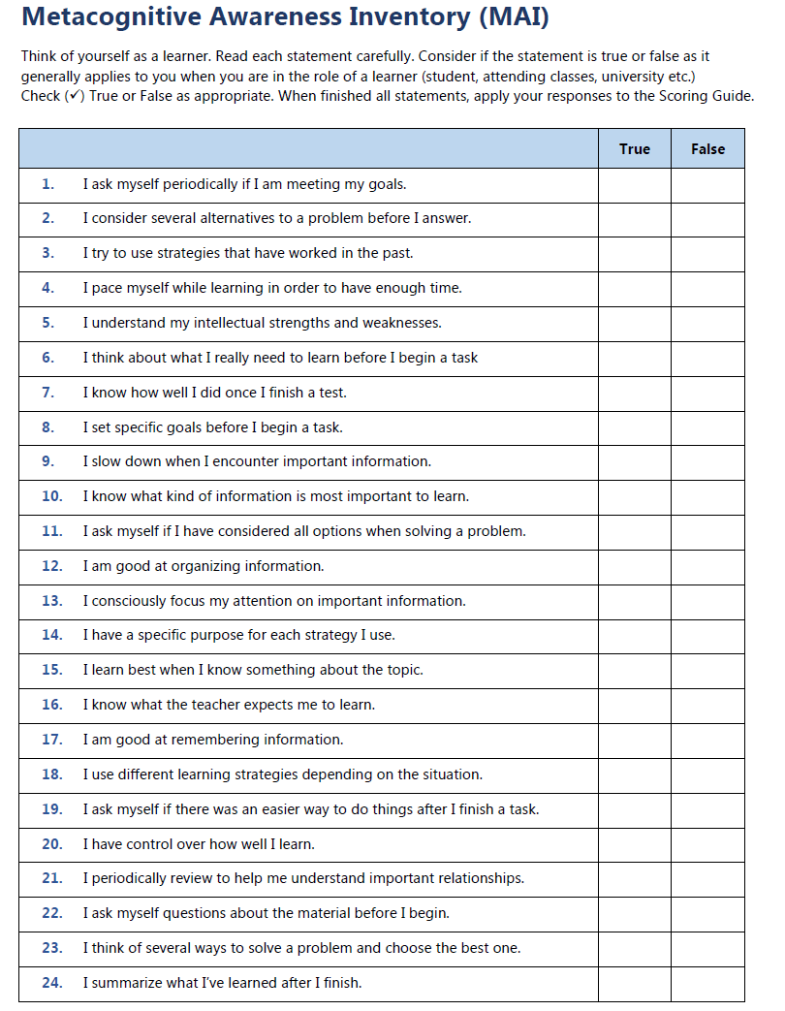
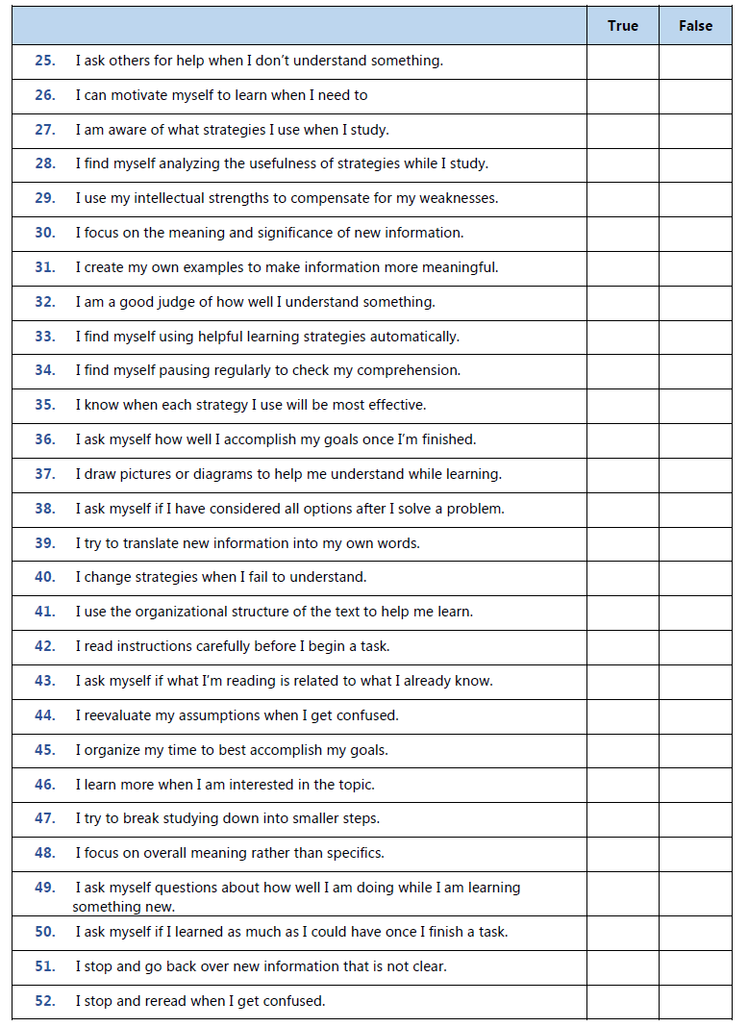
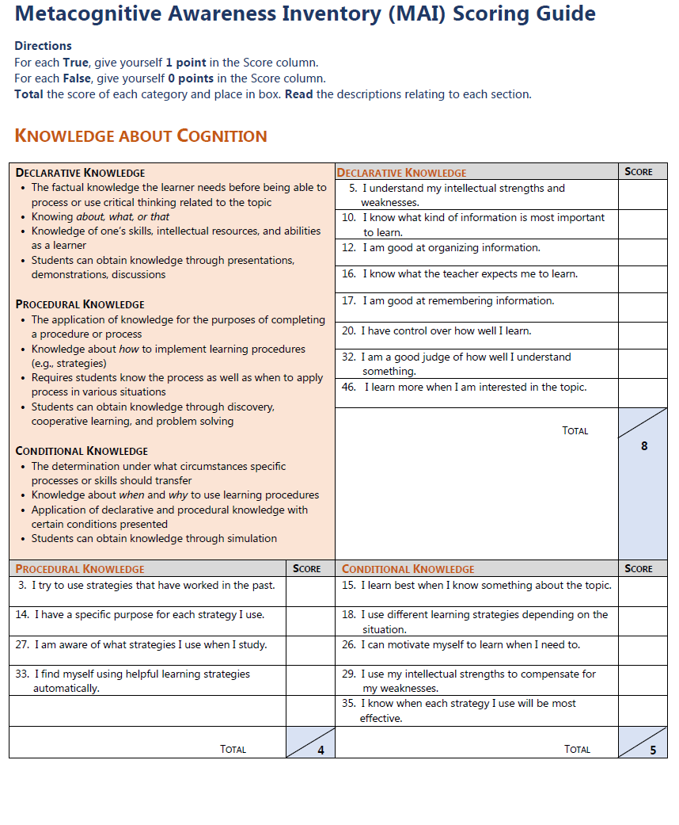
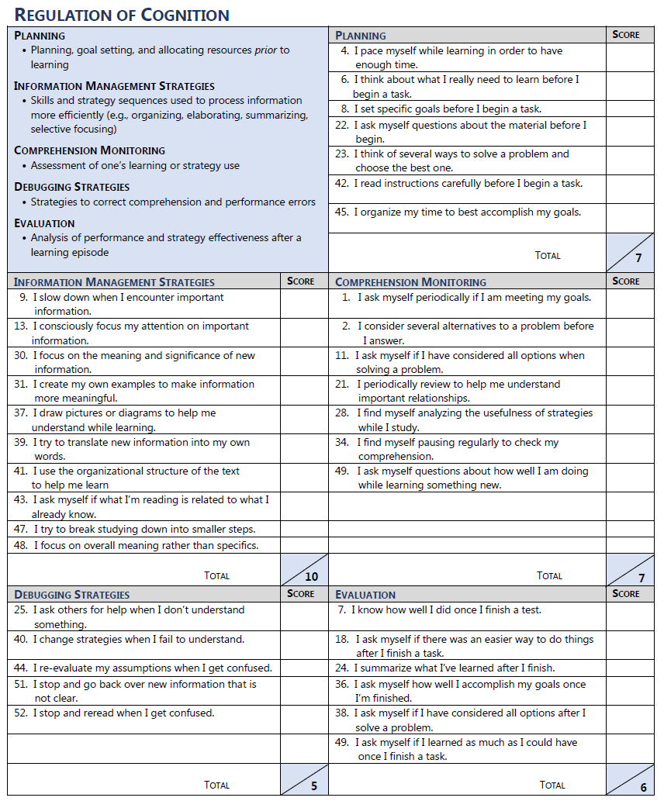
2. Pre-assessment (Self-Assessment) of Content
A simple activity such as finding out what students already know about a topic can help students begin to think about how learning works.
Here are a few was to conduct a pre-assessment (or a student self-assessment) of new content.
- Create a few key questions about the content/topic a week prior to the class. Questions should ask students what they know already about the topic, possible identification of any misconceptions they hold on the topic, challenges or successes they have had with the topic, exploration into past experiences or applications of the content/topic.
These questions may be in the form of a homework assignment, a set of clicker questions for in class voting, a short reflective writing piece done in class and handed in.
- Have the students individually hand in their responses anonymously. Skim through the answers after class. Possibly categorize/summarize all responses by themes.
- Share responses with students the next class either verbally or a summary of themes.
- Have a discussion with students about how asking these questions can help them in thoughtful planning of how they might approach a new idea or topic or how they will approach course content and associated studying/learning strategies.

3. Self-Assessment of Self-Regulated Learning Skills
Students aren’t going to learn how to be good learners unless we engage them in activities and discussions about how they perceive themselves as learners – and to see what approaches are working and not working for their learning.

Here are 21 statements you could pose to students to start them thinking about how they think and think about how they learn. Ideally we hope to have students utilizing deep approaches to learn rather than surface approaches. Strategic approaches are somewhere in between the two but don’t really result in longer term and meaningful learning.

Surface Approach to Learning Questions
- I find I have to concentrate on just memorizing a good deal of what I have to learn.
- I am not really sure what’s important in lectures, so I try to get down all I can.
- I tend to read very little beyond what is actually required to pass.
- I concentrate on learning just those bits of information that I have to know to pass.
- I like to be told precisely what to do in essays or other assignments.
- I often seem to panic if I get behind in my work.
- Often I find myself wondering whether the work I am doing here is really worthwhile.
Strategic Approach to Learning Questions
- I think I am quite systematic and organized when it comes to studying for exams.
- I am pretty good at getting down to work whenever I need to.
- I organize my study time carefully to make the best use of it.
- Before starting work on an assignment or exam question, I think first how best to tackle it.
- I look carefully at my instructor’s comments on course work to see how to get higher marks the next time.
- I put a lot of effort into studying because I am determined to do well.
- When I have finished a piece of work, I check it through to see if it really meets requirements.
Deep Approach to Learning Questions
- When I am reading I stop from time to time to reflect on what I am trying to learn from it.
- When I am working on a new topic, I try to see in my own mind how all the ideas fit together.
- Often I find myself questioning things I hear in lectures or read in books.
- Some of the ideas I come across on the course I find really gripping.
- I usually set out to understand for myself the meaning of what we have to learn.
- I like to play around with ideas of my own even if they don’t get me far.
- It is important for me to be able to follow the argument, or to see the reason behind things.

All items are to be responded by choosing from “strongly agree”, “somewhat agree”, “somewhat disagree” or “strongly disagree”.

These items come from ASSIST (Approaches and Study Skills Inventory for Students) designed to evaluate university students’ conceptualizations of learning, approaches to studying and preferences for different instructional methods (Centre for Research on Learning and Instruction, University of Edinburgh). The ASSIST tool identifies three main approaches to studying: deep, strategic and surface. Deep and strategic approaches usually result in greater success where surface approaches may result in poorer performance by students.

You may put a few of these statements on a slide or on the whiteboard and ask if anyone uses that technique, or you may have a discussion around a collection of statements.

Or you could copy the handout (see next page) and give to students and ask them to check off their level of agreement with each statement. Once completed, ask the students to identify the “approach” for each collection of statements and have them fill in the type of approach used. (Answer: Surface, Strategic and Deep).

What Approach to Learning Do You Use?
Instructions: Read each statement and the column descriptor you feel best represents how you learn. | Strongly Agree | Somewhat Agree | Somewhat Disagree | Strongly Disagree
Approach:
I find I have to concentrate on just memorizing a good deal of what I have to learn.
I am not really sure what’s important in lectures, so I try to get down all I can.
I tend to read very little beyond what is actually required to pass.
I concentrate on learning just those bits of information that I have to know to pass.
I like to be told precisely what to do in essays or other assignments.
I often seem to panic if I get behind in my work.
Often I find myself wondering whether the work I am doing here is really worthwhile.
Approach:
I think I am quite systematic and organized when it comes to studying for exams.
I am pretty good at getting down to work whenever I need to.
I organize my study time carefully to make the best use of it.
Before starting work on an assignment or exam question, I think first how best to tackle it.
I look carefully at my instructor’s comments on course work to see how to get higher marks the next time.
I put a lot of effort into studying because I am determined to do well.
When I have finished a piece of work, I check it through to see if it really meets requirements.
Approach:
When I am reading I stop from time to time to reflect on what I am trying to learn from it.
When I am working on a new topic, I try to see in my own mind how all the ideas fit together.
Often I find myself questioning things I hear in lectures or read in books.
Some of the ideas I come across on the course I find really gripping.
I usually set out to understand for myself the meaning of what we have to learn.
I like to play around with ideas of my own even if they don’t get me far.
It is important for me to be able to follow the argument, or to see the reason behind things.

4. Think Alouds for Metacognition
As the instructor, you are an expert in your field. It can be almost impossible to remember a time when you did not think ‘the way you currently do about your discipline’. At one time you were confused or unsure about studying your discipline. If you can offer to students examples of your own self-reflective examples of your own transition into thinking like an expert in your discipline, this can help students a lot. As researchers and reflective practitioners we are thinking metacognitively all the time (thinking about your own questions, how your thinking has evolved, how you incorporate new knowledge into your practice etc.)
Anytime you can talk out loud (‘think aloud’) about how you view a document or a picture or think about a book, or share your thinking processes with students you are helping them become more metacognitive in their own approaches to the subject.
Once you have modelled for them how you would solve a problem or interpret a piece of writing, have students work in pairs to talk out loud as to how they are thinking about an assignment piece of homework or an assignment.
- One student talks out loud while the partner records what they are saying (the strategy going to be used to complete the homework or do the assignment). The partner also guides them to think through all the steps.
- Students switch roles and do the same for each other.
- Now students have thought out the process for completing the assignment or homework, received some feedback from their partner and possibly have a plan written down as to how they are going to undertake the task. Debrief briefly with class as to lessons learned etc.
“[I]t is terribly important that in explicit and concerted ways we make students aware of themselves as learners. We must regularly ask, not only ‘What are you learning?’ but ‘How are you learning?’ We must confront them with the effectiveness (more often ineffectiveness) of their approaches. We must offer alternatives and then challenge students to test the efficacy of those approaches.” (Weimer, 2012)

5. Concept Mapping and Visual Study Tools
Concept maps were originally developed to enhance meaningful learning in the sciences. A concept map is a way of representing relationships between ideas, images or words. Concept maps are a way to develop logical thinking and study skills by revealing connections to the big ideas or the key concepts you are trying to teach. Concept maps will also help students see how individual ideas relate to the larger whole or the bigger picture.

Learning benefits can be derived from instructor-led or student-constructed concept maps of the connections and key ideas from a course or class. It is best that the instructor demonstrate how to design a concept map of a class or course before students are asked to do the same. Show students how the readings, videos, assignments and activities are connected to the course learning outcomes and other courses.
Design a brief or detailed concept map of the course or sub-components of the course and share with students. Then later on in course students can form small groups and build a concept map as a review activity before a mid-term or as a review of a portion of the course. Students can do for homework or they can do in class and share with each other explaining the interrelationships between each component. Ask the students to draw all the ‘cross-links’ and label them as they see the components connecting fully or partially.

How to use a Concept Map
Every concept map responds to a focus question, and a good focus question can lead to a much richer concept map. When learning to construct concept maps, learners tend to deviate from the focus question and build a concept map that may be related to the domain, but which does not answer the question. It is often stated that the first step to learning about something is to ask the right questions. Steps to create a concept map:
- Construct a Focus Question
- Identify the Key concepts
  - Some people rank the concepts by importance as it may help with the construction of the map
  - This also helps the map maker sort the ideas and if they see no relevant connection they do not have to include the concept
- Construct a Map
  - If this is the first time you are doing one – do it as a group first
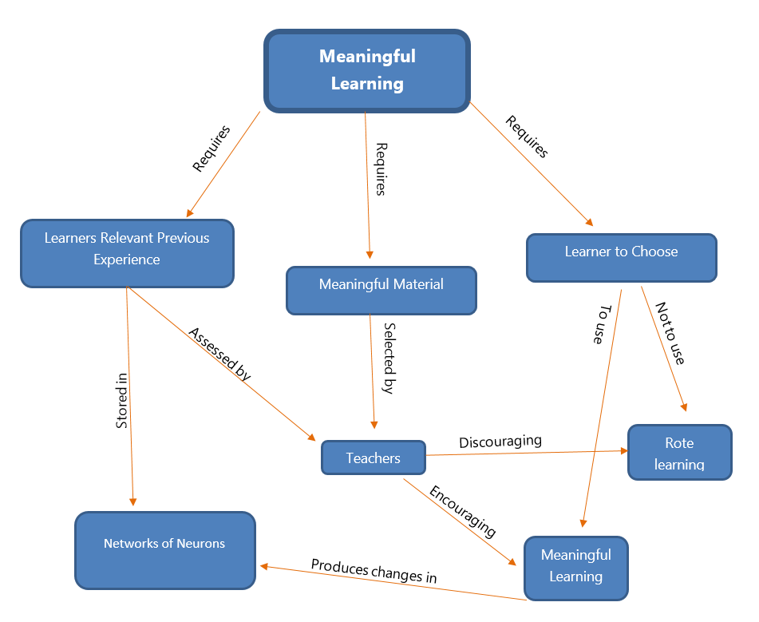
  - You can use partially completed version with students to help them initially build
Example Concept Map: Based on Novak’s concept map of meaningful learning
6. Classroom Assessment Tools
There are many short activities you can do during class time that will help promote metacognitive thinking in your students.
Sometimes these little activities are called “Classroom Assessment Tools – CATS” (term coined by Angelo and Cross).
Here is a sampling of a few tools to consider. They often take a few minutes to do and are easy to implement.
CATs give students and faculty immediate feedback on learning.
Assessment Method | Description | How To Use
Ticket-Out-The-Door | During last few minutes of class, students write response to a question or two about class concepts. Hand in as exit class. | Review/read all before next class and use to clarify, correct or elaborate more for students.
One Minute Paper | During the last few minute of class, students write response to “Most important thing I learned today” and “What I understood the least today”. | Review/read all before next class and use to clarify, correct or elaborate more for students.
Muddiest Point | Similar to One-Minute Paper – but only ask students to describe what they didn’t understand during class and what they think might help them. | Same as One-Minute Paper but if many students have same problem, reteach concept another way.
Student-Generated Test Questions | Divide the class into groups and assign each group a topic on which they are to each write a question and answer for next test. | Use as many of the questions as possible on next test.
Memory Matrix | Students fill in cells of a two-dimensional diagram with instructor-provided labels such as a comparison chart outlining similarities and differences in two columns against a variety of concepts in the discipline. | Tally the number of correct and incorrect responses. Look for patterns amongst the incorrect responses. Address in class.
K-W-L Chart | Label three charts K (What I KNOW Already), W (What I WANT to Know) and L (What I have LEARNED). Complete the first two before a unit/topic and the last one at end. | Discuss with students perceptions of what they thought they knew, what they have come to know etc.
Directed Paraphrasing | Ask students to write a layperson’s “translation” of something they have just learned (geared for a non-expert audience) to assess their ability to comprehend/transfer concepts. | Categorize student responses according to characteristics you feel are important. Address in class.
One Sentence Summary | Students summarize knowledge of a topic by constructing a single sentence to cover the core concept. The purpose is to require students to select only the defining features of an idea. | Evaluate the quality of each summary in brief fashion. Note if students have identified the core concepts of the class topic. Share with students.
Think-Pair-Share | Give the class a question. Allow everyone to think on own for a few minutes jotting down some thoughts. Then ask students to pair up with a peer and discuss thoughts for another few minutes. Can do groups of 4 as well. Ask to share with whole class. | Use when you want to have a better discussion by a greater number of students. By thinking alone first and with small groups of peers, shared responses should be richer and more varied.
Application Cards | After teaching a theory, principle or procedure, ask students to write down at least one real-world application for what they have just learned to determine if they can see the transfer of their recent learning. | Quickly read through once and categorize them according to quality. Pick out a broad range of examples to share with the class the next day.
Classroom Opinion Polls | Using ‘clickers’, or online polling questions, ask students a variety of questions about a topic and seek their anonymous opinion, | Often polling devices can present immediate results back to the class to provide discussion and next steps.
Weekly Report | Written by students each week in which they address three questions: What did I learn this week? What questions remain unclear? And What questions would you ask your students if you were the instructor to find out if they understood the material? | Read at end of each week, categorize responses and share with class. Follow up on unclear questions with class or small group of students.
ConcepTests | Instructor presents one or more questions during class involving key concepts, along with several possible answers (multiple choice). Students indicate (by show of hands, or poll/clicker voting) which answer they think is correct. If most of the class has not identified correct answer, students are given a short time to persuade their neighbor(s) that their answer is correct. The question is asked a second time to gauge class mastery. | Often lasts a few minutes but uncovers misunderstandings, and great conversation amongst students. Share answer after second voting session to see how the class responses changed or didn’t change.
Instructor Meetings | Instructor meets informally with students either in class or after class to answer questions, inquire about conceptual understanding or provide feedback on student learning. | Design specific questions to help guide the meeting and address concepts and understandings you want to know more about.

7. Metacognitive Note Taking Skills
Provide students with guidance and models for how to take good notes during a class. Here is a suggestion for a format you can replicate or draw on the board and discuss with students.

Beginning of Class (Plan + Connect)
In this section, encourage students to prepare their notes in an organized fashion. Stop the class and have them complete the connections questions in their notes. This will help them start thinking about how this class fits in with what they already know or want to know more about.

Date: Course Name: Class Learning Outcomes:
Connections:
- What do I already know about this topic?
- How do I feel about this topic? (excited, anxious, curious, nervous)
- How does this topic relate to something I already know?
- What questions do I have already about this topic?

Middle of Class (Monitoring Learning)
In this section, encourage students to create 2 columns in their notes. In the left column ask students to record insights, ‘ah-ha’ moments, questions students have about the content, connections they are making to other classes/topics, and also any feelings or thoughts they have on the class. In the right column they take traditional notes on what is being presented. Encourage students to refrain from writing everything. Write key concepts and headings on the board and indicate to students when you are shifting to a new section or concept.

Learning Insights | Class Notes

End of Class (Reflecting on Learning)
Near the end of class, ask students to draw a line below their notes and write a summary of the whole class. Just a few sentences is enough to get students thinking about the key learning that has just happened and what the whole class was about.

You can also write a few prompts on the board to help students with their summary note (e.g., what were the most important ideas from today’s class? what did I find most interesting in class today? how did today’s content relate to another class?

See note taking template on next page.
Date: Course Name:
Class Learning Outcomes

Connections
Already Know  In this section briefly list what you already know about the topic for this class | Thoughts  In this section briefly share how you feel about this topic (anxious, nervous, excited, curious)
Relationships + Connections  In this section indicate how this topic connects or relates to previous topics, things you already know etc. | Questions  In this section list any questions you have on this topic before the class begins.

Learning Insights | Class Notes
Record questions about content/class, connections you are making, feelings/thoughts, areas where you understand….  Learning Insights | Record class notes here. Tip: do not write everything! Consider jotting down key concepts and headings and then fill in with other details.  Class Notes
Summary
In two to three sentences write a summary of the key concepts and ideas from this class.

8. Reflective Writing
Reflective writing helps students make connections between what they are learning in their homework/class content and with how they are integrating the content into their current learning structures. Writing helps students observe themselves before, during and after their reading, watching and listening experience. Reflective writing can also take the form of jotting down their affective and other personal reactions to learning the material. The most popular reflective writing activity is the “minute paper” whereby you have students respond to prompts that ask them to think about their experiences with the homework, class activities or recent learning experiences in your class. Here are some sample prompts to use for your reflective writing activities:
- The most important part of the reading, video or class is….
- The most useful or valuable thing(s) I learned today was….
- The most surprising or unexpected idea I encountered was…
- The ideas that stand out the most in my mind are….
- This helped or hindered my understanding of the reading, video or class ….
- Two ideas that I have found confusing are….
- “I learned a lot doing this assignment”. I agree (or disagree) because….
- The advice I’d give myself based on what I know now and if I were starting this assignment over again would be….
- If I were to paraphrase what we have learned today for a high school student it would look like this….
- What I have learned today, I am able to connect to other courses in this way…

Metacognition: Purposefully thinking about one’s own thinking strategies – when students are able to “learn to think” and “think to learn”
Three critical steps to teaching metacognition:
1. Teaching students that their ability to learn is mutable
2. Teaching planning and goal-setting
3. Giving students ample opportunities to practice monitoring their learning and adapting as necessary

9. Wrappers
A quick and easy tool for monitoring and evaluating metacognitive activity. A wrapper is an activity that surrounds pre-existing learning or assessment task and fosters students’ metacognition. You can build a self-monitoring wrapper around any pre-existing part of a course (lecture, homework, or test)
Why Wrappers Work
- Time efficient
- Students are doing the task anyway
- Only add a few minutes to a task
- Metacognition practice is built in to the that task
- Students are self-monitoring in context
- Feedback on accuracy can be built in
- Feedback is immediate
- Support can gradually be faded out
  - in just 3 lessons most students are successful on their own
- Minor Interventions can significantly change behavior

Course/Lesson Wrapper
- Before Lesson Begins: Indicate to students that in the last minutes of class they will be asked to consider the 3 key ideas from the class. Give the students a few tips on how to actively listen, make effective class notes and engage with the content and activities (e.g., while listening think of questions they have about topic, provide headings on board for students to organize notes, ask students to summarize and repeat back key content to peers in activities etc.).
- Near End of Lesson: 10 -15 minutes before class ends, ask students to write 3 key ideas from the class. Students can do individually (on own paper, on a stickie note they paste on board) or do in small groups (on chart paper, on white/blackboard) and share (individual volunteers, reps from small groups, teacher summarizing themes from notes on board).
- Teacher gives his/her list of 3 key ideas for students to self-check. Students record the differences between their responses and the teacher’s.
- Debrief: Have a brief discussion around similarities/differences between students’ and teacher’s 3 key ideas. Summarize class.

Homework Wrapper
- Instructor creates self-assessment questions that focus on skills students should be monitoring
- Students answer questions just before homework
- Complete homework as usual
- After homework, answer similar self-assessment questions and draw their own conclusions
Example
Pre Self-assessment: “This homework is about vector arithmetic… How easily can you solve problems that involve vector subtraction? How confident are you in being successful with the homework?”
Post Self-assessment: “Now that you have completed this homework, how easily can you solve problems around this topic? How confident are you in being successful with future homework around this topic or a test question?”

Exam/Test Wrapper
Most times instructors hand back exams (tests, quizzes, mid-terms) and focus the discussion on the exam questions, the areas where students did well or poorly and rarely engage students in a learning experience around how they prepared, studied or took the test. An exam wrapper is often a handout with a series of questions students answer and then discuss. A process might be:
- Students utilize normal test taking strategies to prepare and take the first exam.
- The first exam is returned and students complete the exam wrapper either in class or online within a course management system. (Instructors can either make the assignment required or award participation points for completion).
- The instructor collects the exam wrapper and reviews student comments. This allows the instructor to assess student behavior patterns and determine whether the teaching staff needs to include additional teaching resources to support student learning.
- The exam wrapper is returned to students within a week or two before the next exam. Students review their comments and then have the opportunity to follow their own advice for studying
Possible Questions for Exam Wrappers
Preparation for Exam
- How did you prepare for the exam? Explain your process.
- What resources did you use in preparing for taking the exam?
- How does your exam preparation compare to three other peers in the class (ask them)

Planning
- What strategies did you use for studying (e.g., study groups, online practice quizzes, office hours with instructor, review sessions, peer teaching etc.)?
- How much time did you study (and how long over what time period)?
- What aspects of the course did you spend more time on (or less time on) based on your current understanding.
- What percentage of your exam preparation time was spent on these activities? (re-reading the textbook section(s)___?; reviewing your own notes (daily)___?, reviewing your own notes (sporadically)____?; reviewing PowerPoint presentations from lecture ____?; generating your own exam questions and answering them____?; studying in groups_____?; other strategies____?
Performance
- How did your actual grade on this exam compare with the grade you expected? How do you explain the difference, if any?
- How do you feel about your exam grade (happy, surprised, disappointed)?
- Examine the items on which you lost points and look for patterns. Were you careless or did you run out of time?
Next Steps
- What are you going to do differently for your next exam?
- What might be your goal (e.g., certain percentage)?
- What study strategies are you going to use next time to enable you to get that score?

10. Retrospective Post-Assessment
Near the end of a topic or end of the course, ask students to reflect (retrospectively) as to what they thought about a topic or concept before the course and what they think about it now. Learning is about change and this activity asks students to reflect on the changes in their knowledge, skills and attitudes and put that into perspective for moving forward. This activity engages students in a mechanism to train students to ‘self-question’, “How has my thinking changes (or not changed) over time?”
- Some instructors record the thoughts of students at the beginning of the course and keep those responses until the end of the course – and revisit those responses. Alternatively, after learning has taken place (after a class or near end of a course) ask students to recall how they were thinking about the topic prior to the course learning activities and compare that with how they are thinking about the same topic now.
- Possibly write two prompts on the board to help students: “Before this course I thought X was….” and “Now I think X is….” OR ask them to write three ways in which their thinking has changed over the time period (a few classes or the course).
- Ask students to complete this task on their own on a piece of paper. During the last class, have a discussion with students as to how much ‘change’ has occurred in their learning. Students could also discuss their responses in small groups and share a summary with the class.

