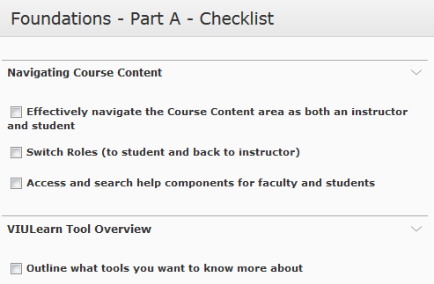The Checklist Tool in VIULearn allows you to build a checklist of readings, activities or assessments for your students. As students complete items on the checklist, they can manually check the boxes off, allowing them to take responsibility for their learning. There is an
example checklist to the right.

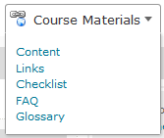1. You can access the Checklist Tool using the course navigation bar. Choose Course Materials and Checklist.

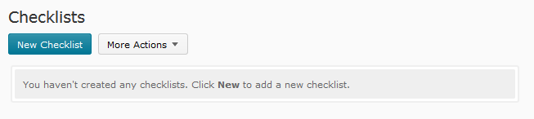2. You will be taken to a new page. To create a new checklist, click the blue New Checklist button.

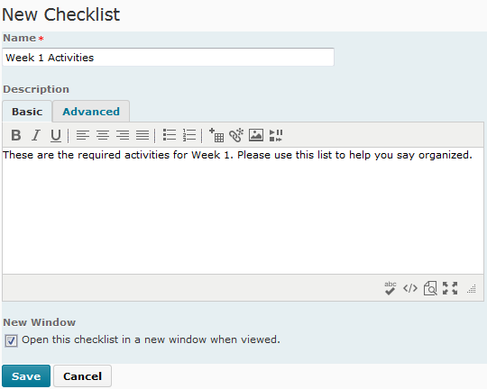3. Give your checklist a name. You can add a description if you want. It will be visible to students if you do add one. You can also choose to have the checklist always open in a new window using the checkbox. When you are happy your settings, choose Save.

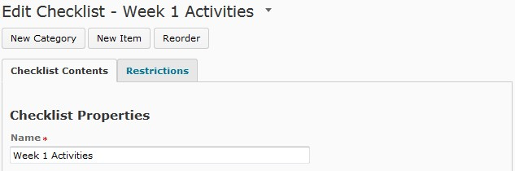4. You must have at least one category before you can add items for the students to check off. Create a new category by clicking on the New Category button.

5. Give your category a name. You can add a description, which will be visible to student, if desired.
You can either Save your category and go back to the previous screen or choose Save and New to save your category and create a new one.
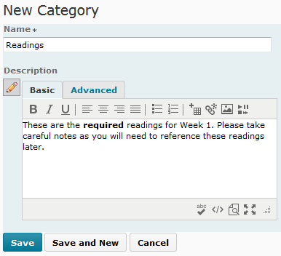

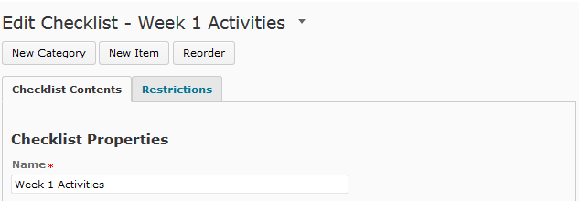6. Once you have at least one category, you can create an item. Choose New Item to create an item.

7. Choose the category for your item, and give your item a name. You can add a description, which will be visible to student, if desired. You can also add a due date to the item, and if you add a due date you can choose to display the due date in the course calendar. You can either Save your item and go back to the previous screen or choose Save and New to save your item and create a new one.
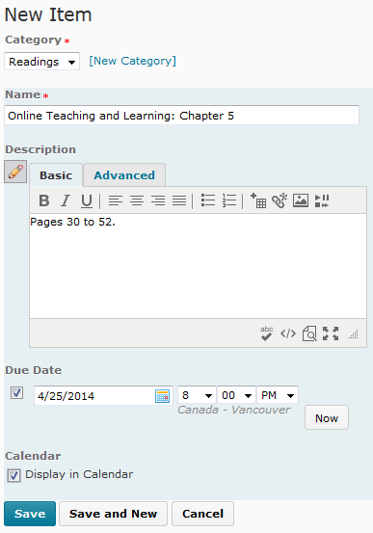

8. You can edit categories or items by clicking directly on their names. You can also edit items by selecting them using the checkboxes and choosing Edit.

9. You can delete items or categories by selecting them using the checkboxes and choosing Delete.

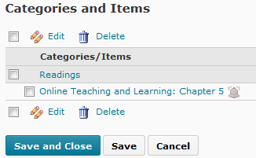10. When you are finished editing your Checklist, choose Save and Close.

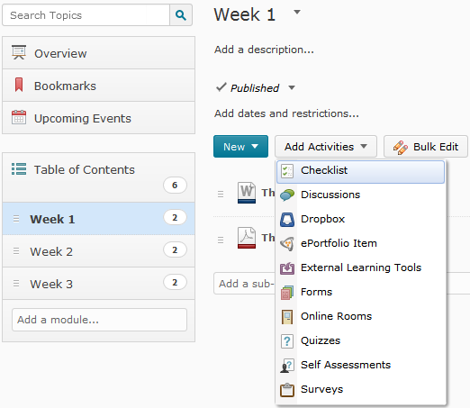11. You can add you checklist to your course content by choosing Course Materials and Content. From there, choose the module that you want the checklist in, and choose Add Activities and Checklist. Select your Checklist from the list, and select it to add it to content.

