- Navigate to https://viutube.viu.ca

- In the top right of the screen, click on “Guest” and choose “Login”

- Login using your computer account credentials
- Your username is your student number
- Your password is your computer account password

- Click on “Add New” and select “Media Upload”

- Click on “Choose a file to upload”, locate the file, and open it.
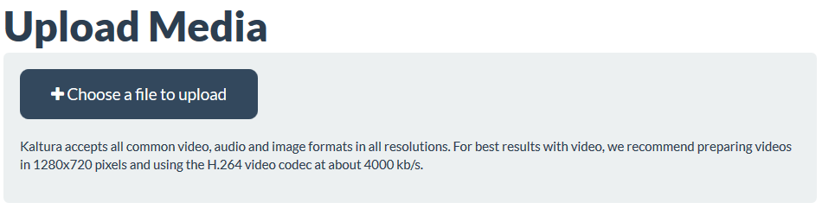
- The video will upload. You must give your video a name and a description before you can save it. You do not have to tag it, although tagging it with the course and assignment may make it easier for you to find later.

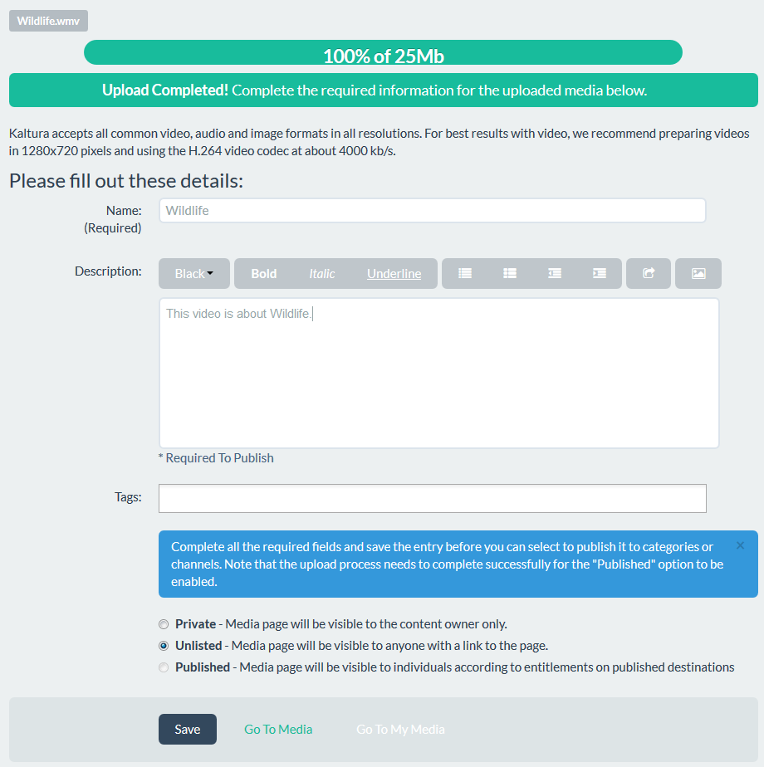

- Important: Leave your video as “Unlisted”. This means that anyone with the link can view it, and it will display correctly when it is embedded. If you change the video to “Private” it will not embed correctly and cannot be viewed using a link. “Unlisted” videos are not shared publically and are not searchable from VIUTube or other search engines like Google.

- Once your video is uploaded, choose “Save” and then either “Go To Media” to view it, or “Go to My Media” to view your media library. Note: Depending on the length of your video, it may take a few minutes to process before being viewable.

